Ministry of Energy, Water Resources and Irrigation, Alternative Energy Promotion Centre (AEPC) Renewable Energy for Rural Areas (RERA) Program
[ICS Capacity Development and ASS Training in Partner (Rural) Municipality]

3/24/19
Namsaling Community Development Center (NCDC) Ilam Municipality-8, Ilam, Nepal

Salient Feature of NCDC
Namsaling Community Development Center (NCDC) has worked as Regional Technical Service Provider (RTSP) of Alternative Energy Promotion Center (AEPC) up to the period of 2018 since 2001. NCDC has mainly facilitated to implement the Rural Energy Technologies especially Mini/Micro/Pico hydro projects, Improved water mills, Improved Cooking Stoves, Metallic Improved Cooking Stoves, Institutional Improved Cooking Stoves, Gasifiers, Solar Home System, Rural Solar Drinking Water Projects, Solar irrigation projects, Institutional Solar Photovoltaic System and Micro/Small/Medium Enterprises (MSMEs) operated from RETs. NCDC has an experienced human resources for the implementation/dissemination of those RETs since 2001. Also, NCDC has involved to disseminate/implement different models of improved cooking stoves in African countries such as Tanzania, Togo, Mozambique, Kenya and Asian countries such as Kazakhstan and India through the program of Fredskorpset (FK) Norway program. The Improved Cooking Stove technologies in rural area of Nepal is not new thing but the importance of this technologies is increasing day by day due to its benefits on the health, forest, time saving etc. The government of Nepal has announced to get free indoor air pollution from cooking by 2017 but that could not be done due to many reasons such as earthquake and time constraint but the government of Nepal is planning to get that goal by 2023. In order to get that goal within the time frame, the organizations involved in this sector have to go ahead jointly in coordination with government of Nepal by increasing the capacity of local people.
To till date, NCDC has successfully completed 174 numbers of stove master training (new trainees) in total. Those training have conducted in Nepal, India, Tanzania, Mozambique, Kenya, Togo and Kazakhstan from which 2219 number of participants have already get training and most of them are working for the promotion of ICS. Also, NCDC has provided 68 numbers of stove master refresher training for previously trained stove masters in different districts of Nepal from which 961 numbers of stove masters have benefitted.
NCDC is one of a NGO in Nepal who is involved in the promotion and dissemination of ICS form the very beginning of the Biomass Energy program implementation by Alternative Energy Promotion Center (AEPC) in Nepal.

Table of Contents
1 Salient Feature of NCDC 2
2 Table of Contents 3
3 CHAPTER I 3
3.1 INTRODUCTION 3
3.1.1 BACK GROUND OF THE TRAINING 3
3.1.2 OBJECTIVE OF THE TRAINING 4
3.1.3 METHODOLOGY 5
4 CHAPTER II 6
4.1 GENERAL PROJECT DESCRIPTION 6
4.2 TRAINING OF SELECTED PARTICIPANTS 6
4.2.1 THEORY AND PRACTICAL CLASSES 8
4.2.2 CURRICULUM OF ICS 9
4.2.3 BILL OF THE QUANTITY OF MATERIALS 12
4.2.4 TOOLS 21
5 CHAPTER III 22
5.1 IMPLEMENTATION OF ICS OF PARTNER (RURAL) MUNICIPALITY 22
5.1.1 HIGH HILL CLUSTER 22
5.1.2 MID HILL CLUSTER 24
5.1.3 LOW HILL CLUSTER 25
5.1.4 TERAI 27
6 Annexes: 29
6.1 Technical drawings 29
6.2 Dissemination and Awareness booklets 33
6.3 Bill of quantities and materials required for each stove type 85
6.4 Technical specification of tools including moulds and purpose 86
6.5 Flyer and posters 87

CHAPTER I

INTRODUCTION

BACK GROUND OF THE TRAINING
AEPC/RERA has awarded to provide 8 numbers of ICS Capacity Development and After Sale Service Training in 7 Rural Municipality and One Municipality of Province number 1 of Nepal. The total trainees from those 8 numbers of trainings are 73 numbers. The training was conducted in the sharing basis between NCDC and AEPC/RERA in which all the cost except cost of dissemination leaflet, demonstration poster is covered by AEPC/RERA and the cost of dissemination leaflet, demonstration poster is covered by NCDC. NCDC has started the first 6 day’s ICS capacity development and After Sale Service training at Miklajung Rural Municipality Panchthar on 21st Poush 2075 (5th January 2019) and completed the last training at Manebhanjyang Rural Municipality on 1st Chaitra 2075 (15th March 2019) in which 67 trainees have actively participated against the proposed plan of providing the training to 73 trainees.

OBJECTIVE OF THE TRAINING
The detail objective of that 6 day’s ICS capacity build up and after sale service training was as follows:
    - Provide information to trainees about the Concept, Process and Skills for making different models of ICS
    - Provide practical and theoretical trainings to trainees for the promotion and dissemination of different models of ICS
    - Provide information to trainees about building different models of ICS with approved standards
    - Provide Social and Cultural part of different models of ICS at household, local and community level
    - Provide information and skills about Repair & Maintenance of ICS & MICS (MICS in case of High Hill) and Biofuel
    - Enhance the skills of trainees, dissemination and awareness on indoor air pollution, energy efficiency and monitoring of different models of Improved Cooking Stove

METHODOLOGY
The 6 day’s ICS capacity build up and after sale service training course is done as per AEPC model except the reduction of training days from 8 to 6 days. All the courses are put as per AEPC standards. The training has conducted at 7 Rural Municipalities (i.e. Miklajung, Mangsebung, Gaurigunj, Jahada, Aamchowk, Hatuwagadhi and Manebhanjyang) and 1 Municipality (Mai Municipality) for 67 trainees in total. The course was a mix of practical session and theoretical session with following topics:
    - Lecture/Logical
    - Practical
    - Individual/GroupWise practical
    - Role of Stove masters
    - Operation & maintenance and after sales service of different models of Improved Cooking Stoves as well as monitoring methods.
The 6 day’s ICS/MICS (MICS in case of high hill) capacity build up and after sale service training at partner (Rural) Municipality was divided in different seasons that includes the following topics:
      - Introduction of traditional and Improved Cooking Stove
      - Kitchen management Gender and Social Issue of ICS/MICS
      - Principal and structure of ICS/MICS
      - Types of ICS/MICS
      - Parts of ICS/MICS
      - Practical to make different models of ICS/MICS
      - Solution to solve the problem of different model of ICS/MICS
      - Visit to households installing traditional and improved cook stove
      - Interaction to users of traditional and improved cook stove
      - Individual/Group wise practical
      - Work plan preparation and presentation
      - Evaluation of training

The training was conducted in the method by learning by doing of lecture (24%) and practical work (76%). Each season has their own objective and this training would have enhanced the skills of participants to be a good stove masters after the training. The topics of practical and theoretical work is specified in the section 4.2.1 Theory and Practical Classes section of the report.

CHAPTER II

GENERAL PROJECT DESCRIPTION
NCDC has coordinated with partner (Rural) Municipality and AEPC/RERA staffs about the training venue and participants before the training date. AEPC/RERA staffs and partner (Rural) Municipality have actively assisted for the event. NCDC has made preparation work for the management of materials required for the training as well as the blocks making process before the training. Partner (Rural) Municipality has provided 67 numbers of Trainees at the training venue through the energy committee of (Rural) Municipality in coordination with AEPC/RERA representative. The training was started on 21st Poush 2075 (5th January 2019) at Miklajung Rural Municipality and completed the last training at Manebhanjyang Rural Municipality on 1st Chaitra 2075 (15th March 2019). Staffs from AEPC Biratnagar has monitored the training session in those partner (Rural) Municipality at the time of training period.

The main objective of this training is to make technically sound for those trainees to install and monitor different models of ICS. Each participant of the training has practiced individually to install 1 Pot Hole ICS, 2 Pot Hole ICS, 3 pot Hole ICS, 2 Pot Hole & 3 Pot Hole MICS (MICS is in case of high hill), repair and maintenance knowledge of ICS/MICS, knowledge of kitchen management, after sale service of ICS/MICS and monitoring method of ICS/MICS. Finally, the trainers have assigned to each participants to provide finishing work of improved cooking stove after learning/practicing to install each type of stoves individually. All the trainees have installed each type of stove (i.e. 1 pot hole ICS, 2 Pot hole ICS, 3 pot hole ICS, 2 Pot Hole MICS and 3 Pot Hole MICS) separately during practice work but those Trainees of partner (Rural) Municipality are able to complete the finishing work of 43 numbers of 1 Pot Hole ICS, 48 numbers of 2 pot hole ICS and 20 numbers of 3 pot hole ICS during the training session due to time constraint because the training is reduced to 6 days from 8 days. Now, all those new stove masters are capable to install different types of ICS (i.e. 1 pot hole ICS, 2 Pot hole ICS and 3 pot hole ICS) when there would be demand in the rural village for ICS.

The total budget of the ICS Capacity Development and After Sale Service Training in those partner (Rural) Municipality was NRs 2,292,721.00 (In words Two Million Two Hundred Ninety-Two Thousand Seven Hundred Twenty-One Rupees Only). AEPC/RERA has allocated NRs 2,152,571.00 (In words Two Million One Hundred Fifty-Two Thousand Five Hundred Seventy-One Rupees Only) and NCDC has to contribute NRs 140,150.00 (In words One Hundred Forty Thousand One Hundred Fifty Rupees Only) as their organizational contribution.

TRAINING OF SELECTED PARTICIPANTS
67 participants have actively participated on the training of partner (Rural) Municipality held from 21st Poush 2075 (5th January 2019) at Miklajung Rural Municipality and completed on 1st Chaitra 2075 (15th March 2019) at Manebhanjyang Rural Municipality. The participants have selected through energy committee of respective rural municipality/municipality. The detail of trainees in partner (Rural) Municipality are as follows:

SN | Name of Trainees | Address | Phone Number | Remarks
1. | Mr. Ram Kumar Rai | Miklajung RM-2 | 9816967723
2. | Ms. Sunita Tamang | Miklajung RM-3 | 9816017416
3. | Ms. Ganga Lawati | Miklajung RM-4 | 9817903608
4. | Mr. Kalendra Lawati | Miklajung RM-5 | 9823411548
5. | Mr. Dhan Kumar Rai | Miklajung RM-6 | 9741451367
6. | Mr. Fanindra Tamang | Miklajung RM-7 | 9815397352
7. | Mr. Lok Bahadur Thapa | Miklajung RM-8 | 9745156647
8. | Mr. Tika Thapa | Miklajung RM-8 | 9825959521
9. | Mr. Chakra Bahadur Adhikari | Mangsebung RM-1 | 9842784139
10. | Mr. Hem Prakash Dhungana | Mangsebung RM-1 | -
11. | Mr. Mohan Raj Shrestha | Mangsebung RM‐2 | 9815907492
12. | Mr. Rabindra Kafle | Mangsebung RM-2 | 9816969293
13. | Ms. Dil Maya Rai | Mangsebung RM-3 | 9824961292
14. | Mr. Santa Kumar Rai | Mangsebung RM-3 | 9741018706
15. | Mr. Min Kumar Nepali Damai | Mangsebung RM-3 | -
16. | Mr. Tilak Rai | Mangsebung RM-4 | 9741451367
17. | Ms. Buddha Rani Limbu | Mangsebung RM-4 | 9816979661
18. | Mr. Suman B.K. | Mangsebung RM-4 | 9824057636
19. | Ms. Asmita Lawati | Mangsebung RM-5 | 9814920933
20. | Mr.Makardhoj Limbu | Mangsebung RM-5 | 9860714208
21. | Mr. Govinda Prasad Rai | Mangsebung RM-6 | -
22. | Ms. Alisha Shrestha | Mai Municipality-1 | 9842720843
23. | Ms. Oma Devi Dulal | Mai Municipality-2 | 9807904192
24. | Mr. Lok Bahadur Limbu | Mai Municipality-3 | 9815923358
25. | Ms. Devi Maya Lungeli | Mai Municipality‐4 | 9823019111
26. | Ms. Hem Kumari Rai | Mai Municipality‐5 | 9814963741
27. | Mr. Deep Kishor Lingden | Mai Municipality‐6 | -
28. | Ms. Reeta Saru Magar | Mai Municipality‐7 | 9817025278
29. | Ms. Deepa Kerung | Mai Municipality-8 | 9815916540
30. | Mr. Dawa Sherpa | Mai Municipality-9 | 9814941771
31. | Ms. Malina Kumari Tamang | Mai Municipality-10 | 9815963867
32. | Mr. Santosh Paswan | Gaurigunj RM‐1 | 9807944969
33. | Mr. Rajendra Prasad Rajbansi | Gaurigunj RM‐2 | 9818785847
34. | Ms. Gita Poudel | Gaurigunj RM‐3 | 9814974189
35. | Mr. Birchandra Kumar Babaji | Gaurigunj RM‐4 | 9815902081
36. | Ms. Anju Thakur | Gaurigunj RM‐5 | 9804933070
37. | Ms. Sagbati Rajbansi | Gaurigunj RM‐6 | 9806087104
38. | Mr. Fagu Risidev | Jahada RM‐2 | -
39. | Ms. Dina Kumari Mandal | Jahada RM‐5 | 9807904192
40. | Mr. Sanjaya Kumar Singh Nuniya | Jahada RM‐6 | 9810413431
41. | Ms. Uma Tudu | Jahada RM‐7 | 9810533892
42. | Mr. Dhiraj Rai | Aamchowk RM‐1 | 9862123301
43. | Mr. Karma Sherpa | Aamchowk RM‐2 | 9829339896
44. | Mr. Sonarbu Sherpa | Aamchowk RM‐3 | 9866047067
45. | Ms. Milan Rai | Aamchowk RM‐4 | 9866796968
46. | Ms. Susita Rai | Aamchowk RM‐5 | 9818582617
47. | Mr. Prem Kumar Rai | Aamchowk RM‐6 | 9810337909
48. | Ms. Pampla Maya Rai | Aamchowk RM‐7 | 9817301017
49. | Mr. Singha Ba. Shrestha | Aamchowk RM‐8 | 9862285584
50. | Mr. Rakam Singh Rai | Aamchowk RM‐9 | 9804058777
51. | Ms. Sabita Rai | Aamchowk RM‐10 | 9866456093
52. | Ms. Aruna Bhujel | Hatuwagadhi RM‐1 | 9862123301
53. | Mr. Puspalal Rai | Hatuwagadhi RM‐2 | 9829339896
54. | Mr. Ranjit Rai | Hatuwagadhi RM‐3 | 9866047067
55. | Mr. Ashpura Rai | Hatuwagadhi RM‐4 | 9866796968
56. | Ms. Sujata Rai | Hatuwagadhi RM‐5 | 9818582617
57. | Mr. Ash Kumar Rai | Hatuwagadhi RM‐6 | 9810337909
58. | Mr. Prem Kumar Rai | Hatuwagadhi RM‐7 | 9817301017
59. | Ms. Sita Kumar Rai | Hatuwagadhi RM‐8 | 9862285584
60. | Ms. Dil Kumari Rai | Hatuwagadhi RM‐9 | 9804058777
61. | Mr. Tulla Bahadur Shrestha | Manebhanjyang RM-2 | 9861135073
62. | Mr. Dal Bahadur Pulami | Manebhanjyang RM-5 | 9843854586
63. | Mr. Dhan Bahadur Shrestha | Manebhanjyang RM-5 | 9844480903
64. | Mr. Pahalman Rai | Manebhanjyang RM-6 | 9861701703
65. | Mr. Matrika Prasad Gautam | Manebhanjyang RM-7 | 9842971045
66. | Mr. Dilli Bahadur Thapamagar | Manebhanjyang RM-8 | 9865598456
67. | Mr. Chet Bahadur Ale Magar | Manebhanjyang RM-9 | 9840104371
Note: Male: 42; Female:25; Ethnic: 53; Dalit: 4; Other (Bramin/Chhetri/Madhesi):10

THEORY AND PRACTICAL CLASSES
The training was conducted in the method by learning by doing of lecture (24%) and practical work (76%). Each session has their own objective and this training would have enhanced the skills of participants to be a good stove masters after the training.
The main topics included in practical classes of the training are as follows:

      - Method of using Tools used to make ICS
-Scissors, Plier, Frame set, measuring tape label, Hacksaw, Saw, Hammer, Small Spate (Karni), Mixing Pot, Spatula (Metal Ruksa and Wooden Ruksa), Gloves, Hoe and Shovel

      - Method of making normal blocks and chimney blocks
-Ratio of materials such as clay, water, saw dust, cow dung etc. mix
-Timing of making dry for normal and chimney blocks

      - Selection of location for ICS inside the kitchen
-Direction of air circulation

      - Method of making 1 pot hole ICS/2 pot hole ICS/3 pot hole ICS
-Cutting process of blocks
-Piece of rod requirement and cutting process
-Pot hole fixing of ICS
-Making process of wall for chimney and ICS
-Baffle adjustment
-Materials such as salt, sugar, oil, clay, white cement etc. mixing/making process for finishing
-Stand making process for ICS

      - Method of making chimney outlet
-Cutting process of galvanized sheet for chimney outlet
-Bending process of sheet
-Making process of cap of chimney outlet

      - Method of installation and maintenance of MICS (For High hill region only)
-Location of MICS to be install inside kitchen
-Process of installation of 2 pot hole and 3 pot hole MICS
-Maintenance idea of 2 pot hole and 3 pot hole MICS

      - Problems, reasons and solution during the operation of ICS
-Problems raised during operation of ICS
-Reasons of those problems
-Solution to the problems

Each participant has practiced to make different types (i.e. 1 pot hole, 2 pot hole and 3 pot hole) of ICS during the training period individually but the finishing work has done for some of ICS only due to time constraint of training.

The main topic included in theoretical classes of the trainings are as follows:

      - Relation between ICS and Health
-Indoor Air Pollution concept related to Traditional and Improved ICS
-Reduction of disease related to Indoor Air Pollution
-Cleanness of kitchen

      - Knowledge of other Biomass Energy Technologies
-Different models of ICS, Rocket stoves, IICS, Gasifiers etc
-Type of firewood requirement

      - Role of ICS for environment and forest conservation
-Reduction of firewood
-Reduction of deforestation
-Temperature balance
-Pollution reduction

      - Kitchen management and ICS & GESI issue
-Selection of location for the kitchen
-Lighting availability of kitchen
-Air circulation in kitchen
-Management of waste from kitchen
-Relation of ICS and kitchen
-Safety against fire in kitchen
-Storing of foods inside kitchen
-GESI issue related to ICS

      - Technique to make clay, blocks, chimney, different models of ICS
-Mixing process of clay, cow dung, saw dust and water to make ICS blocks
-Process of making chimney
-Handling process of Tools required to make ICS

      - Time saving factor of ICS

      - Role of stove masters to disseminate ICS
-Promotion technique
-Technical accuracy maintain
-Monitoring of ICS/MICS (MICS is for high hill region only)
-Problems management related to ICS technology

      - Need, Use, Installation and maintenance process of MICS (for high hill region only)

      - Evaluation of Trainees

CURRICULUM OF ICS
The training was conducted in the method by learning by doing of lecture (24%) and practical work (76%). Each session has their own objective and this training would have enhanced the skills of participants to be a good stove masters after the training. The curriculum of ICS capacity Development and ASS Training for high hill and medium hill/low hill/terai is different and presented as follows:

For High Hill Region:
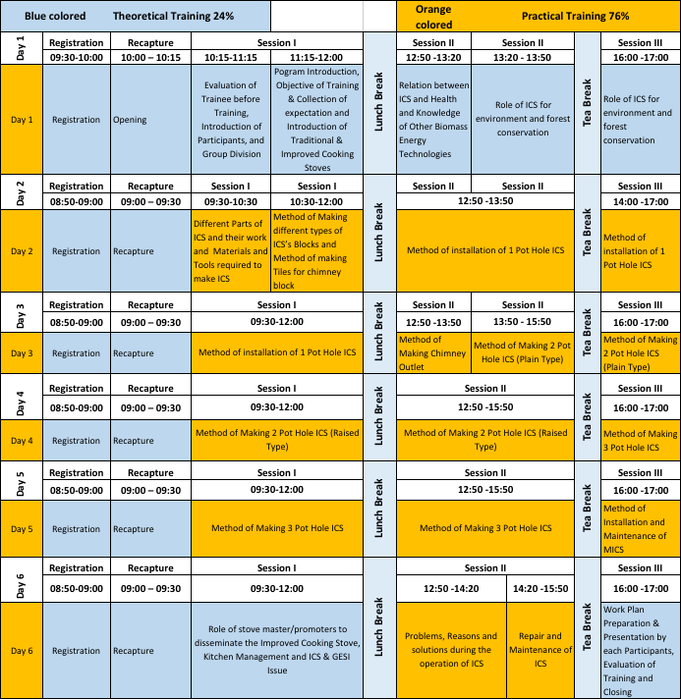

For Mid Hill/Low Hill and Terai Region:
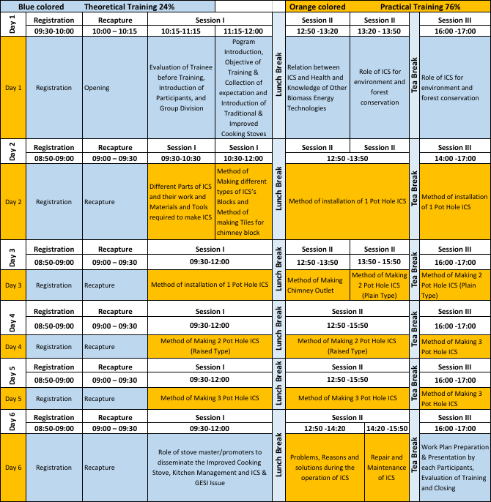

BILL OF THE QUANTITY OF MATERIALS
The materials required to make ICS is used two times during the training/installation process of ICS. The ICS blocks have made 1 week earlier than the proposed date of the training because the blocks should be completely dry before the training period. The actual materials requirement to make different types of ICS is as follows:
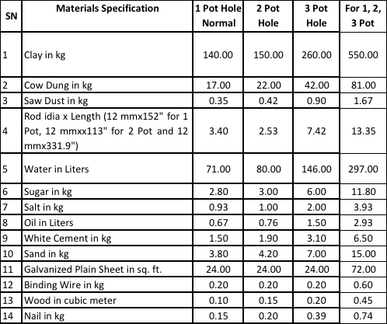
Note: The quantity of clay, water and sand required depend up on the moisture available on clay. Those materials would vary from place to place and may not match with estimated calculation.
The bill of quantity along with its cost used in in the training of ICS capacity Development and ASS Training of 7 RMs and 1 Municipality and the actual budget in plan are as follows:

Miklajing RM, Panchthar:
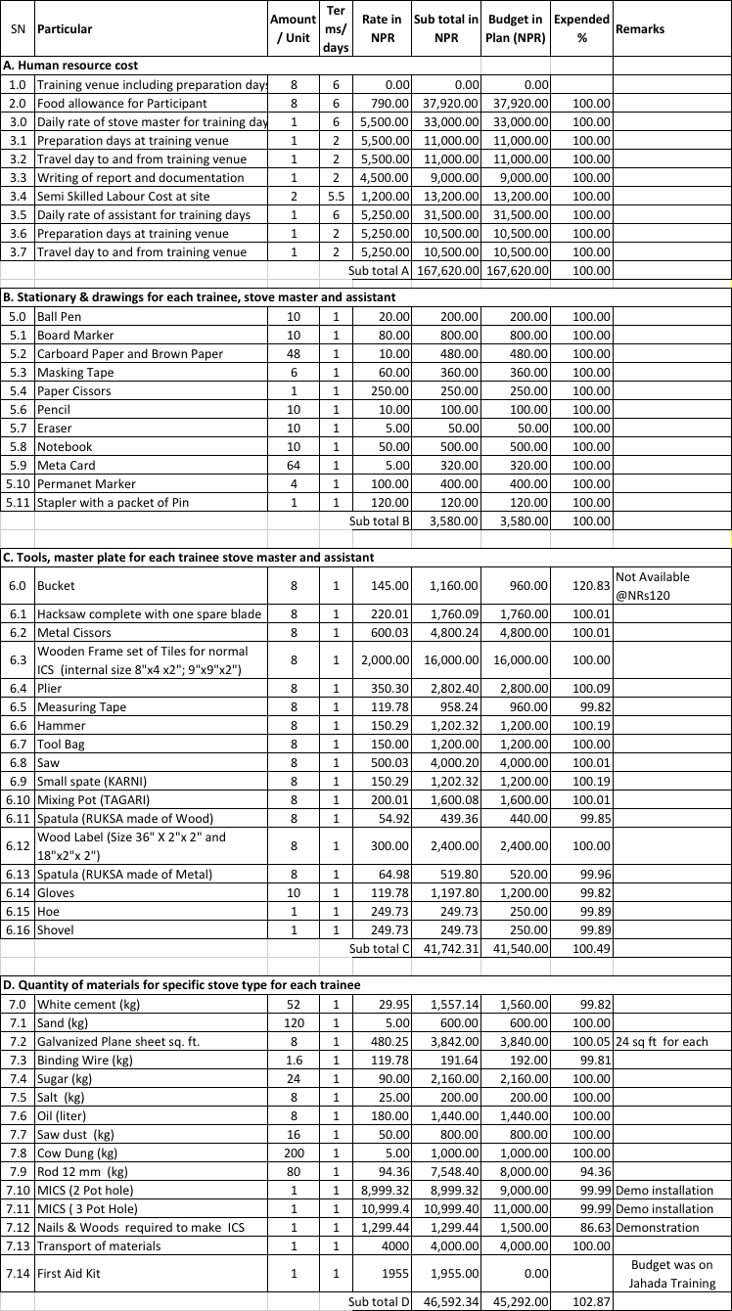

For Mangesung RM, Ilam:
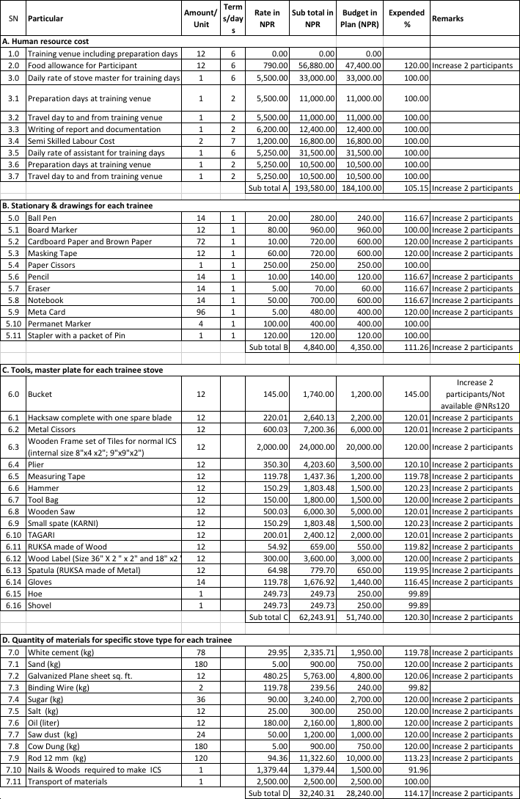

For Mai Municipality, Ilam:
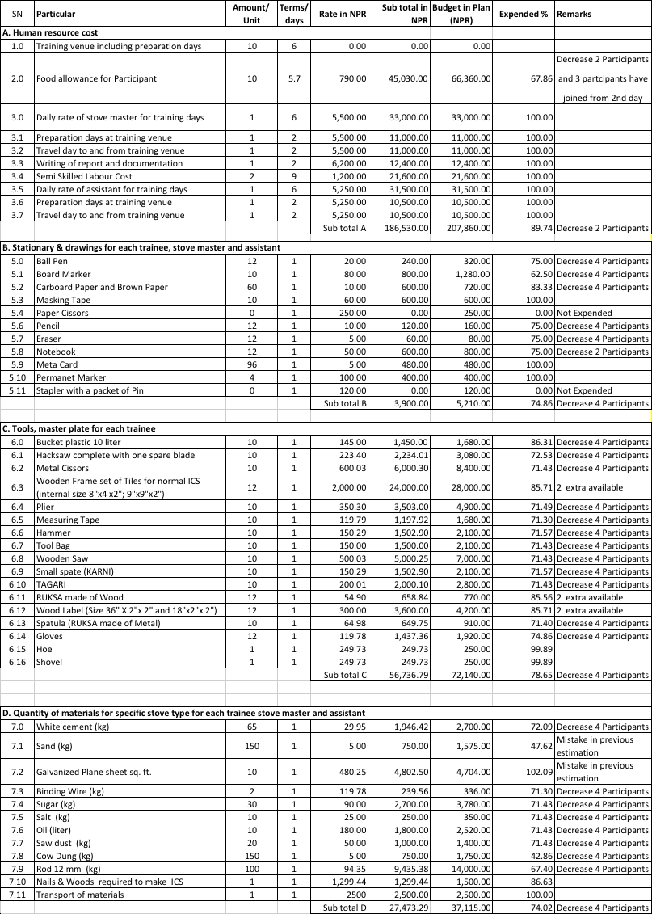

For Gaurigunj RM, Jhapa:
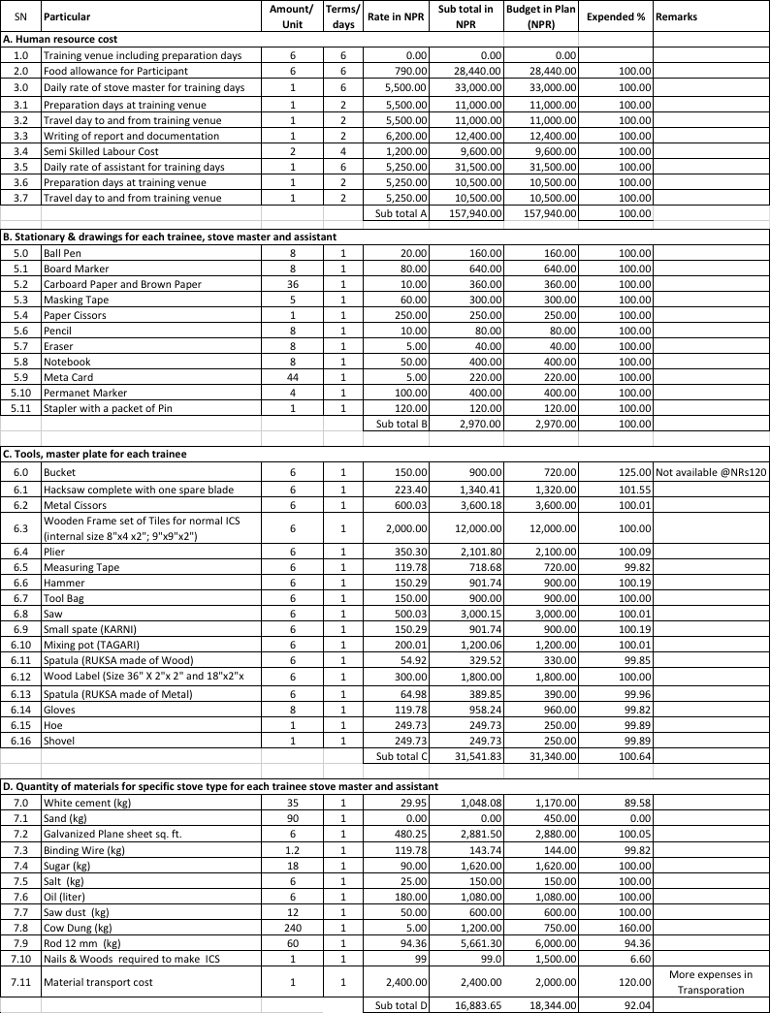

For Jahada RM, Morang:
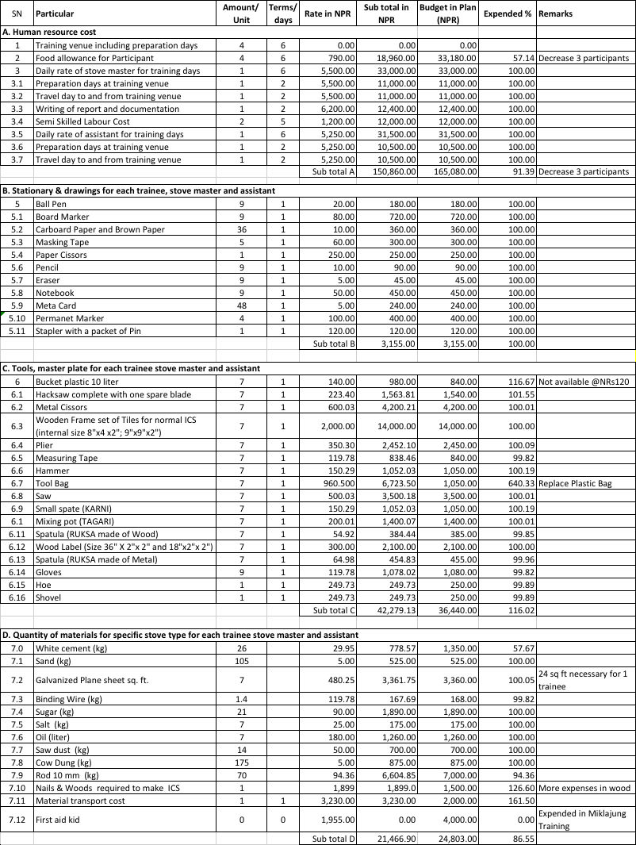

For Aamchowk RM, Bhojpur:
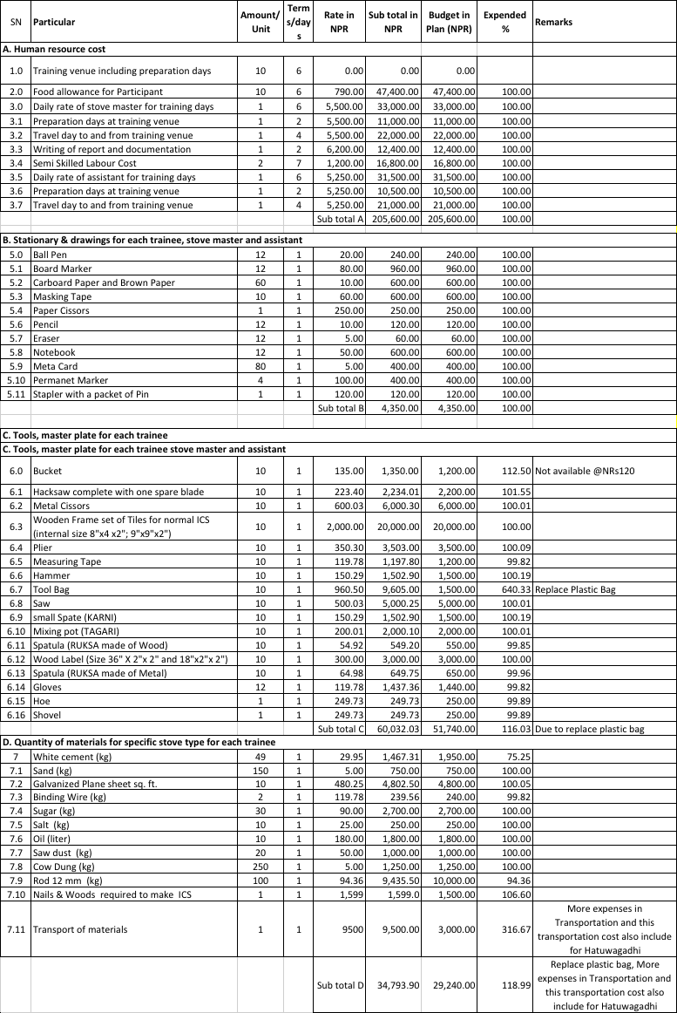
For Hatuwagadhi RM, Bhojpur:
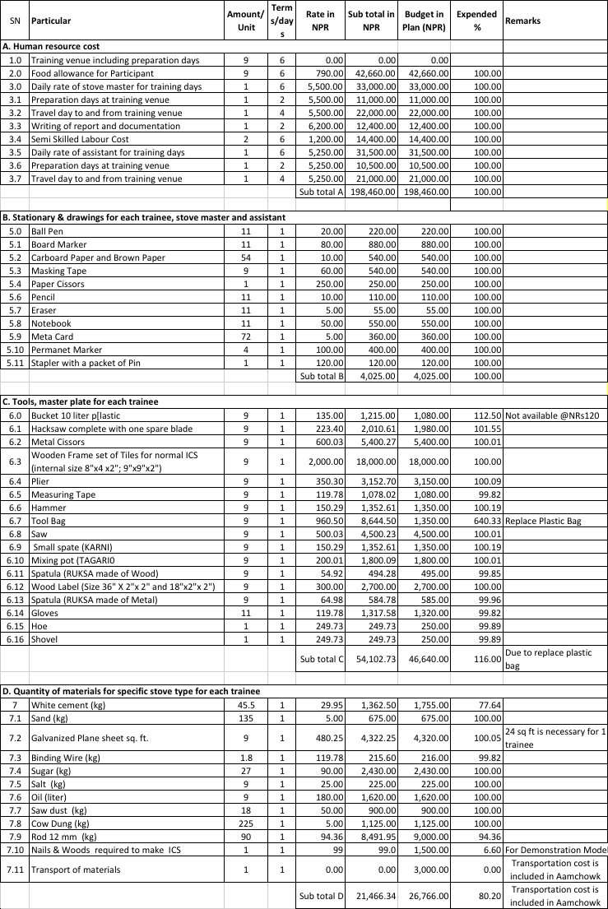

For Manebhanjyang RM Okhaldhunga:
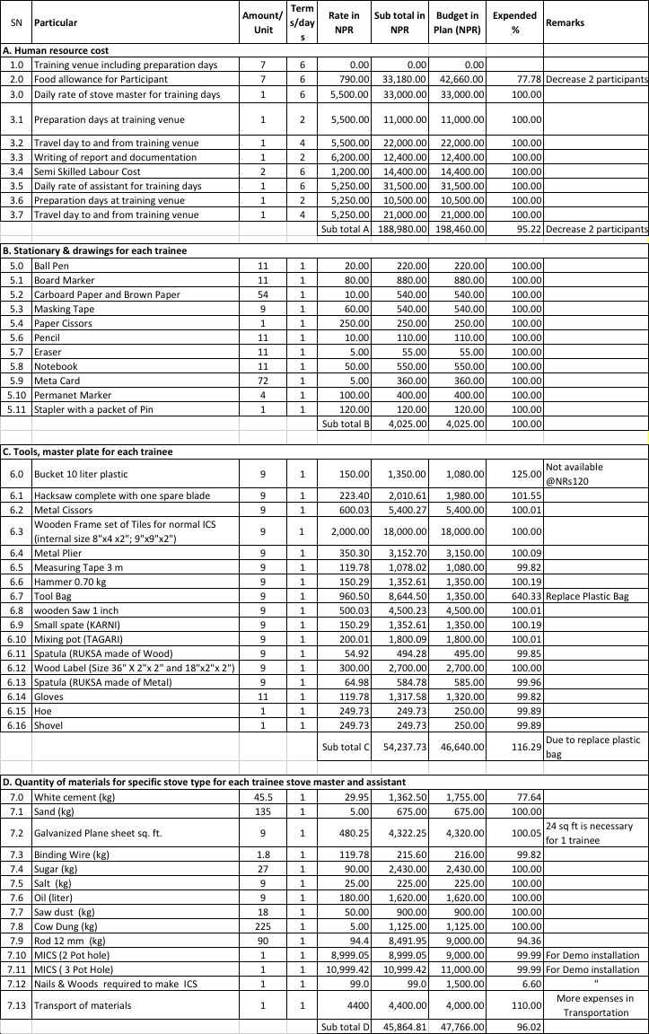

NCDC has trained those trainees for making them technically sound to install and monitor different models of ICS. Each participant of the training has practiced individually to install 1 Pot Hole ICS, 2 Pot Hole ICS, 3 pot Hole ICS, 2 Pot Hole & 3 Pot Hole MICS (MICS is in case of high hill), repair and maintenance knowledge of ICS/MICS, knowledge of kitchen management, after sale service of ICS/MICS and monitoring method of ICS/MICS. Finally, the trainers have assigned to each participants to provide finishing work of improved cooking stove after learning/practicing to install each type of stoves individually. All the trainees have installed each type of stove (i.e. 1 pot hole ICS, 2 Pot hole ICS, 3 pot hole ICS, 2 Pot Hole MICS and 3 Pot Hole MICS) separately during practice work but the finishing work of each installed ICSs by those stove masters were not completed due to time constraint because the training was reduced to 6 days from 8 days. All the Trainees of partner (Rural) Municipality are able to complete the finishing work of 43 numbers of 1 Pot Hole ICS, 48 numbers of 2 pot hole ICS and 20 numbers of 3 pot hole ICS during the training session. Now, all those new stove masters are capable to install different types of ICS (i.e. 1 pot hole ICS, 2 Pot hole ICS and 3 pot hole ICS) when there would be demand in the rural village for ICS. The number of trainees, ICS installed on practice session except finishing work and finishing work of ICS done during the training season of each partner (Rural) Municipality is as follows:

SN | Name of Partner (Rural) Municipality | Trainees  (Nos.) | No. of ICS installed on practice session except finishing work (Nos.) | No. of ICS installed with finishing work  (Nos.)
1. | Miklajung RM | 8 | 1 Pot Hole-8 nos. | 1 Pot Hole-2 nos.
 |  |  | 2 Pot Hole-8 nos. | 2 Pot Hole-2 nos.
 |  |  | 3 Pot Hole-8 nos. | 3 Pot Hole-2 nos.
2. | Mangsebung RM | 13 | 1 Pot Hole-13 nos. | 1 Pot Hole-3 nos.
 |  |  | 2 Pot Hole-13 nos. | 2 Pot Hole-4 nos.
 |  |  | 3 Pot Hole-13 nos. | 3 Pot Hole-2 nos.
3. | Mai Municipality | 10 | 1 Pot Hole-10 nos. | 1 Pot Hole-2 nos.
 |  |  | 2 Pot Hole-10 nos. | 2 Pot Hole-6 nos.
 |  |  | 3 Pot Hole-10nos. | 3 Pot Hole-3 nos.
4. | Gaurigunj RM | 6 | 1 Pot Hole-6 nos. | 1 Pot Hole-6 nos.
 |  |  | 2 Pot Hole-2 nos. | 2 Pot Hole-6 nos.
 |  |  | 3 Pot Hole-2 nos. | 3 Pot Hole-3 nos.
5. | Jahada RM | 4 | 1 Pot Hole-2 nos. | 1 Pot Hole-4 nos.
 |  |  | 2 Pot Hole-2 nos. | 2 Pot Hole-4 nos.
 |  |  | 3 Pot Hole-2 nos. | 3 Pot Hole-2 nos.
6. | Aamchowk RM | 10 | 1 Pot Hole-2 nos. | 1 Pot Hole-10 nos.
 |  |  | 2 Pot Hole-2 nos. | 2 Pot Hole-10 nos.
 |  |  | 3 Pot Hole-2 nos. | 3 Pot Hole-2 nos.
7. | Hatuwagadhi RM | 9 | 1 Pot Hole-2 nos. | 1 Pot Hole-9 nos.
 |  |  | 2 Pot Hole-2 nos. | 2 Pot Hole-9 nos.
 |  |  | 3 Pot Hole-2 nos. | 3 Pot Hole-3 nos.
8. | Manebhanjyang RM | 7 | 1 Pot Hole-2 nos. | 1 Pot Hole-7 nos.
 |  |  | 2 Pot Hole-2 nos. | 2 Pot Hole-7 nos.
 |  |  | 3 Pot Hole-2 nos. | 3 Pot Hole-3 nos.
Total |  | 67 | 201 | 111

TOOLS
NCDC has purchased all the tools required for those ICS Capacity Development and ASS Training as per the rule and regulations of organization. The tools requirement is of 73 sets in total as per the approved proposal but the participants are not available as per the target in Mai Municipality, Jahada RM and Manebhanjyang RM. The participants in Mangsebung RM is increased by 3 numbers than the number specified in proposal. Some tools have handover to related municipality/rural municipality during the training and some of them are with NCDC. The detail of tools provided to each trainees, municipality/rural municipality in ICS Capacity Development and ASS Training of 7 Rural Municipality and 1 Municipality and the tools available at NCDC are as follows:
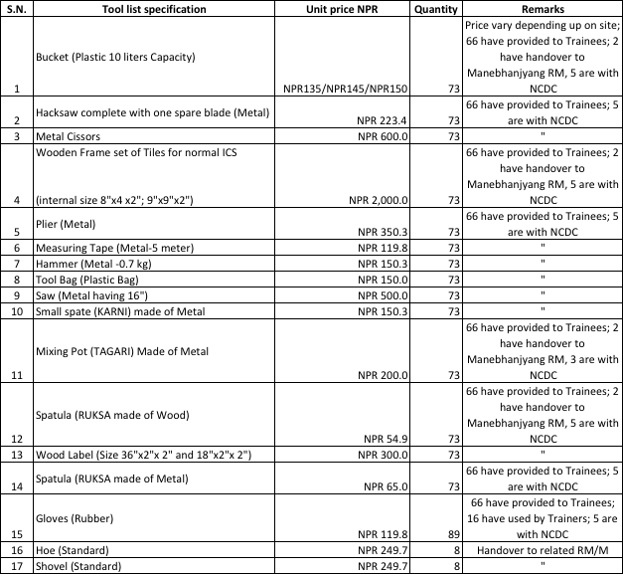
The technical specification and purpose of each tools is specified in 6.4 Technical specification of each tools including moulds of annex part.

CHAPTER III

IMPLEMENTATION OF ICS OF PARTNER (RURAL) MUNICIPALITY
RERA is working on 8 partner (Rural) Municipality (7 Rural Municipality and 1 Municipality) of province number 1 of Nepal in the sector of renewable energy to sustainably develop by using own natural sources of energy. The main source of cooking in those partner (Municipality) is firewood and most people of those partner (Rural) Municipality are using traditional stove for cooking. The firewood used due to use of traditional stove is increasing resulting the increasing rate of deforestation day by day. As a part of RERA program, RERA has supported for one ICS capacity development and ASS training in each partner (Rural) Municipality to develop local technical person for the promotion dissemination of improved cooking stoves.

HIGH HILL CLUSTER

EVALUATION SHEET OF TRAINEES
The ICS evaluation sheet of Miklajung RM and Manebhanjyang RM build by each trainee are as follows:
ICS Evaluation Sheet of Miklajung RM build by each trainee
Evaluator Name:  Shailendra Narayan Yadav |  |  |  | Email address: sallu5657@gmail.com |  |  |  |  | Date:  10-01-2019
ICS Capacity training session at Miklajung RM from 05-01-2019 to 10-01-2019
Ward No. | Full Name | Mobile | Gender |  |  | GESI Groups & DAG | 1 Pot Stove *100 % | 2 Pot Stove *100 % |  | 3 Pot Stove *100 % | Theor.  **100% | Average
 |  |  | Male |  | Fe-male
2 | Mr. Ramkumar Rai | 9816967723 | √ |  |  | Ethnic | 85 | 85 |  | 90 | 80 | 85%
3 | Ms. Sunita Tamang | 9816017416 |  |  | √ | Ethnic | 70 | 75 |  | 80 | 75 | 75%
4 | Ms. Ganga Lawati | 9817903608 |  |  | √ | Ethnic | 75 | 75 |  | 75 | 75 | 75%
5 | Mr. Kalendra Lawati | 9823411548 | √ |  |  | Ethnic | 85 | 80 |  | 85 | 80 | 83%
6 | Mr. Dhankumar Rai | 9741451367 | √ |  |  | Ethnic | 85 | 85 |  | 85 | 80 | 84%
7 | Mr. Fanindra Tamang | 9815397350 | √ |  |  | Ethnic | 90 | 85 |  | 85 | 80 | 85%
8 | Mr. Lokbahadur Thapa | 9745156647 | √ |  |  | Chhetri | 85 | 85 |  | 85 | 85 | 85%
8 | Mr. Tika Thapa | 9825959521 | √ |  |  | Chhetri | 90 | 90 |  | 90 | 90 | 90%

ICS Evaluation Sheet of Manebhanjyang RM build by each trainee
Evaluator Name:  Shantiram Ghimire |  |  |  | Email address: srghimire@ncdcilam.org.np |  |  |  |  | Date:  15-03-2019
ICS Capacity training session at Manebhanjyang RM from 10-03-2019 to 15-03-2019
Ward No. | Full Name | Mobile | Gender |  |  | GESI Groups & DAG | 1 Pot Stove *100 % | 2 Pot Stove *100 % |  | 3 Pot Stove *100 % | Theor.  **100% | Average
 |  |  | Male |  | Fe-male
2 | Mr. Tulla Bahadur Shrestha | 9861135073 | √ |  |  | Ethnic | 85 | 85 |  | 90 | 80 | 85%
5 | Mr. Dal Bahadur Pulami | 9843854586 | √ |  |  | Ethnic | 70 | 75 |  | 80 | 75 | 75%
5 | Mr. Dhan Bahadur Shrestha | 9844480903 | √ |  |  | Ethnic | 75 | 75 |  | 75 | 75 | 75%
6 | Mr. Pahalman Rai | 9861701703 | √ |  |  | Ethnic | 85 | 80 |  | 85 | 80 | 83%
7 | Mr. Matrika Prasad Gautam | 9842971045 | √ |  |  | Ethnic | 85 | 85 |  | 85 | 80 | 84%
8 | Mr. Dilli Bahadur Thapamagar | 9865598456 | √ |  |  | Ethnic | 90 | 85 |  | 85 | 80 | 85%
9 | Mr. Chet Bahadur Ale Magar | 9840104371 | √ |  |  | Ethnic | 85 | 85 |  | 85 | 85 | 85%
*Quality & Standards & Technical status of institutional stove build out of *100%
** Understanding of theoretical session on indoor pollution, health hazards, biomass, bill of quantity and materials, environmental impact & monitoring out of **100%

SOURCES OF BIO MASS
Miklajung is a rural municipality in Panchthar district and has an area of 166.61 square kilometers. The total population of the municipality is 24715 as per Nepal Population Census 2011. Arubote, Sarangdanda, Rabi, Kurumba, Limba and Durdimba which previously were all separate Village development committee merged to form this rural municipality. The rural municipality is divided into total 8 wards and the headquarter of rural municipality is situated in Rabi.
Manebhanjyang is a Rural Municipality of Okhaldhunga district and has an area of 146.61 square kilometers (56.61 square mile). The total population of the municipality is 21082 as per Nepal Population Census 2011. Moli, Baska, Ubu, Manebhanjyang, Thakle, Thoksela and Madhaypur which previously were all separate village development committee merged to form this rural municipality. The rural municipality is divided into 9 wards and headquarter is situated in Manebhanjyang.
Both partner Rural Municipalities have rich in biomass energy and most people of those area are using self-made cooks stove (i.e. traditional cooks stove) for cooking resulting more use of firewood for cooking. The use of firewood is assumed to reduce by use of Improved Cooking Stove instead of traditional cook stove.

BASE LINE INFORMATION ON COOKING ISSUE
The data of baseline survey on Cooking train of Miklajung RM and Manebhanjyang RM are as follows:
Miklajung RM:
3-stone cook stove | Self-made cook stove | ICS | LPG | Remarks
5.01% | 55.64% | 33.08% | 6.27% | Based on number of households
Source: RERA Biratnagar
Manebhanjyang RM:
3-stone cook stove | Self-made cook stove | ICS | LPG | Remarks
24.37% | 41.71% | 23.62% | 10.3% | Based on number of households
Source: RERA Biratnagar

MID HILL CLUSTER

EVALUATION SHEET OF TRAINEES
The ICS evaluation sheet of Aamchowk RM and Hatuwagadhi RM build by each trainee are as follows:
ICS Evaluation Sheet of Aamchowk Rural Municipality build by each trainee
Evaluator Name:  Buddhi Thapa |  |  |  |  | Email address: buddhithapa32@gmail.com |  |  |  |  | Date:  06-03-2019
ICS Capacity training session at Aamchowk RM from 01-03-2019 to 06-03-2019
Ward No. | Full Name |  | Mobile | Gender |  |  | GESI Groups & DAG | 1 Pot Stove *100 % | 2 Pot Stove *100 % |  | 3 Pot Stove *100 % | Theor.  **100% | Average
 |  |  |  | Male |  | Fe-male
1 | Mr. Dhiraj Rai | 9862140093 |  | √ |  |  | Ethnic | 75 | 75 |  | 60 | 60 | 67.5%
2 | Mr. Karma Sherpa | 9862143096 |  | √ |  |  | Ethnic | 80 | 80 |  | 65 | 60 | 71.25%
3 | Mr. Sonarbu Sherpa | 9863671170 |  | √ |  |  | Ethnic | 80 | 80 |  | 65 | 60 | 71.25%
4 | Ms. Milan Rai | 9862130636 |  |  |  | √ | Ethnic | 70 | 70 |  | 55 | 45 | 60%
5 | Ms. Susita Rai | 9818582617 |  |  |  | √ | Ethnic | 70 | 70 |  | 55 | 45 | 60%
6 | Mr. Prem Kumar Rai | 9840363788 |  | √ |  |  | Ethnic | 70 | 70 |  | 55 | 45 | 60%
7 | Ms. Pampla Maya Rai | 9869036264 |  |  |  | √ | Ethnic | 65 | 65 |  | 50 | 50 | 56.25%
8 | Mr. Singha Ba. Shrestha | 9862133702 |  | √ |  |  | Ethnic | 65 | 65 |  | 50 | 50 | 56.25%
9 | Mr. Rakam Singh Rai | 9804058777 |  | √ |  |  | Ethnic | 65 | 65 |  | 50 | 50 | 56.25%
10 | Ms. Sabita Rai | 9866456093 |  |  |  | √ | Ethnic | 60 | 60 |  | 50 | 40 | 52.5%

ICS Evaluation Sheet of Hatuwagadhi Rural Municipality build by each trainee
Evaluator Name:  Shantiram Ghimire |  |  |  | Email address: srghimire@ncdcilam.org.np |  |  |  |  | Date:  06-03-2019
ICS Capacity training session at Hatuwagadhi RM from 01-03-2019 to 06-03-2019
Ward No. | Full Name | Mobile | Gender |  |  | GESI Groups & DAG | 1 Pot Stove *100 % | 2 Pot Stove *100 % |  | 3 Pot Stove *100 % | Theor.  **100% | Average
 |  |  | Male |  | Fe-male
1 | Ms. Aruna Bhujel | 9862123301 |  |  | √ | Ethnic | 70 | 75 |  | 70 | 70 | 71.25%
2 | Mr. Puspalal Rai | 9829339896 | √ |  |  | Ethnic | 70 | 70 |  | 70 | 70 | 70%
3 | Mr. Ra,jit Rai | 9866047067 | √ |  |  | Ethnic | 80 | 80 |  | 80 | 75 | 78.25%
4 | Mr. Ashpura Rai | 9866796968 | √ |  |  | Ethnic | 80 | 60 |  | 75 | 75 | 72.5%
5 | Ms. Sujata Rai | 9818582617 |  |  | √ | Ethnic | 65 | 65 |  | 75 | 60 | 66.25%
6 | Mr. Ash Kumar Rai | 9810337909 | √ |  |  | Ethnic | 80 | 75 |  | 85 | 75 | 78.75%
7 | Mr. Prem Kumar Rai | 9817301017 | √ |  |  | Ethnic | 70 | 55 |  | 65 | 50 | 60%
8 | Ms. Sita Kumar Rai | 9862285584 |  |  | √ | Ethnic | 65 | 65 |  | 65 | 55 | 62.5%
9 | Ms. Dil Kumari Rai | 9804058777 |  |  | √ | Ethnic | 65 | 60 |  | 65 | 50 | 60%
*Quality & Standards & Technical status of institutional stove build out of *100%
** Understanding of theoretical session on indoor pollution, health hazards, biomass, bill of quantity and materials, environmental impact & monitoring out of **100%

SOURCES OF BIOMASS
Aamchowk has an area of 184.89 square kilometers (71.39 square mile) situated in Bhojpur district and as per Nepal Population Census 2011, the total population of the municipality is 18,720. Wasingtharpu, Yoo, Dummana, Thidingkha, Pawala, Dewantar, Balankha and Pangcha Village Development Committee (VDCs) were merged to form this rural municipality. Balankha is the headquarter of Aamchowk rural municipality.
Hatuwagadhi is a rural municipality situated in Bhojpur district and has an area of 142.61 square kilometers (55.06 square mile). The total population of the municipality is 20,543 as per population Nepal population census. Hatuwagadhi was known as Majh Kirant before the unification of Nepal by Shah Kings. It was capital of Kirat Kingdom. The ruins of the ancient capital and forts still exist at Hatuwagadhi.
Both partner (Rural) Municipalities have rich in biomass energy and most people of those area are using self-made cooks stove (i.e. traditional cooks stove) for cooking resulting more use of firewood for cooking. The use of firewood is assumed to reduce by use of Improved Cooking Stove instead of traditional cook stove.

BASE LINE INFORMATION ON COOKING ISSUE
The data of baseline survey on Cooking train of Aamchowk RM and Hatuwagadhi RM are as follows:

Aamchowk RM:
Self-made Cook stove | LPG | ICS | 3 Stone | Remarks
16.28% | 2.33% | 23.26% | 58.14%
Source: RERA Office Biratnagar
Hatuwagadhi RM:
Self-made Cook stove | LPG | ICS | 3 Stone | Remarks
13.25% | 2.17% | 31.81% | 52.77%
Source: RERA Office Biratnagar

LOW HILL CLUSTER

EVALUATION SHEET OF TRAINEES
The ICS evaluation sheet of Mangsebung RM and Mai Municipality build by each trainee are as follows:
ICS Evaluation Sheet of Mangsebung RM build by each trainee
Evaluator Name:  Buddhi Thapa |  |  |  | Email address: buddhithapa32@gmail.com |  |  |  |  | Date:  17-01-2019
ICS Capacity training session at Mangsebung RM from 12-01-2019 to 17-01-2019
Ward No. | Full Name | Mobile | Gender |  |  | GESI Groups & DAG | 1 Pot Stove *100 % | 2 Pot Stove *100 % |  | 3 Pot Stove *100 % | Theor.  **100% | Average
 |  |  | Male |  | Fe-male
1 | Mr. Chakra Bahadur Adhikari | 9842784139 | √ |  |  | Bramin | 90 | 90 |  | 90 | 85 | 88.75%
1 | Mr. Hem Prakash Dhungana | - | √ |  |  | Bramin | 70 | 70 |  | 70 | 70 | 70%
2 | Mr. Mohan Raj Shrestha | 9815907492 | √ |  |  | Ethnic | 75 | 75 |  | 75 | 75 | 75%
2 | Mr. Rabindra Kafle | 9816969293 | √ |  |  | Ethnic | 70 | 70 |  | 70 | 70 | 70%
3 | Ms. Dil Maya Rai | 9824961292 |  |  | √ | Ethnic | 75 | 75 |  | 75 | 80 | 76.25%
3 | Mr. Santa Kumar Rai | 9741018706 | √ |  |  | Ethnic | 75 | 70 |  | 70 | 65 | 70%
3 | Mr. Min Kumar Nepali Damai | - | √ |  |  | Dalit | 65 | 65 |  | 65 | 65 | 65%
4 | Mr. Tilak Rai | 9741451367 | √ |  |  | Ethnic | 80 | 75 |  | 70 | 65 | 72.5%
4 | Ms. Buddha Rani Limbu | 9816979661 |  |  | √ | Ethnic | 85 | 85 |  | 85 | 90 | 86.25%
4 | Mr. Suman B.K. | 9824057636 | √ |  |  | Dalit | 65 | 65 |  | 65 | 65 | 65%
5 | Ms. Asmita Lawati | 9814920933 |  |  | √ | Ethnic | 75 | 75 |  | 75 | 80 | 76.25%
5 | Mr. Makardhoj Limbu | 9860714208 | √ |  |  | Ethnic | 70 | 70 |  | 70 | 70 | 70%
6 | Mr. Govinda Prasad Rai | - | √ |  |  | Ethnic | 75 | 75 |  | 75 | 70 | 73.75%

ICS Evaluation Sheet of Mai Municipality build by each trainee
Evaluator Name:  Buddhi Thapa |  |  |  | Email address: buddhithapa32@gmail.com |  |  |  |  | Date:  24-01-2019
ICS Capacity training session at Mai Municipality from 19-01-2019 to 24-01-2019
Ward No. | Full Name | Mobile | Gender |  |  | GESI Groups & DAG | 1 Pot Stove *100 % | 2 Pot Stove *100 % |  | 3 Pot Stove *100 % | Theor.  **100% | Average
 |  |  | Male |  | Fe-male
1 | Mr. Chakra Bahadur Adhikari | 9842784139 | √ |  |  | Bramin | 90 | 90 |  | 90 | 85 | 88.75%
1 | Ms. Alisha Shrestha | 9842720843 |  |  | √ | Ethnic | 70 | 70 |  | 70 | 65 | 68.75%
2 | Ms. Oma Devi Dulal | 9807904192 |  |  | √ | Bramin | 80 | 80 |  | 80 | 80 | 80%
3 | Mr. Lok Bahadur Limbu | 9815923358 | √ |  |  | Ethnic | 70 | 70 |  | 70 | 70 | 70%
4 | Ms. Devi Maya Lungeli | 9823019111 |  |  | √ | Ethnic | 75 | 75 |  | 75 | 75 | 75%
5 | Ms. Hem Kumari Rai | 9814963741 |  |  | √ | Ethnic | 70 | 70 |  | 70 | 70 | 70%
6 | Mr. Deep Kishor Lingden | - | √ |  |  | Ethnic | 70 | 70 |  | 70 | 75 | 71.25%
7 | Ms. Reeta Saru Magar | 9817025278 |  |  | √ | Ethnic | 70 | 70 |  | 70 | 75 | 71.25%
8 | Ms. Deepa Kerung | 9815916540 |  |  | √ | Ethnic | 70 | 70 |  | 70 | 70 | 70%
9 | Mr. Dawa Sherpa | 9814941771 |  |  | √ | Ethnic | 70 | 70 |  | 70 | 70 | 70%
10 | Ms. Malina Kumari Tamang | 9815963867 |  |  | √ | Ethnic | 75 | 75 |  | 70 | 80 | 75%

*Quality & Standards & Technical status of institutional stove build out of *100%
** Understanding of theoretical session on indoor pollution, health hazards, biomass, bill of quantity and materials, environmental impact & monitoring out of **100%

SOURCES OF BIOMASS
Mangsebung is a rural municipality situated in Ilam district and has an area of 142.41 square kilometers. The total population of the rural municipality is 18503 as per Nepal Population Census 2011.Banjho, Ibhang, and Gajurmukhi which previously were all separate Village development committee merged to form this rural municipality. The rural municipality is divided into 6 wards and the headquarter of this newly formed rural municipality is situated in Ibhang.
Mai is a municipality of Ilam district of Province No. 1 of Nepal. It was formed in May 2017 with merging VDCs Mahamai, Danabari and Chisapani. The municipality is divided into ten wards which is surrounded by Deumai Municipality and Ilam Municipality from north, Suryodaya Municipality from north-east, Jhapa district from south-east and Mangsebung and Chulachuli Rural Municipality from west. Mai Municipality is 9th in rank of province number 1 with reference to the area of Municipality. It has an area of 246.11 square kilometers. According to Nepal Population Census 2011, it had population of 33,210 people, in which female comprises of 17,111 numbers.
Both partner Rural Municipalities have rich in biomass energy and most people of those area are using self-made cooks stove (i.e. traditional cooks stove) for cooking resulting more use of firewood for cooking. The use of firewood is assumed to reduce by use of Improved Cooking Stove instead of traditional cook stove.

BASE LINE INFORMATION ON COOKING ISSUE
The data of baseline survey on Cooking train of Mangsebung Rural Municipality is as follows:
Mangsebung RM:
LPG | Rice Cooker | Traditional stove | Biogas | ICS | Rocket Stove | Remarks
31.55% | 2.38% | 90.18% | 9.52% | 22.62% | 0.30% | Many households have more than 1 option and used alternatively
Source: RERA office Biratnagar

Mai Municipality:
LPG | Rice Cooker | Traditional stove | Biogas | ICS | Electric Stove | Remarks
31.38% | 10.90% | 84.04% | 14.89% | 15.16% | 0.27% | Many households have more than 1 option and used alternatively
Source: RERA office Biratnagar

TERAI

EVALUATION SHEET OF TRAINEES
The ICS evaluation sheet of Gaurigunj RM and Jahada RM build by each trainee are as follows:
ICS Evaluation Sheet of Gaurigunj Rural Municipality build by each trainee
Evaluator Name:  Shantiram Ghimire |  |  |  | Email address: srghimire@ncdcilam.org.np |  |  |  |  | Date:  10-02-2019
ICS Capacity training session at Gaurigunj RM from 05-02-2019 to 10-02-2019
Ward No. | Full Name | Mobile | Gender |  |  | GESI Groups & DAG | 1 Pot Stove *100 % | 2 Pot Stove *100 % |  | 3 Pot Stove *100 % | Theor.  **100% | Average
 |  |  | Male |  | Fe-male
1 | Mr. Santosh Paswan | 9842720843 | √ |  |  | Dalit | 80 | 80 |  | 75 | 80 | 78.25%
2 | Mr. Rajendra Prasad Rajbansi | 9807904192 | √ |  |  | Terrai Ethnic | 80 | 80 |  | 75 | 80 | 78.25%
3 | Ms. Gita Poudel | 9815923358 |  |  | √ | Bramin | 80 | 80 |  | 75 | 75 | 77.5%
4 | Mr. Birchandra Kumar Babaji | 9823019111 | √ |  |  | Bramin | 80 | 80 |  | 75 | 75 | 77.5%
5 | Ms. Anju Thakur | 9814963741 |  |  | √ | Terrai Ethnic | 75 | 75 |  | 70 | 65 | 71.25%
6 | Ms. Sagbati Rajbansi | - |  |  | √ | Terrai Ethnic | 75 | 75 |  | 70 | 65 | 71.25%

ICS Evaluation Sheet of Jahada Rural Municipality build by each trainee
Evaluator Name:  Shantiram Ghimire |  |  |  | Email address: srghimire@ncdcilam.org.np |  |  |  |  | Date:  26-02-2019
ICS Capacity training session at Jahada RM from 21-02-2019 to 26-02-2019
Ward No. | Full Name | Mobile | Gender |  |  | GESI Groups & DAG | 1 Pot Stove *100 % | 2 Pot Stove *100 % |  | 3 Pot Stove *100 % | Theor.  **100% | Average
 |  |  | Male |  | Fe-male
2 | Mr. Fagu Risidev | - | √ |  |  | Dalit | 80 | 75 |  | 75 | 50 | 70%
5 | Mr. Sanjaya Kumar Singh Nuniya | 9810413431 | √ |  |  | Madhesi | 75 | 70 |  | 70 | 70 | 71.25%
6 | Ms. Dina Kumari Mandal | 9807904192 |  |  | √ | Madhesi | 70 | 65 |  | 60 | 65 | 65%
7 | Mr. Uma Tudu | 9810533892 | √ |  | √ | Terrai Ethnic | 70 | 70 |  | 55 | 65 | 65%
*Quality & Standards & Technical status of institutional stove build out of *100%
** Understanding of theoretical session on indoor pollution, health hazards, biomass, bill of quantity and materials, environmental impact & monitoring out of **100%

SOURCES OF BIOMASS
Gaurigunj is a rural municipality of Jhapa district and has an area of 101.35 square kilometers (39.13 square mile). The total population of the municipality is 33,038 as per Nepal Population Census 2011. Korobari, Mahabhara, Khajurgachhi and Gauriganj which previously were all separate Village development committee merged to form this rural municipality. The rural municipality is divided into total 6 wards and the headquarter of this newly formed rural municipality is situated in Gaurigunj.
Jahada is of a rural municipality of Morang district and has an area of 62.38 square kilometers (24.09 square mile). The total population of the municipality is 41819 as per Nepal Population Census 2011. Bhathigach, Majhare, Sisawanijahada, Pokhariya and Budhanagar which previously were all separate Village development committee merged to form this rural municipality. The rural municipality is divided into total 7 wards and the headquarter of this newly formed rural municipality is situated in Majhare.
Both partner Rural Municipalities have rich in biomass energy and most people of those area are using self-made cooks stove (i.e. traditional cooks stove) for cooking resulting more use of firewood for cooking. The use of firewood is assumed to reduce by use of Improved Cooking Stove instead of traditional cook stove.

BASE LINE INFORMATION ON COOKING ISSUE
The data of baseline survey on Cooking train of Gaurigunj Rural Municipality and Jahada Rural Municipality are as follows:

Gaurigunj RM:
Self-made Cook stove | LPG | Biogas Stove | Remarks
76.5% | 20.75% | 2.75%
Source: RERA Office Biratnagar
Jahada RM:
Self-made Cook stove | LPG | Biogas Stove | 3 Stone | ICS | Remarks
90% | 5.24% | 0.75% | 1.5% | 0.50%
Source: RERA Office Biratnagar

Annexes:

Technical drawings

  - Pot Hole Normal ICS

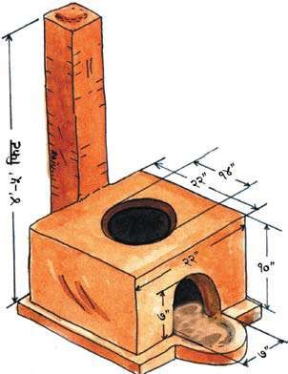
  - Pot Hole Normal ICS

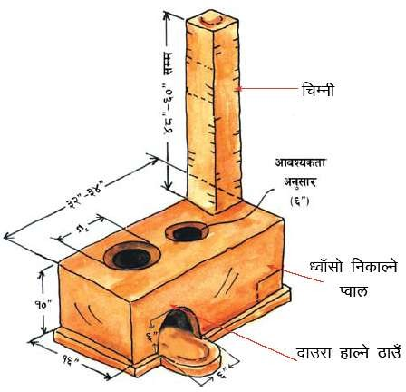

  - Pot Hole Normal ICS

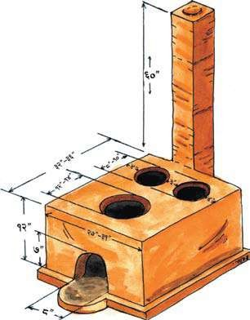

Dissemination and Awareness booklets

Instruction and maintenance manual for stove master:
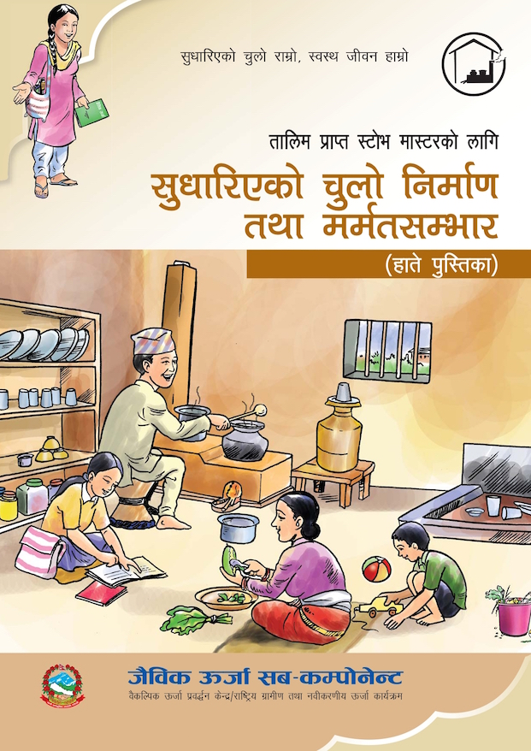
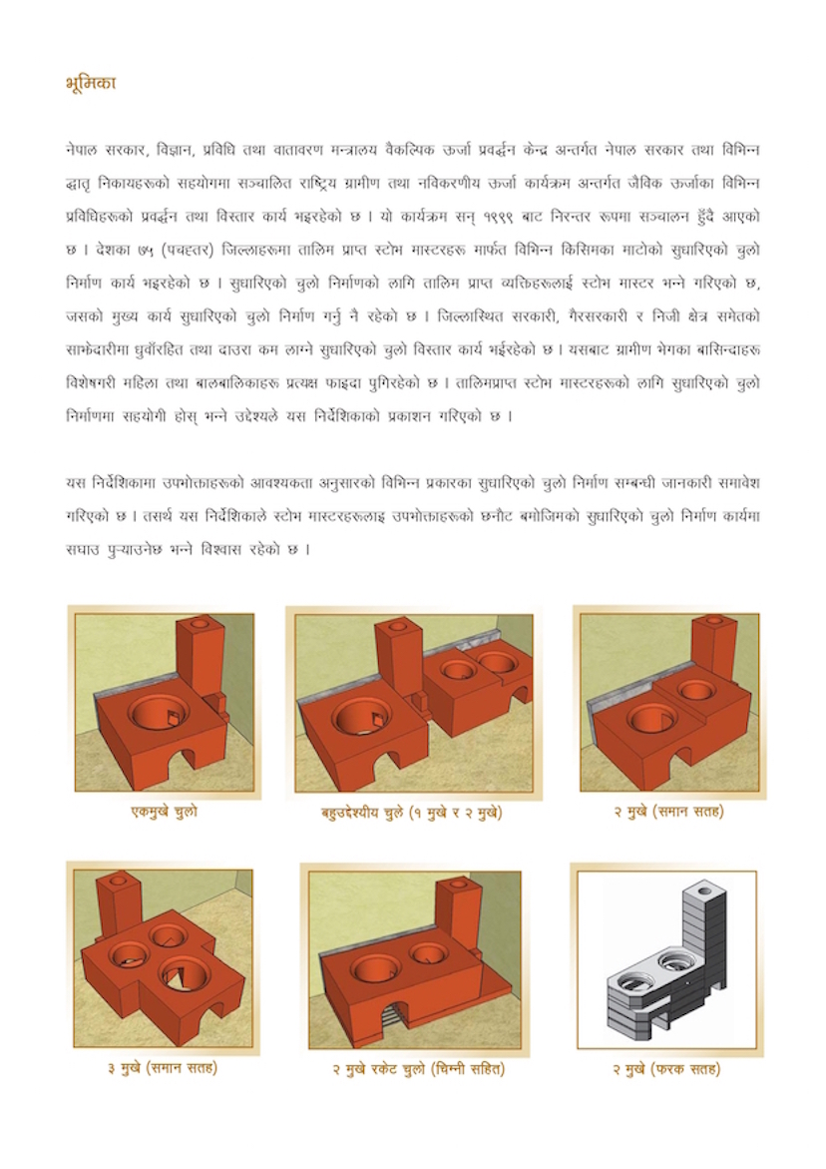

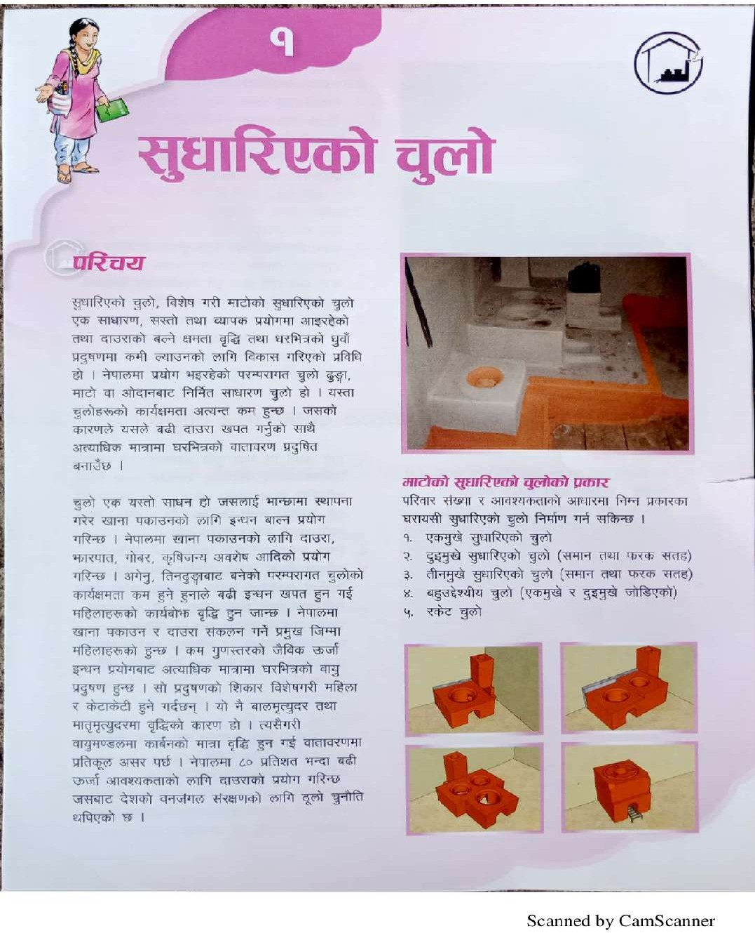

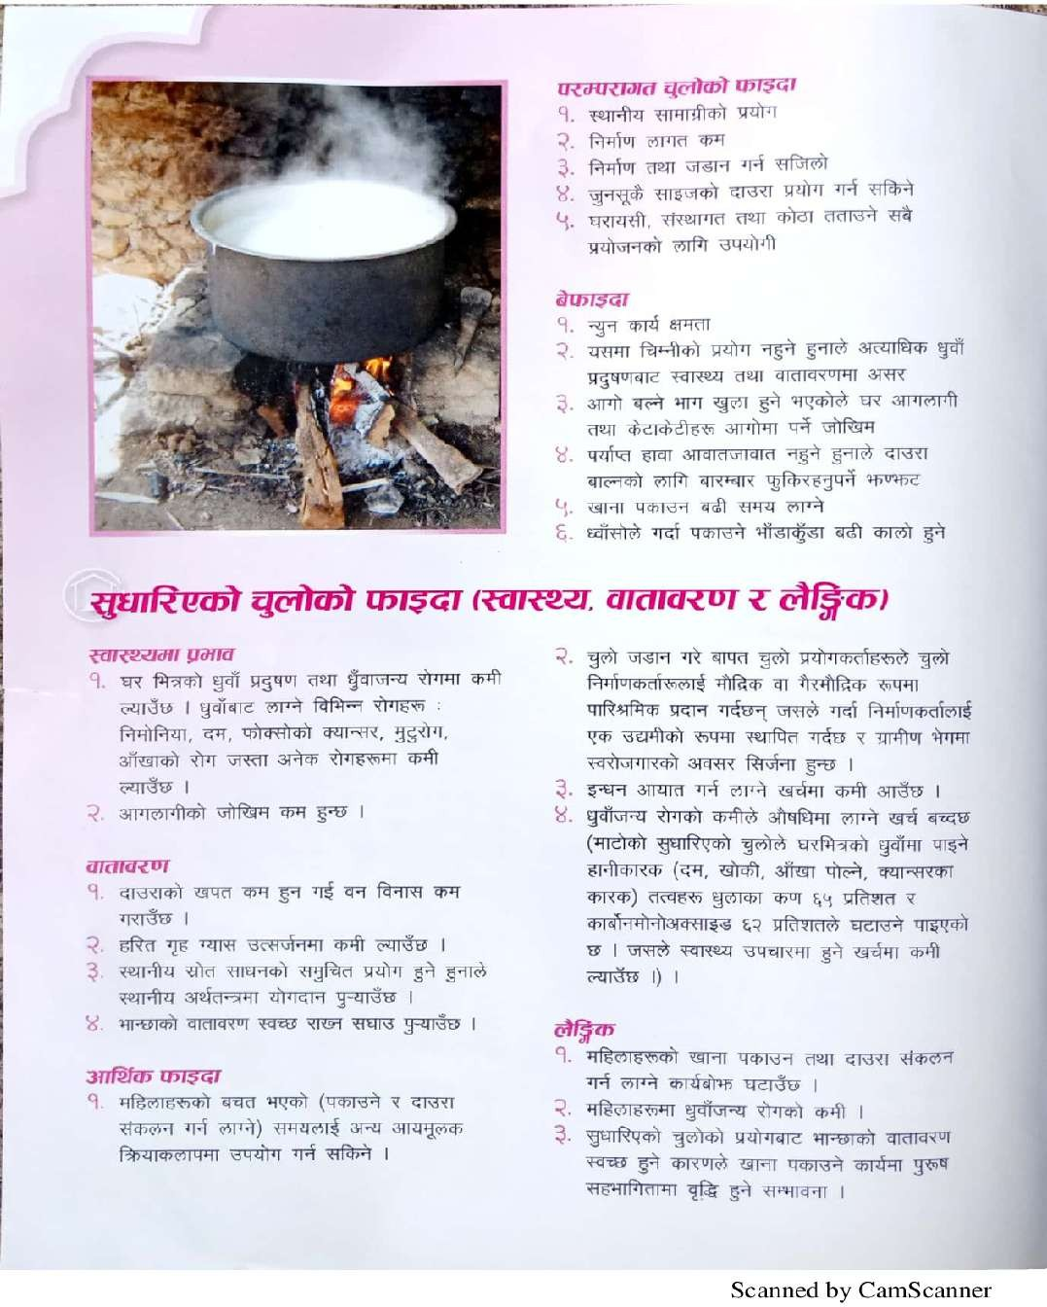

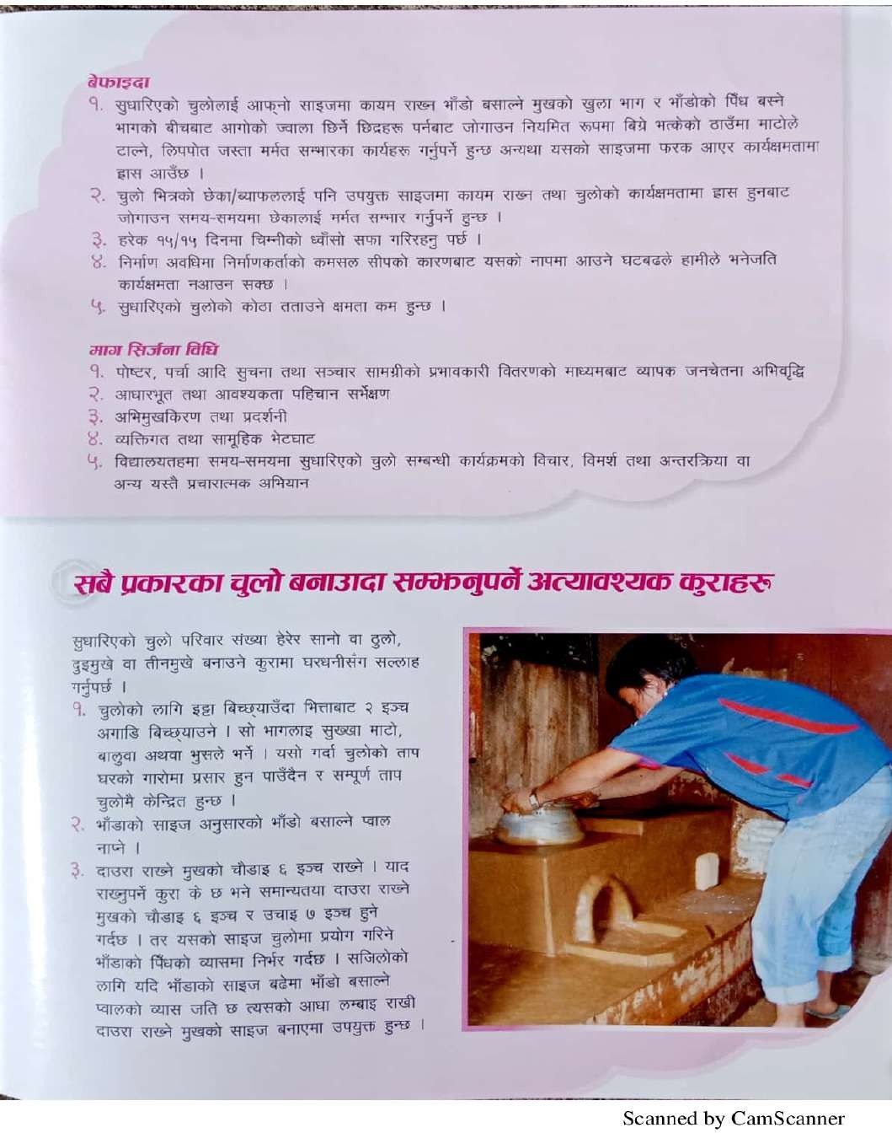

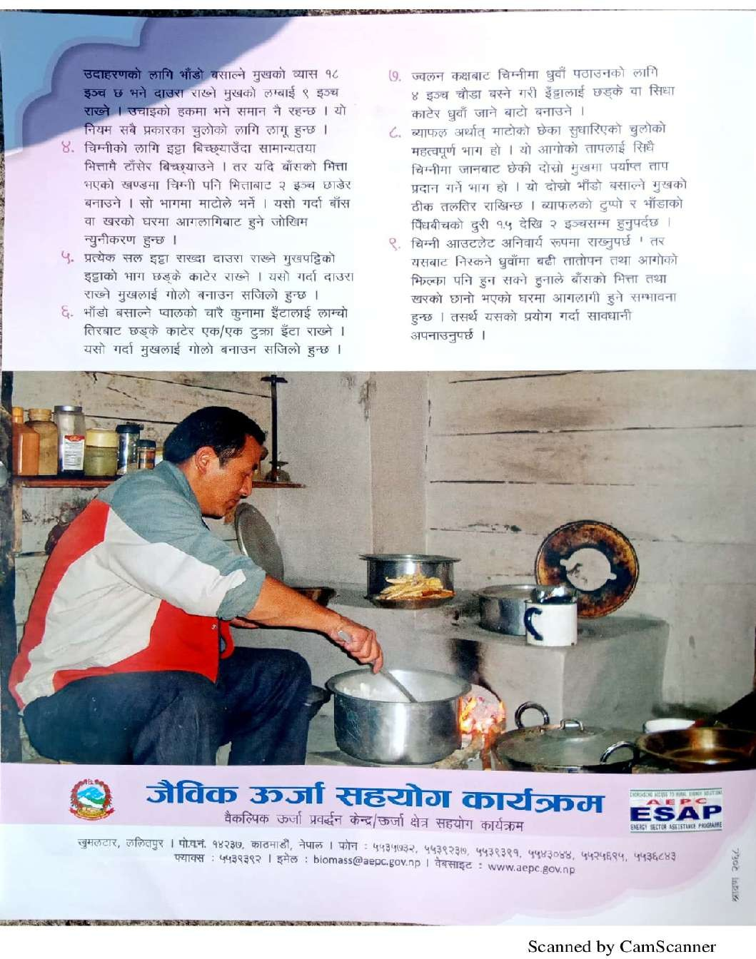

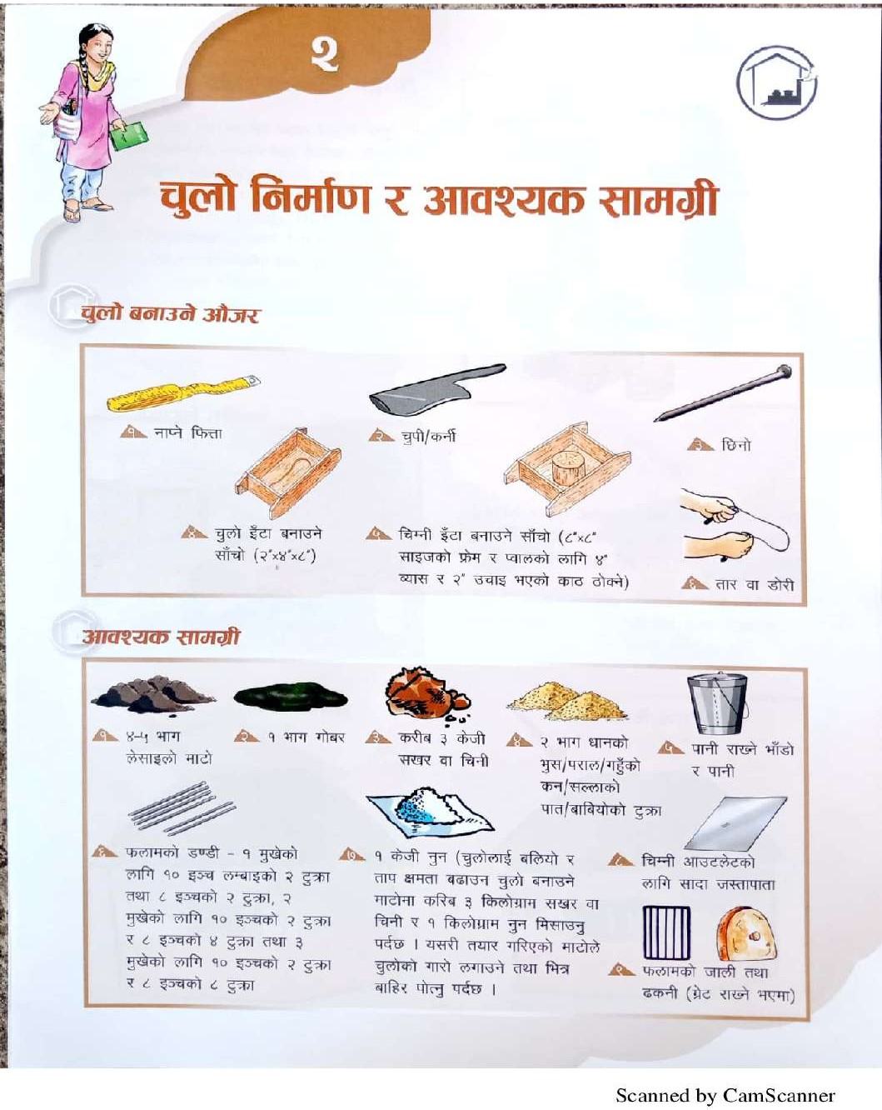

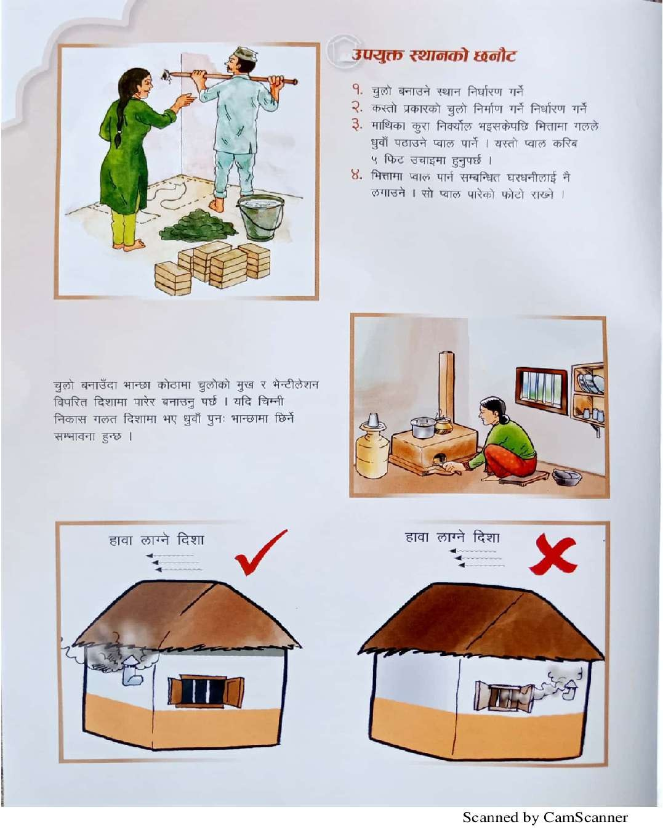

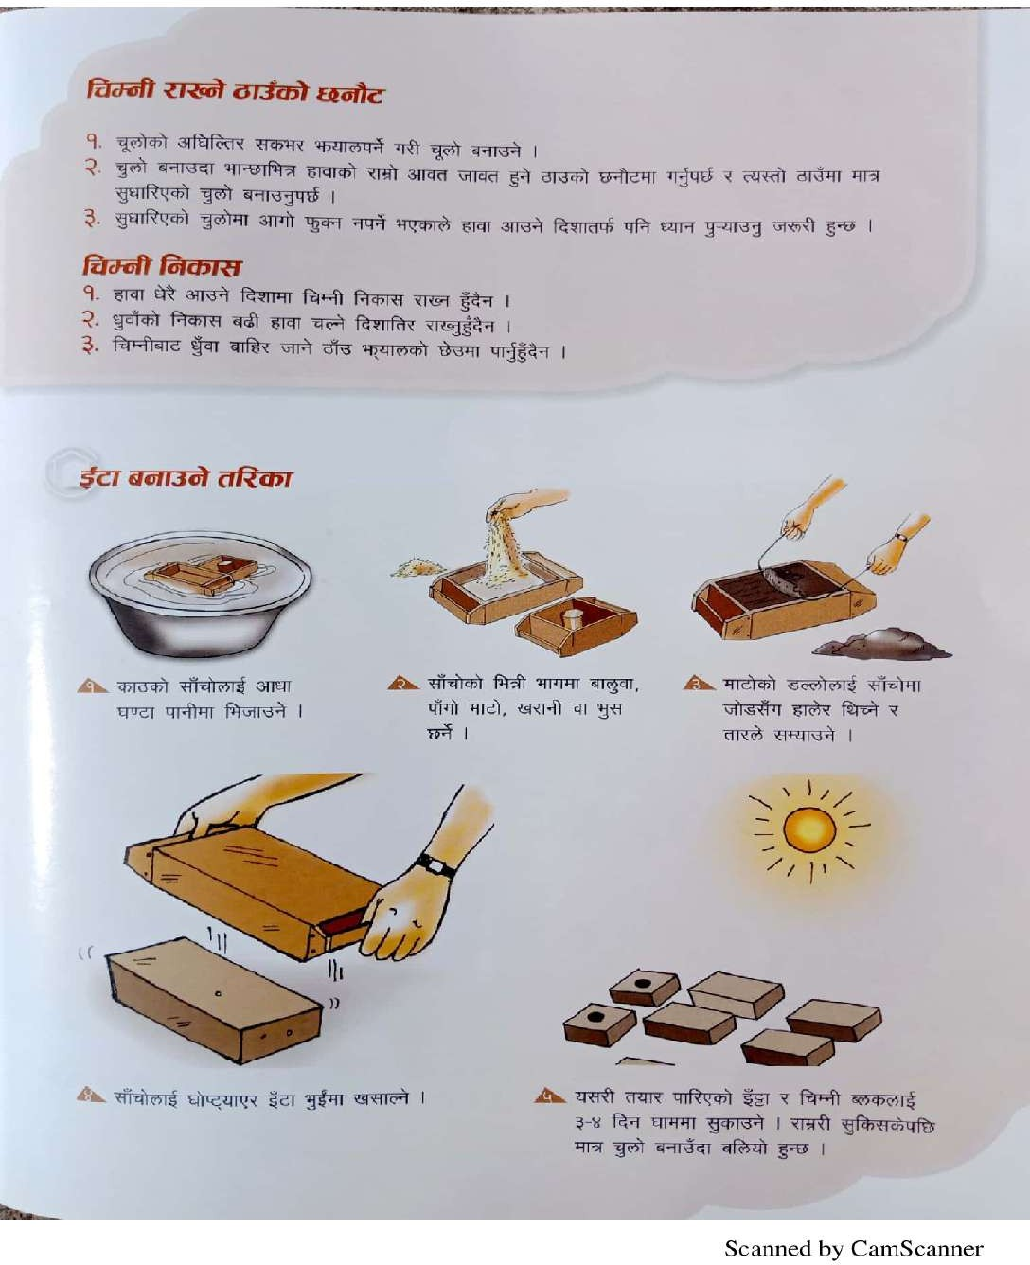

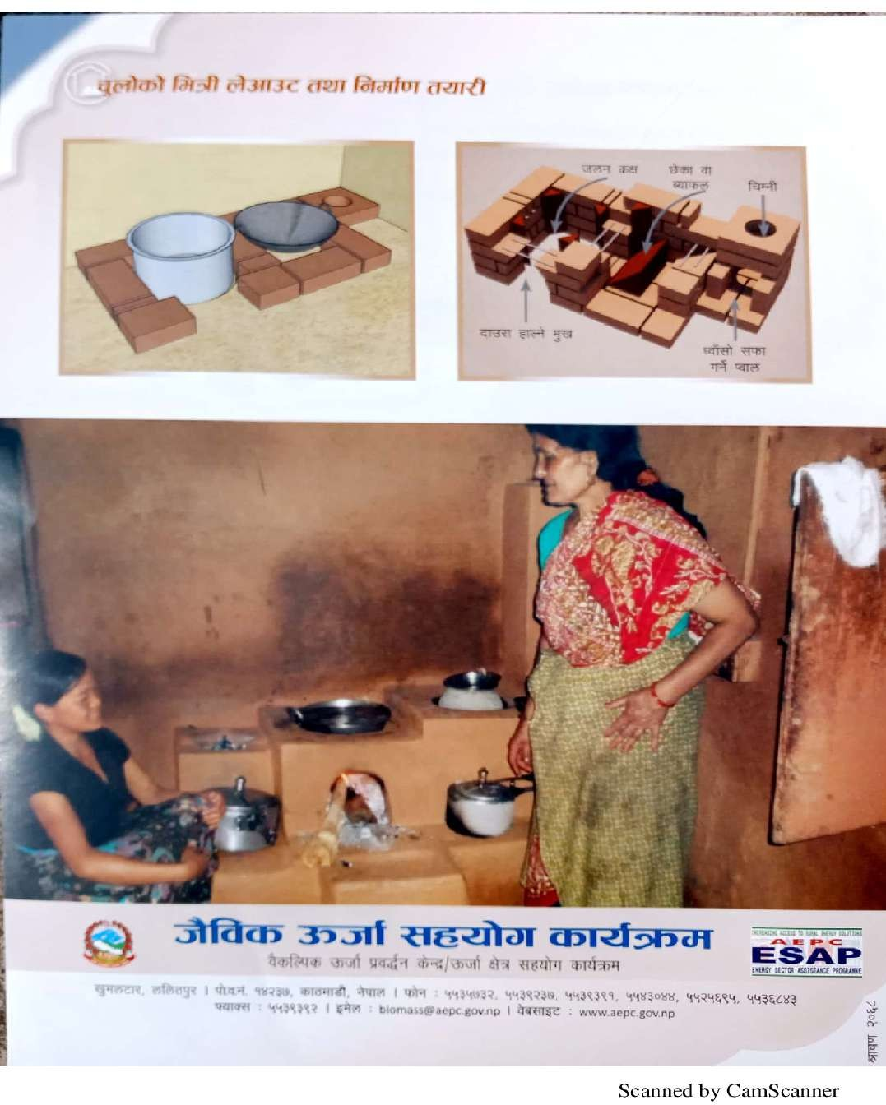

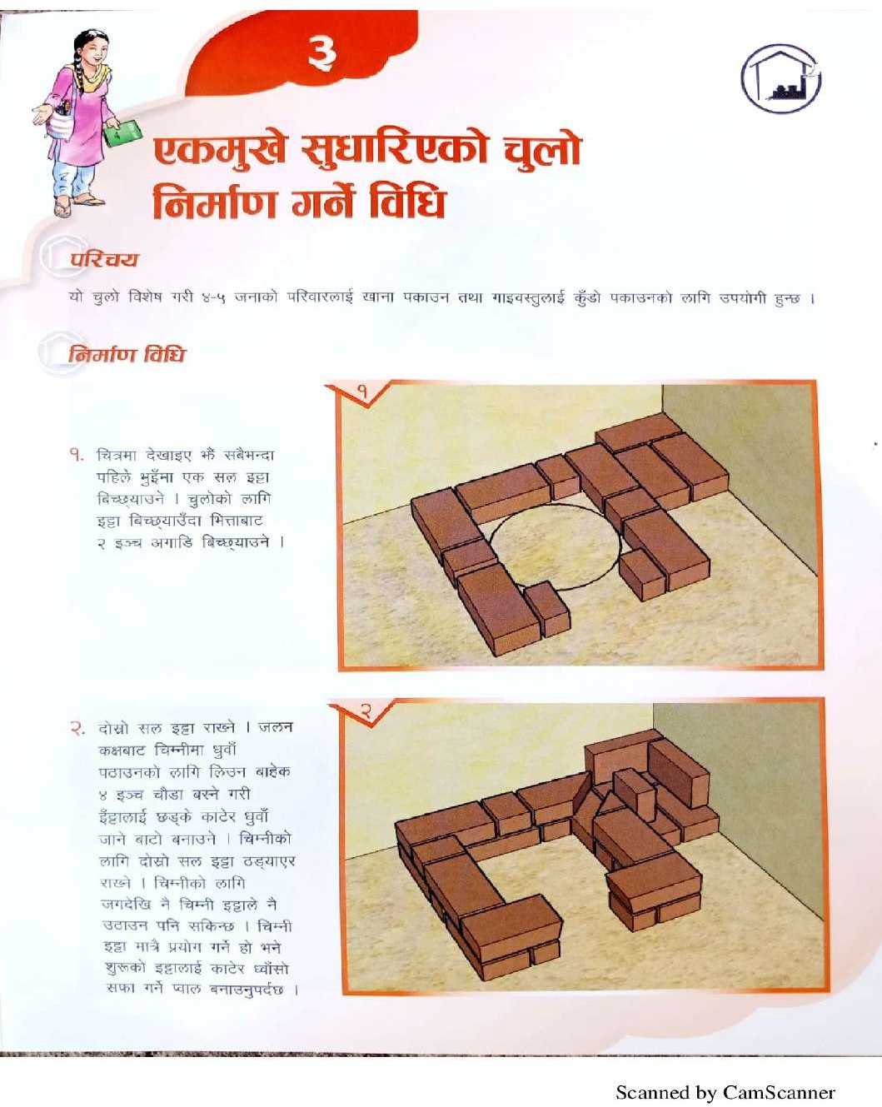

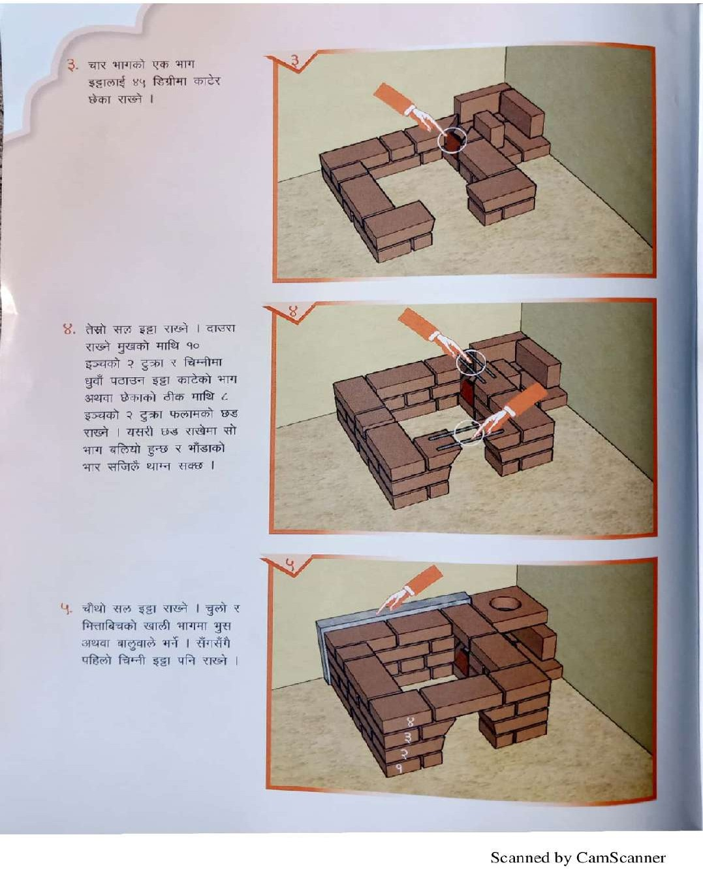

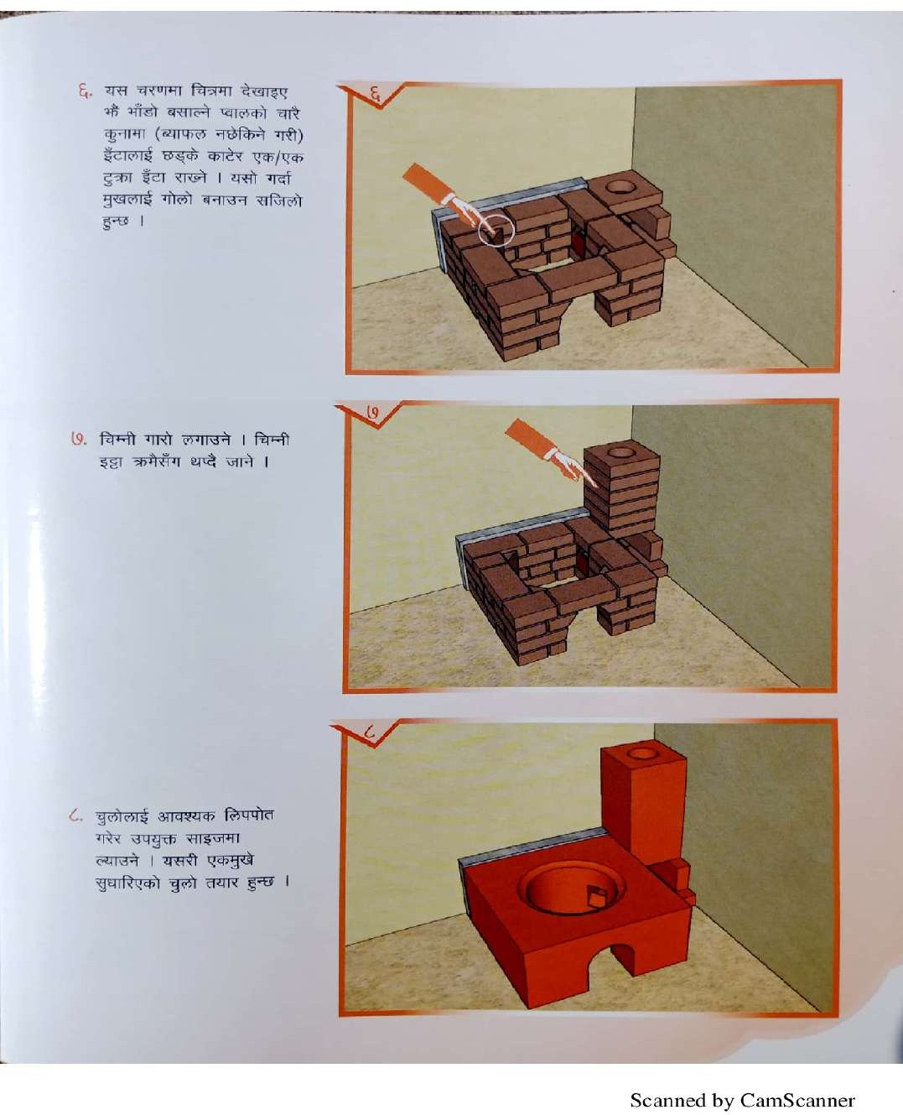

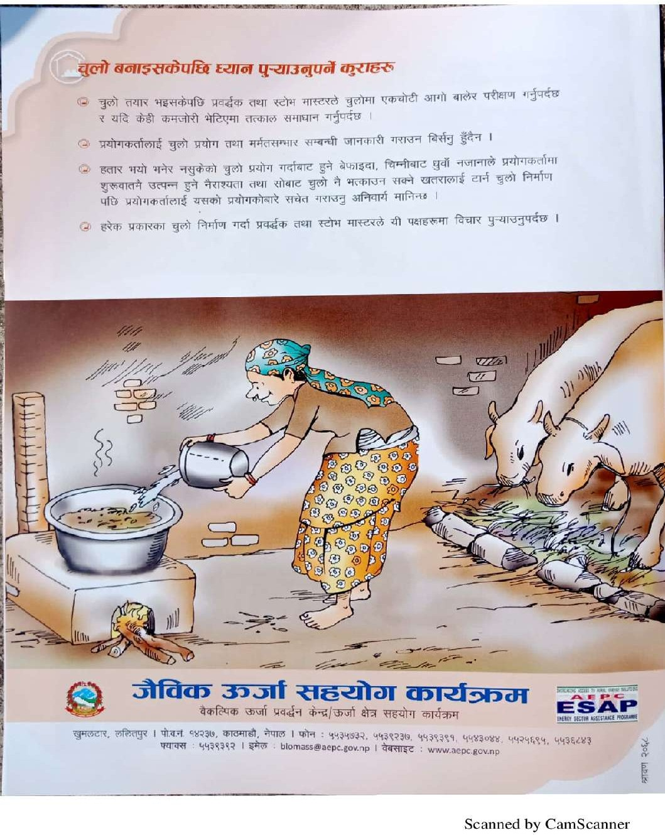

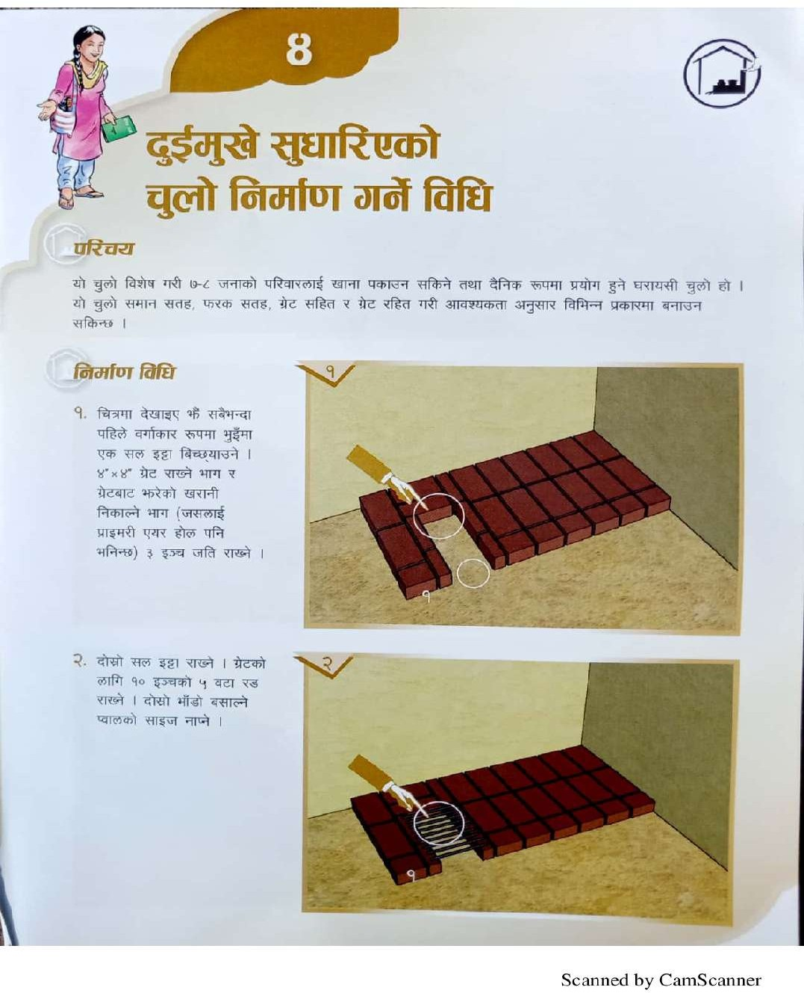

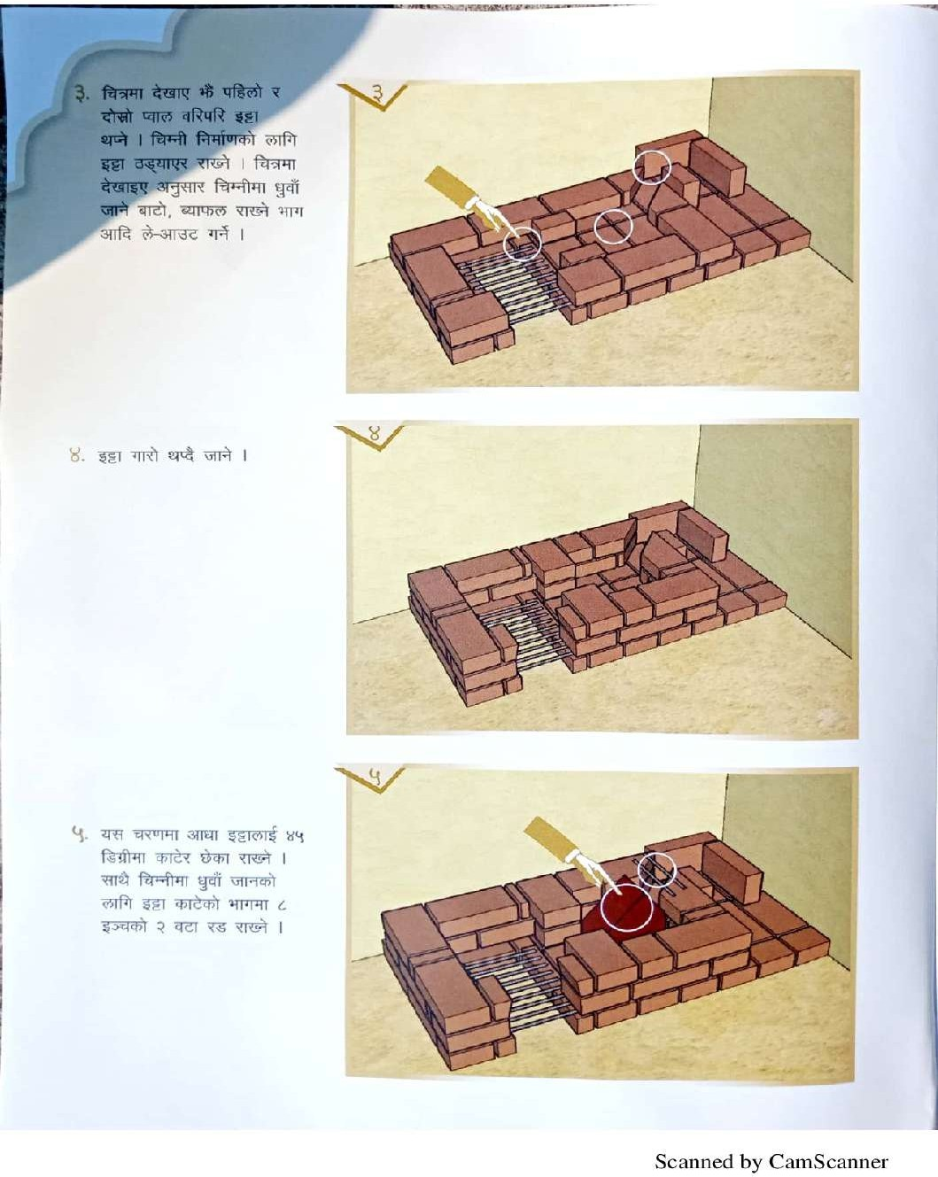

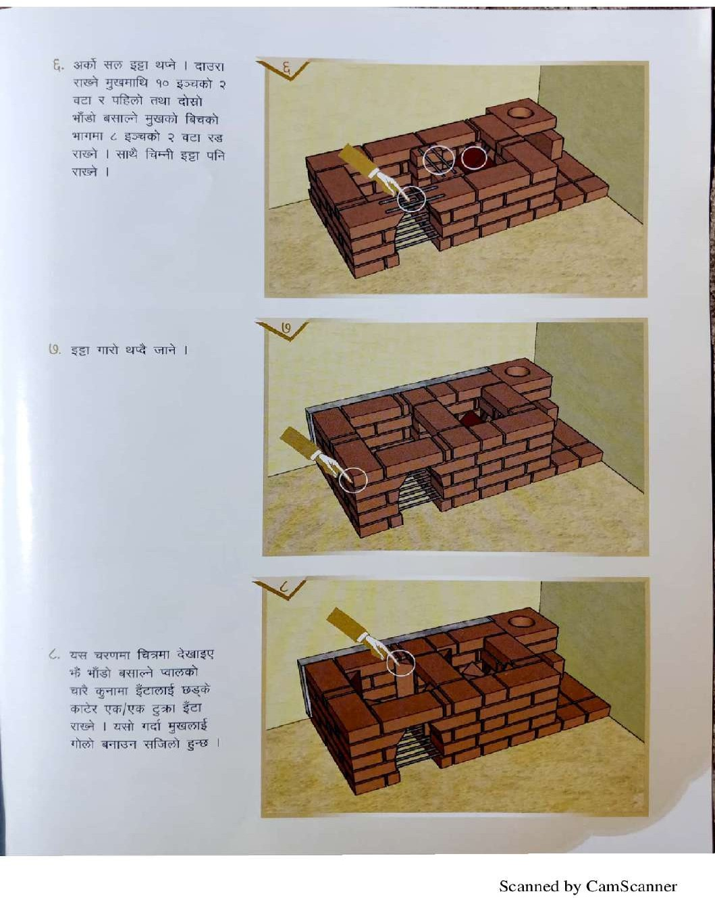

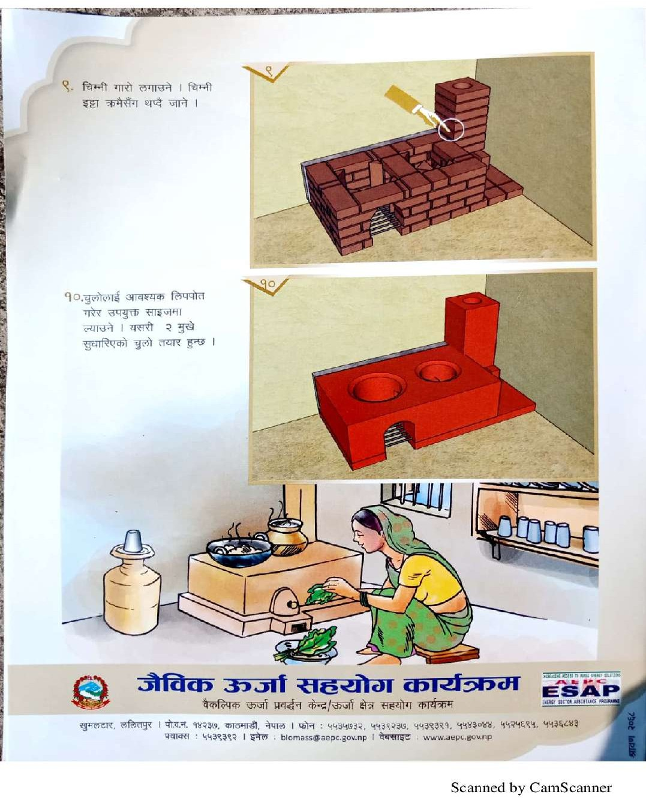

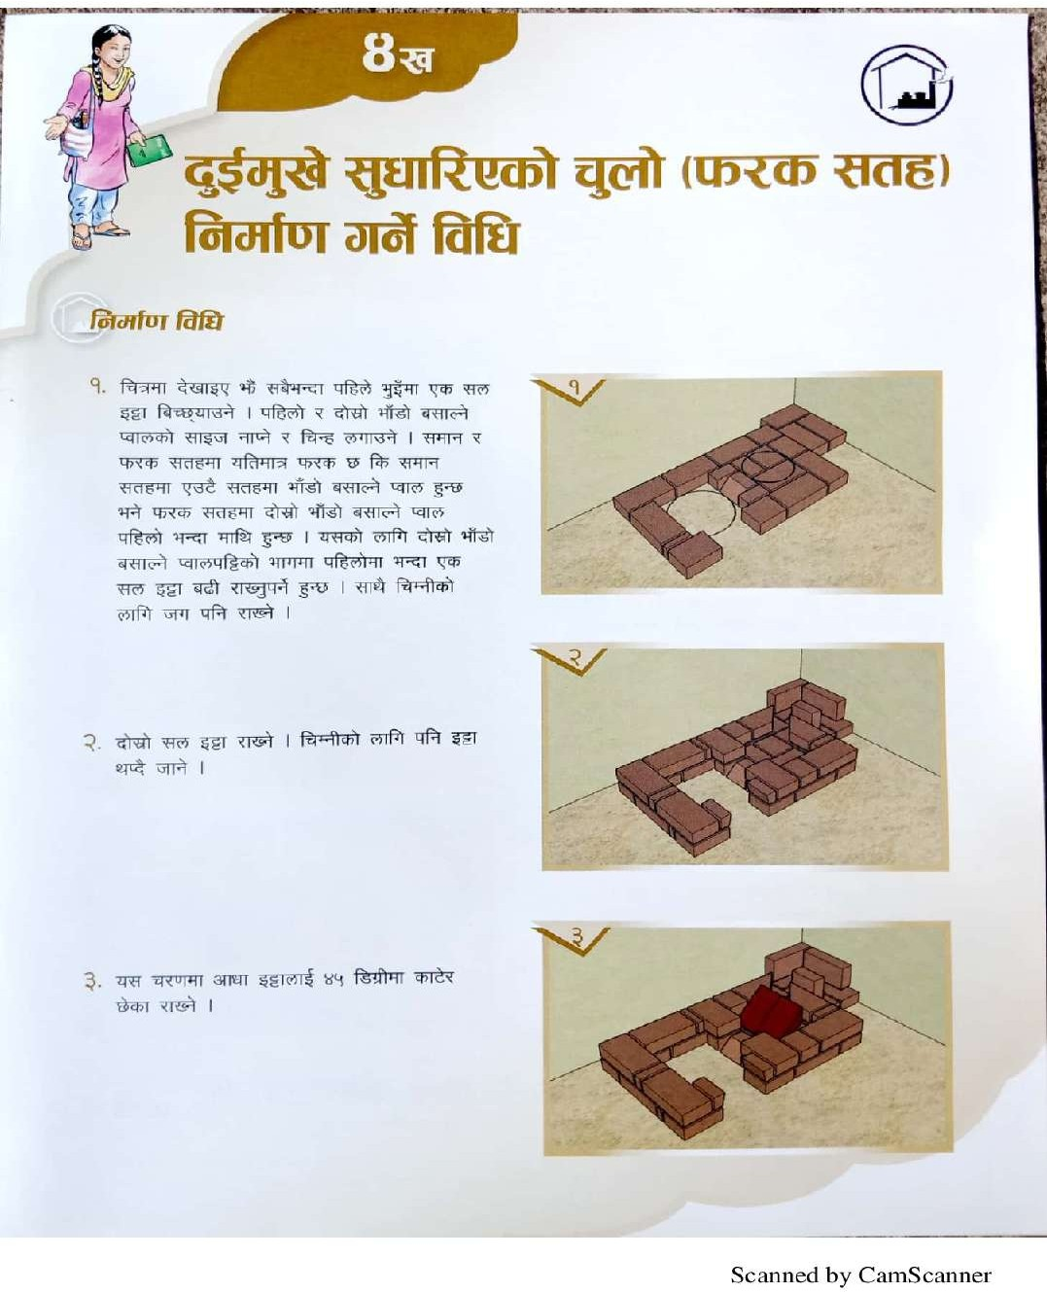

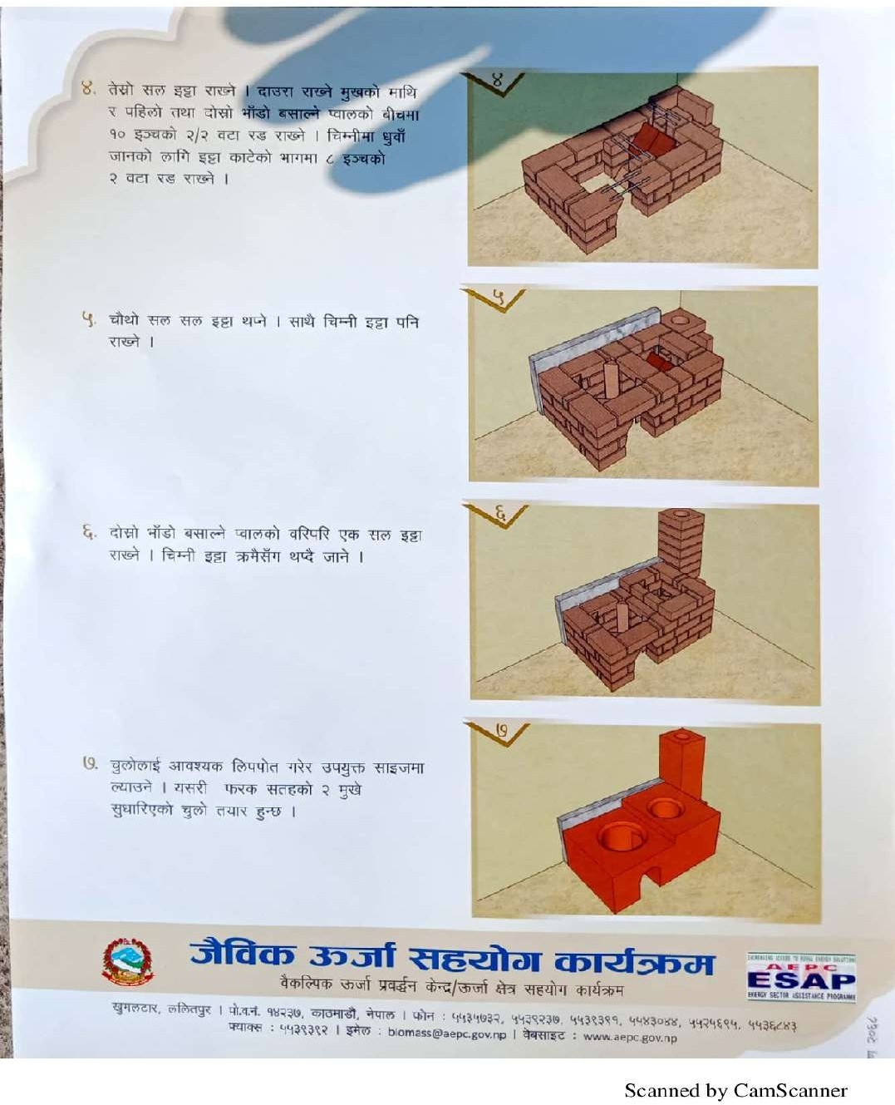

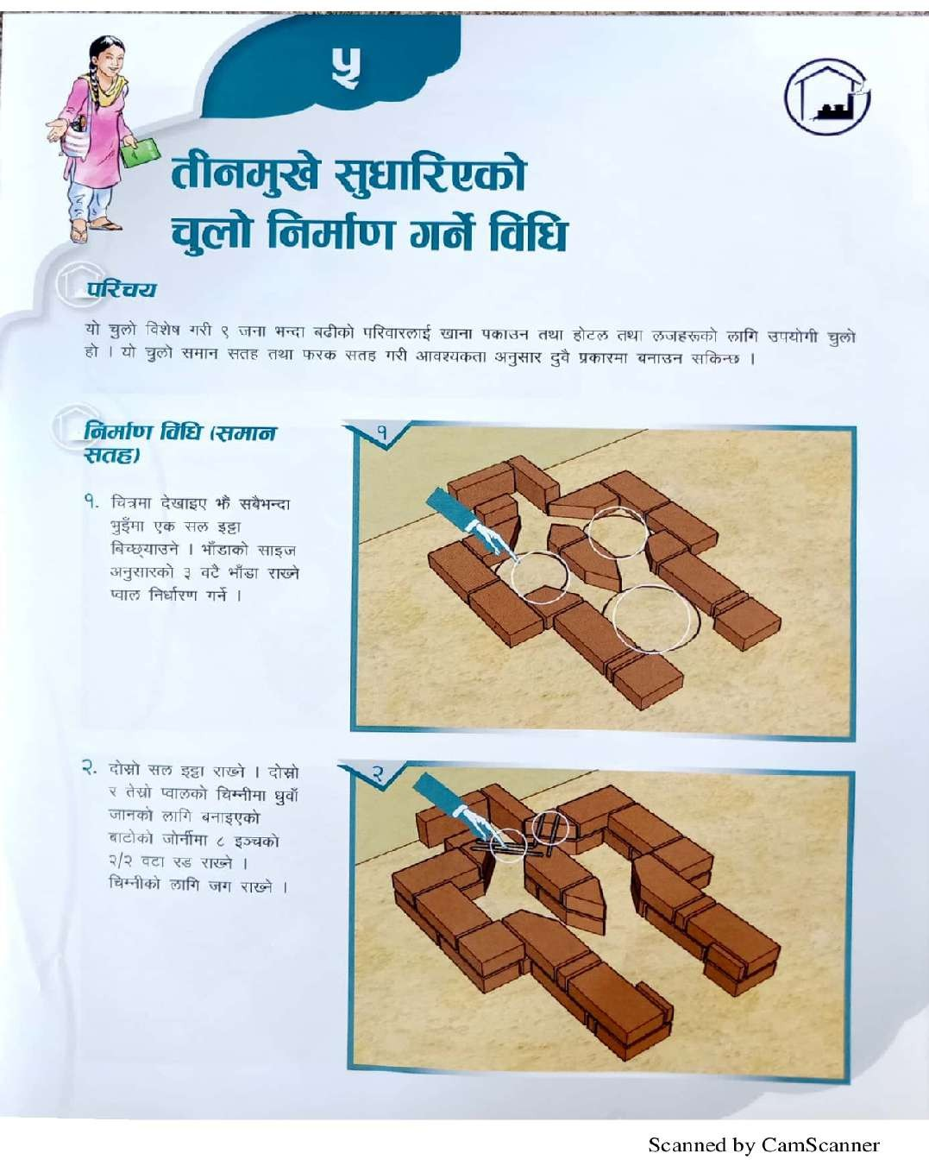

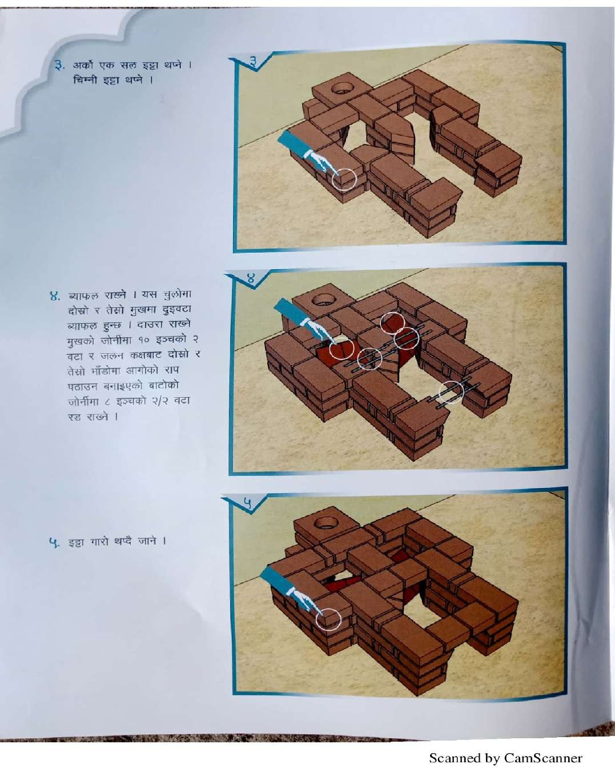

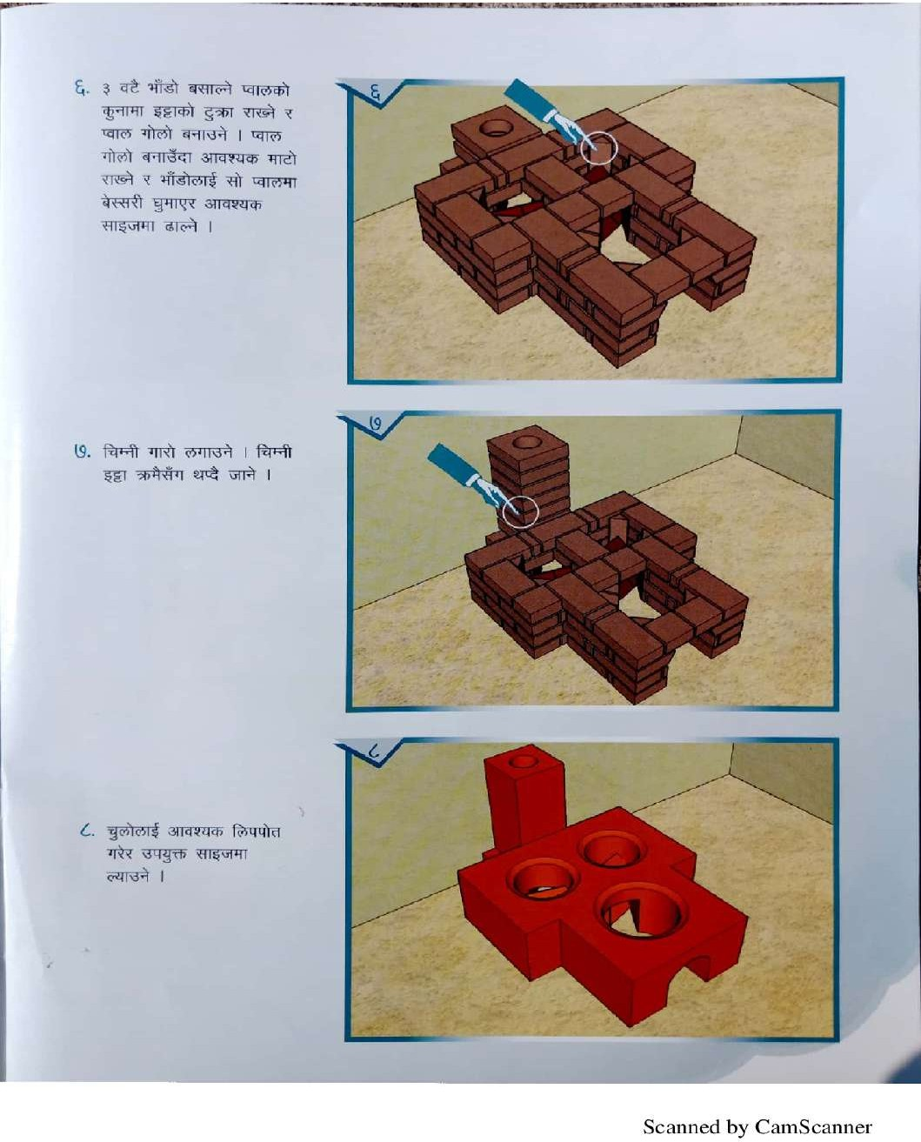

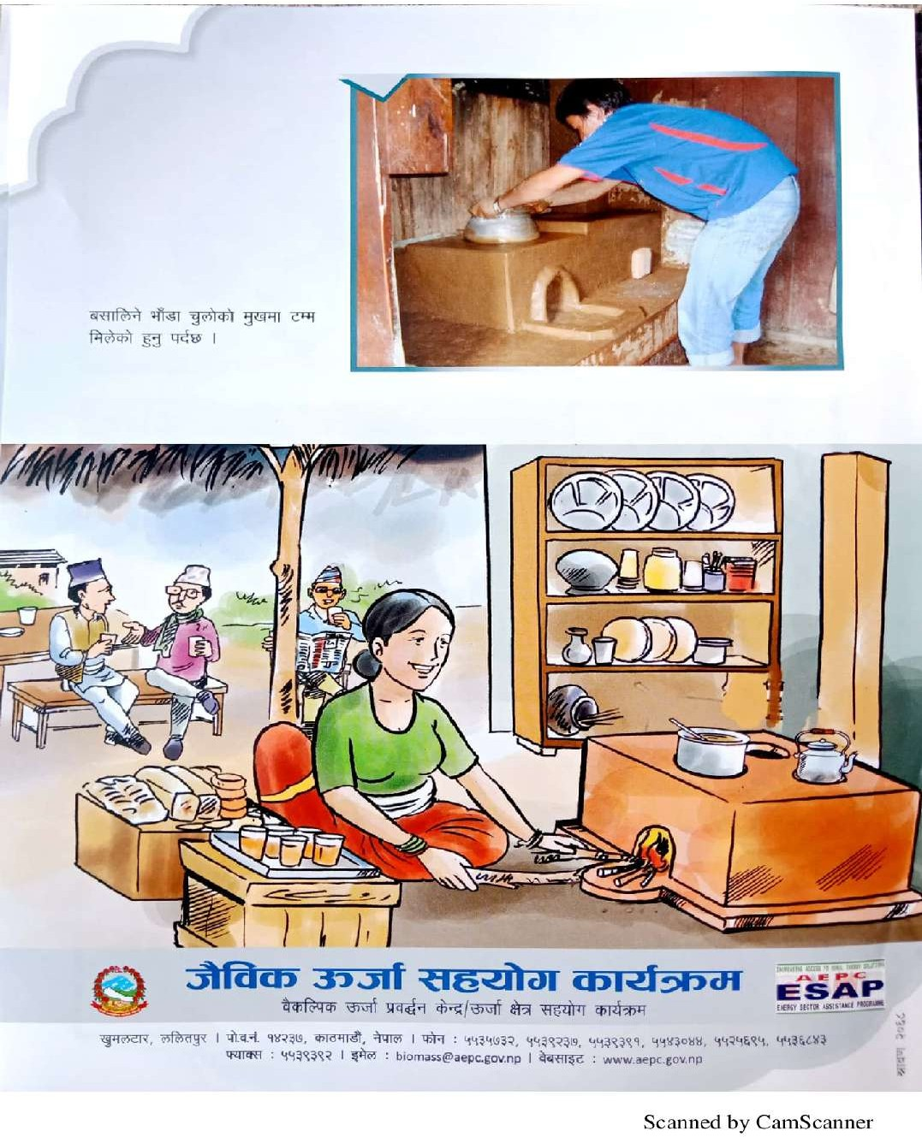

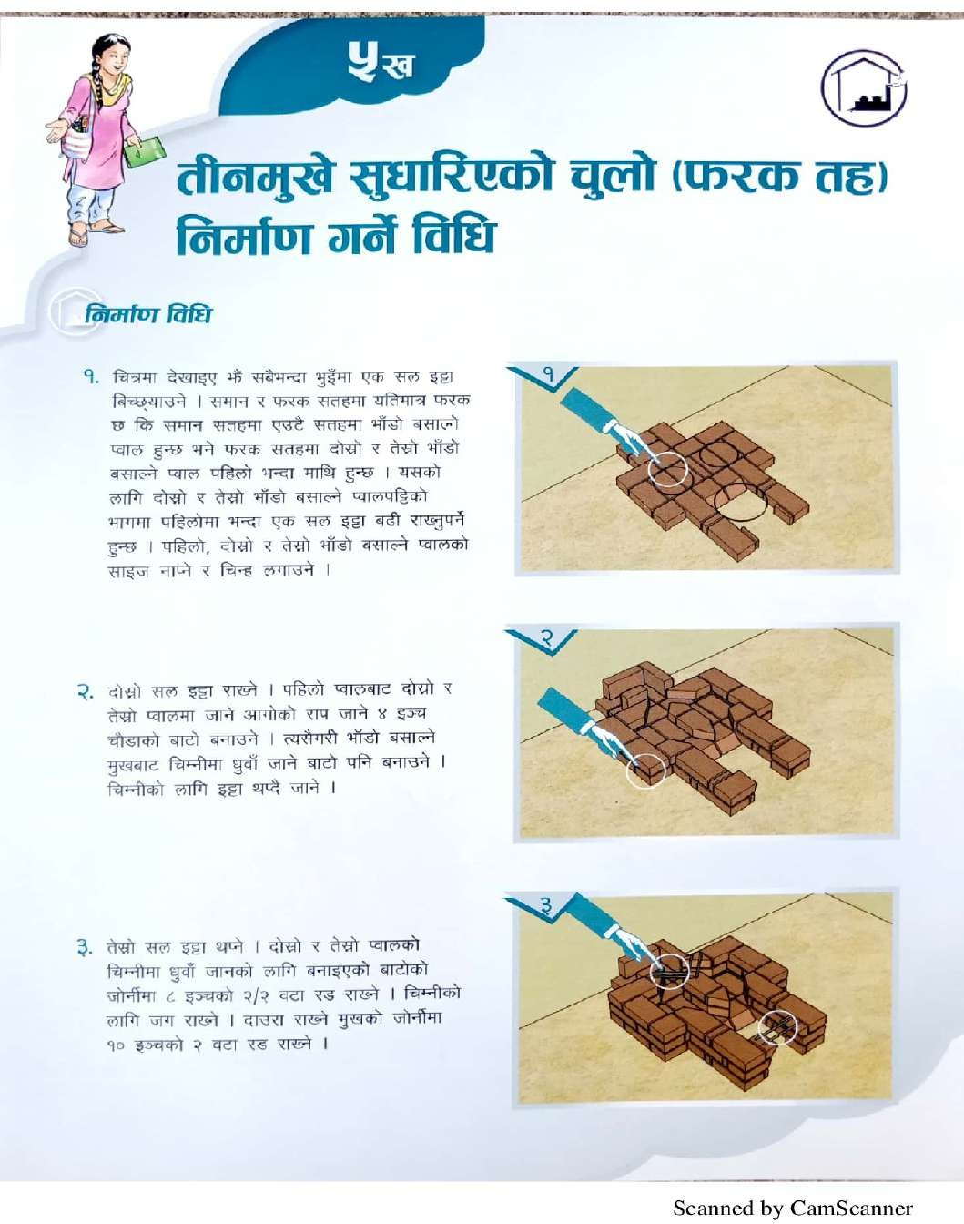

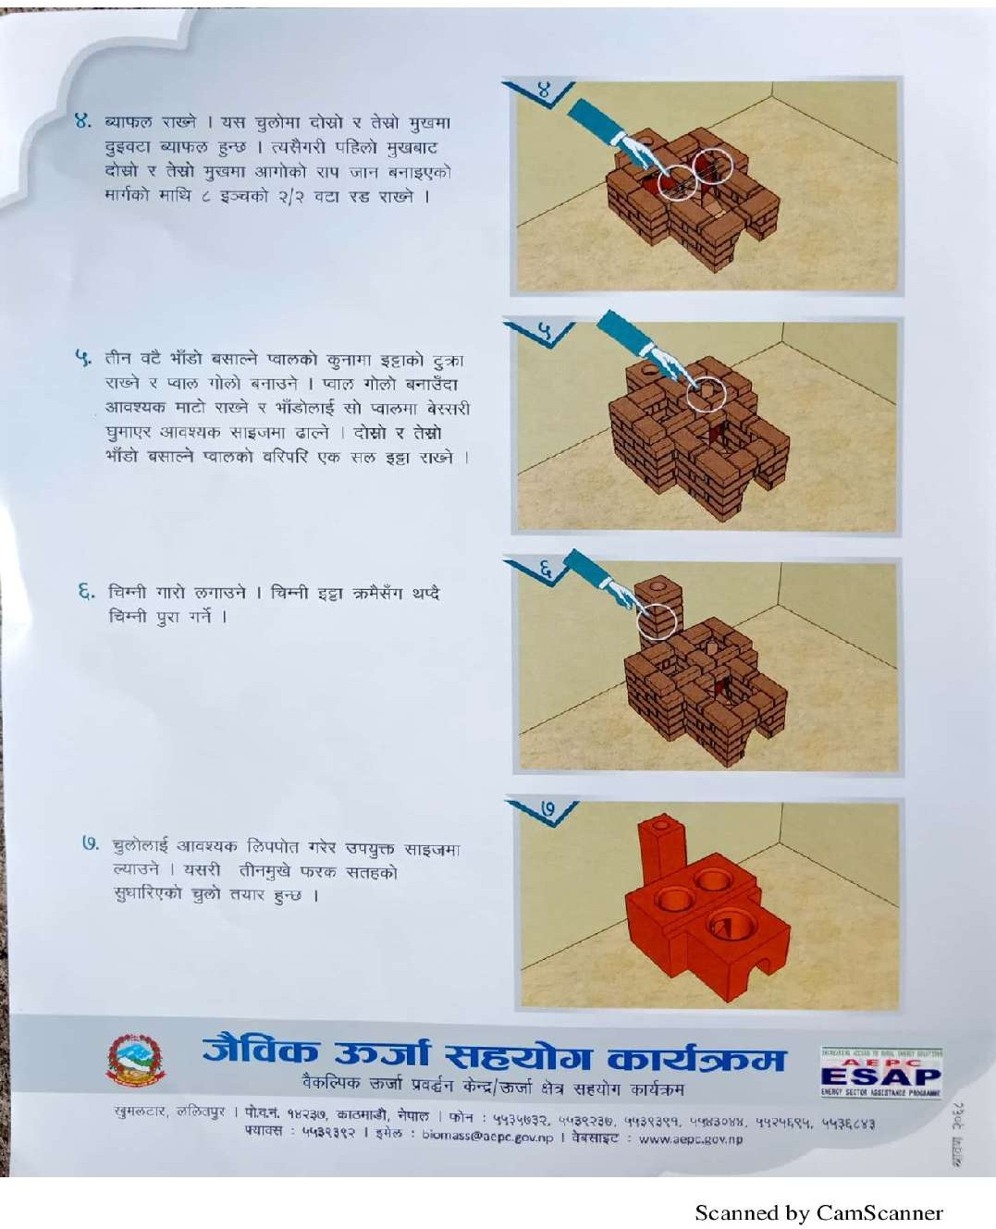

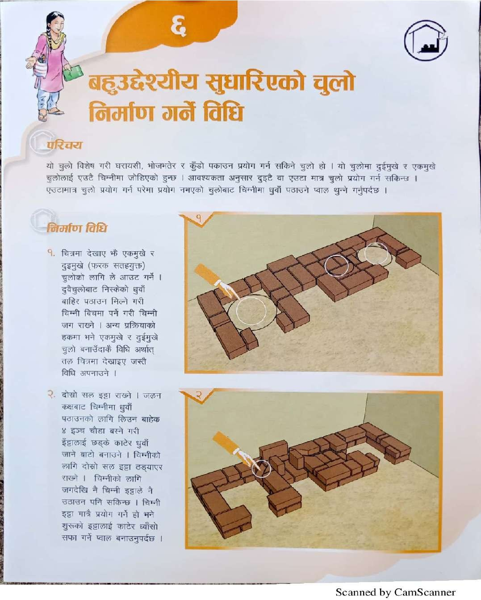

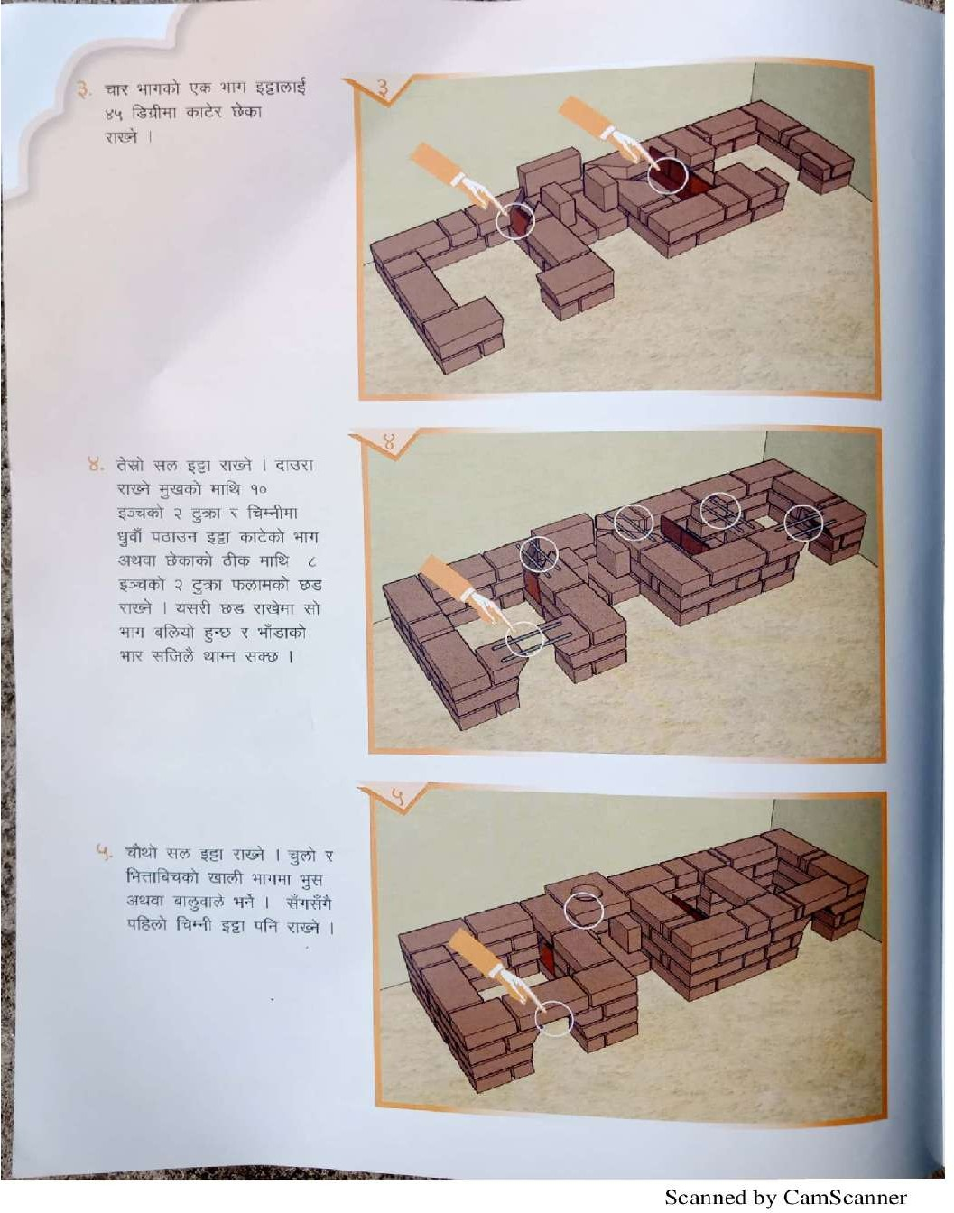

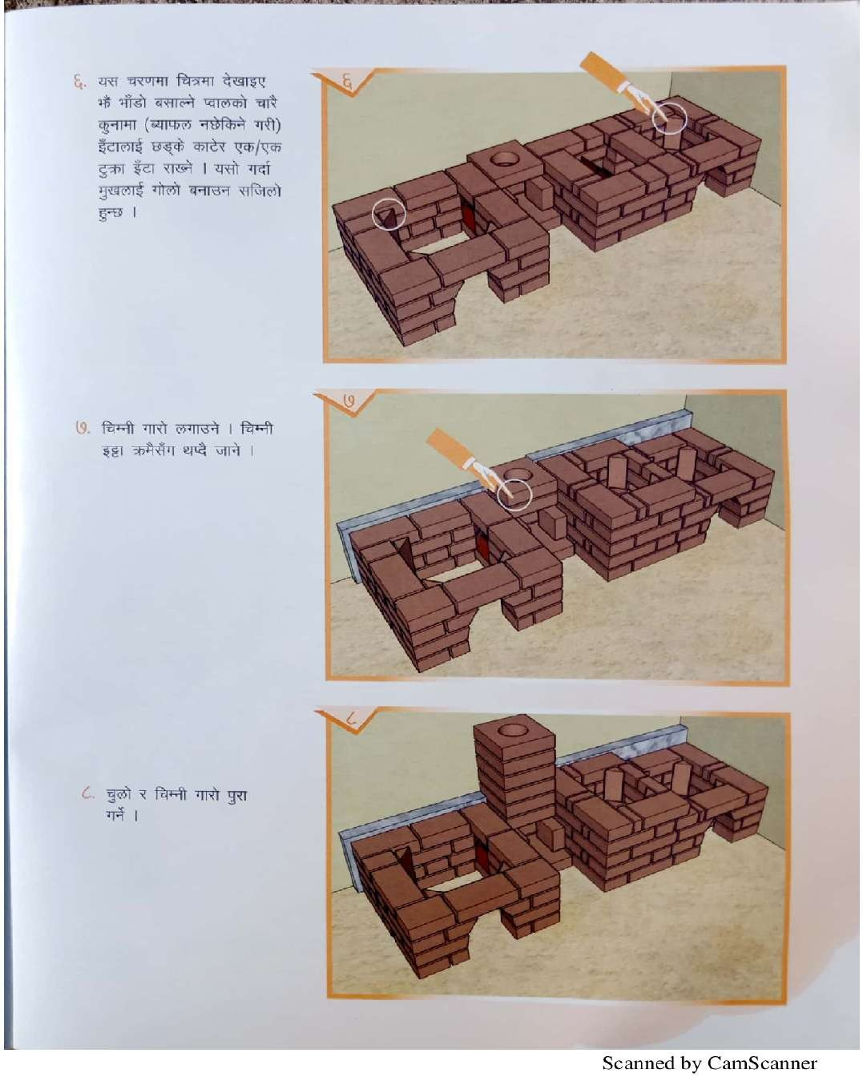

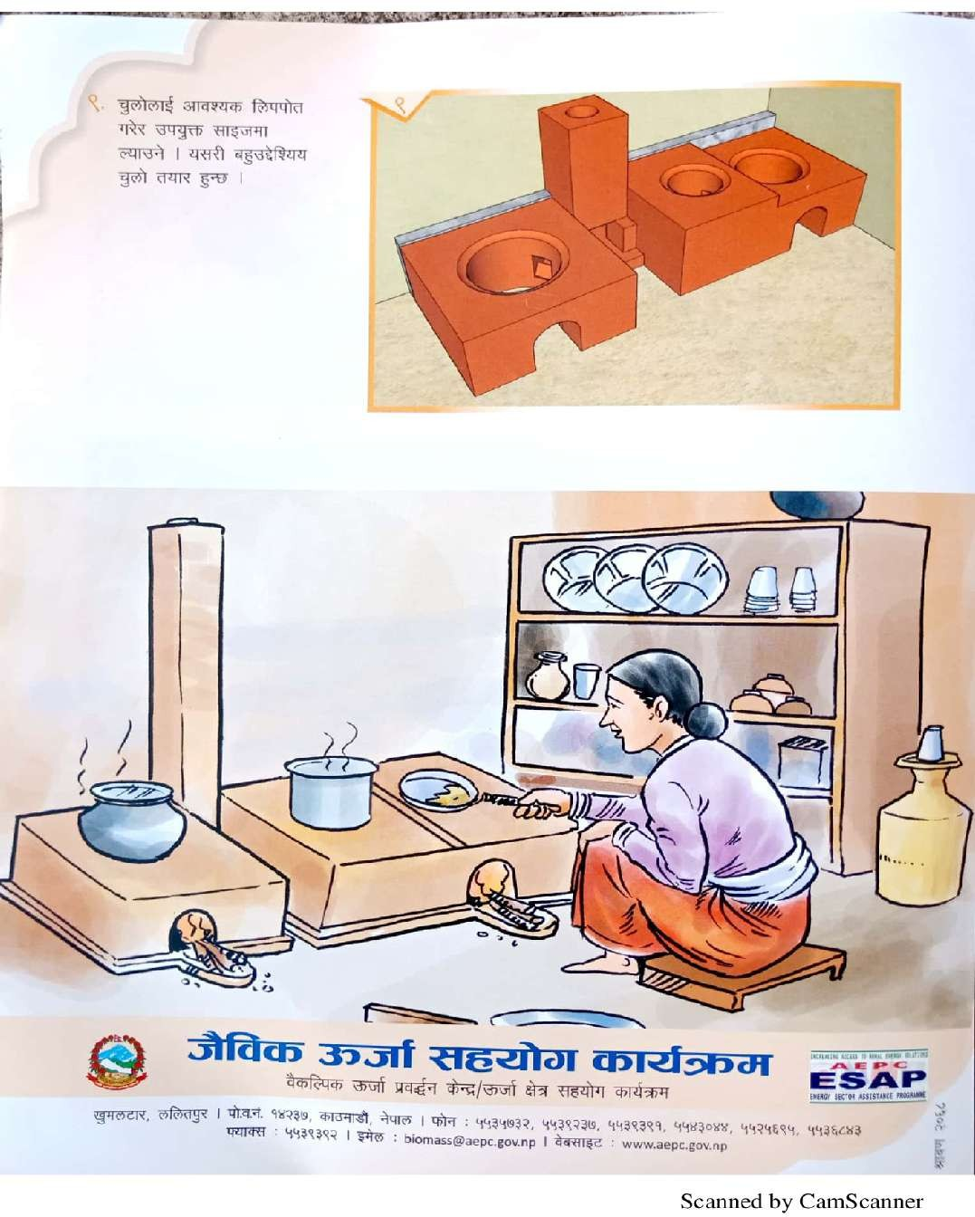

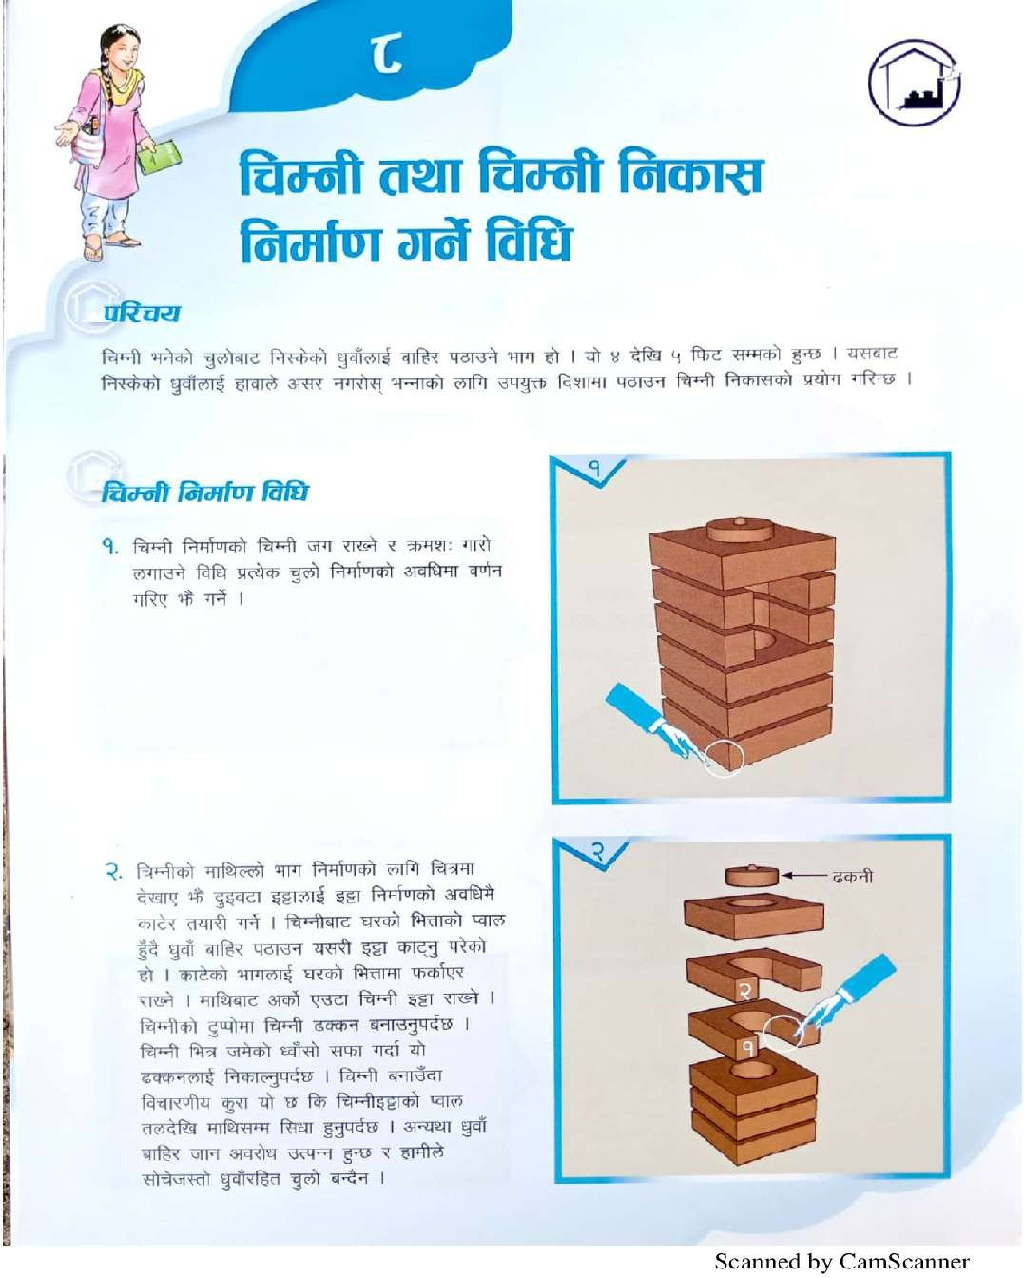

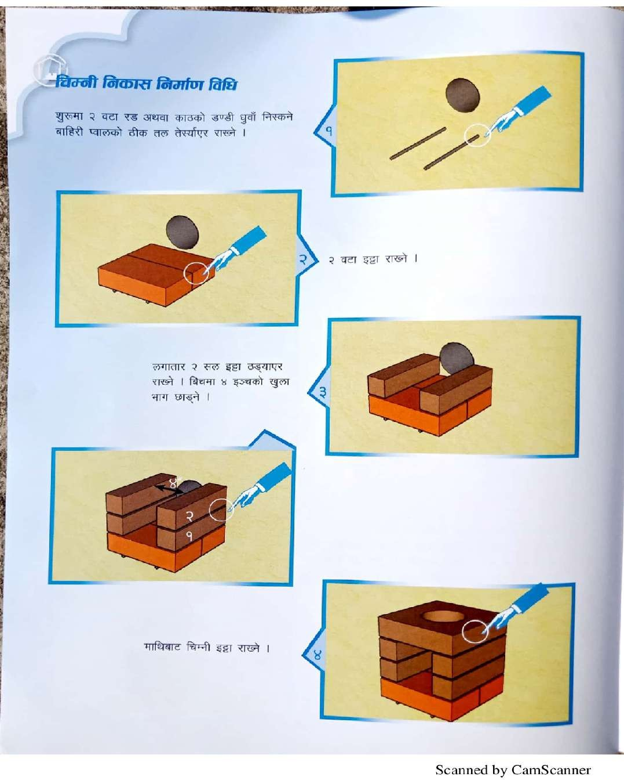

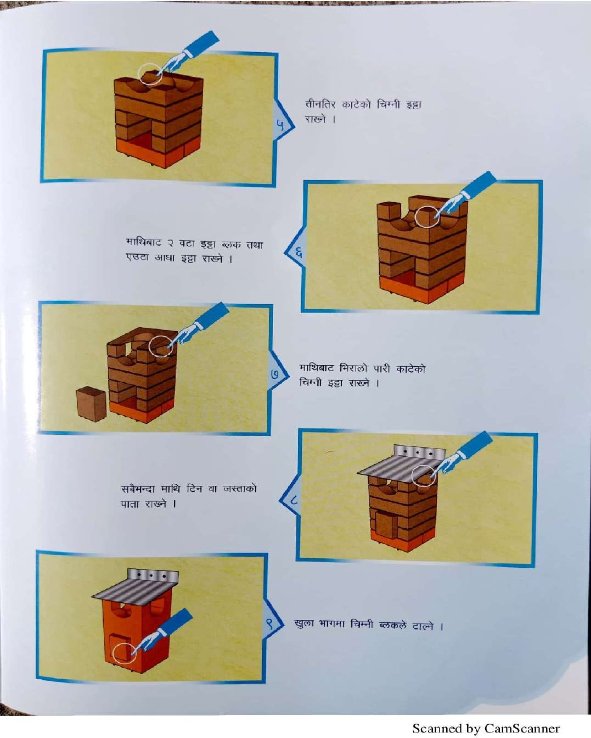

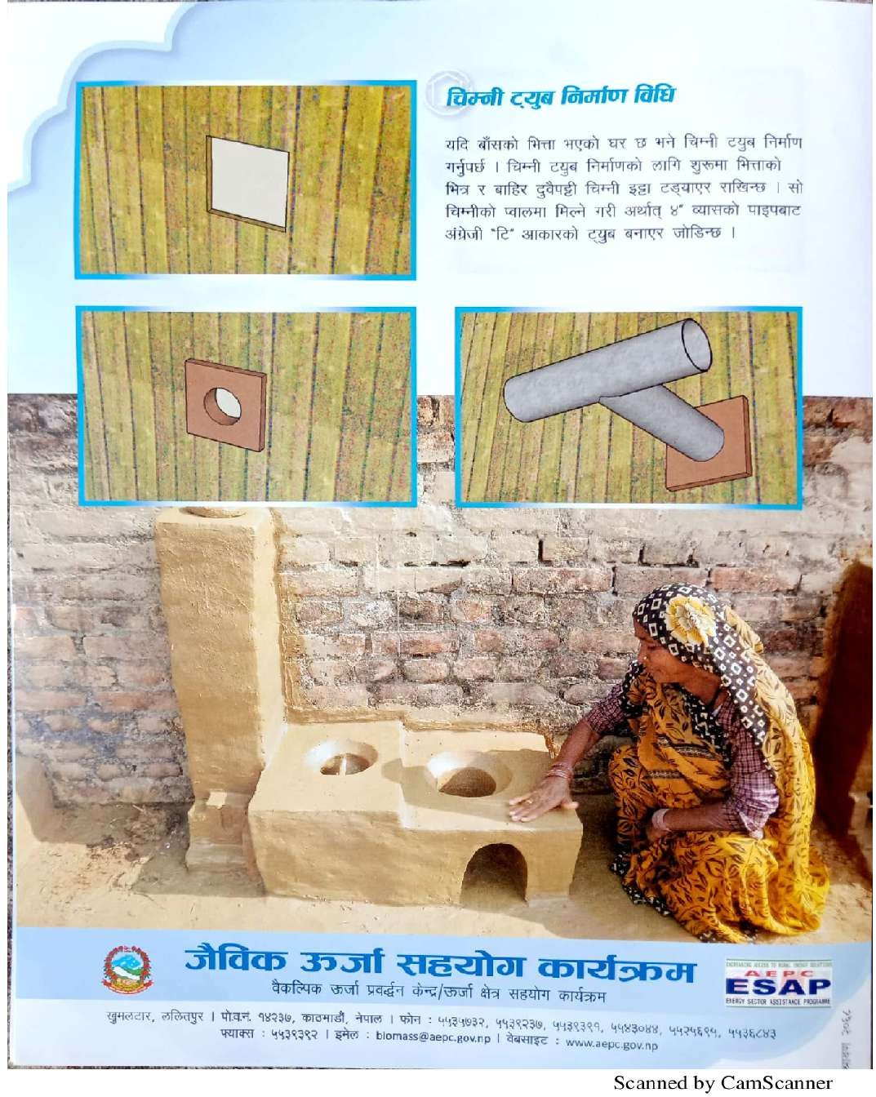

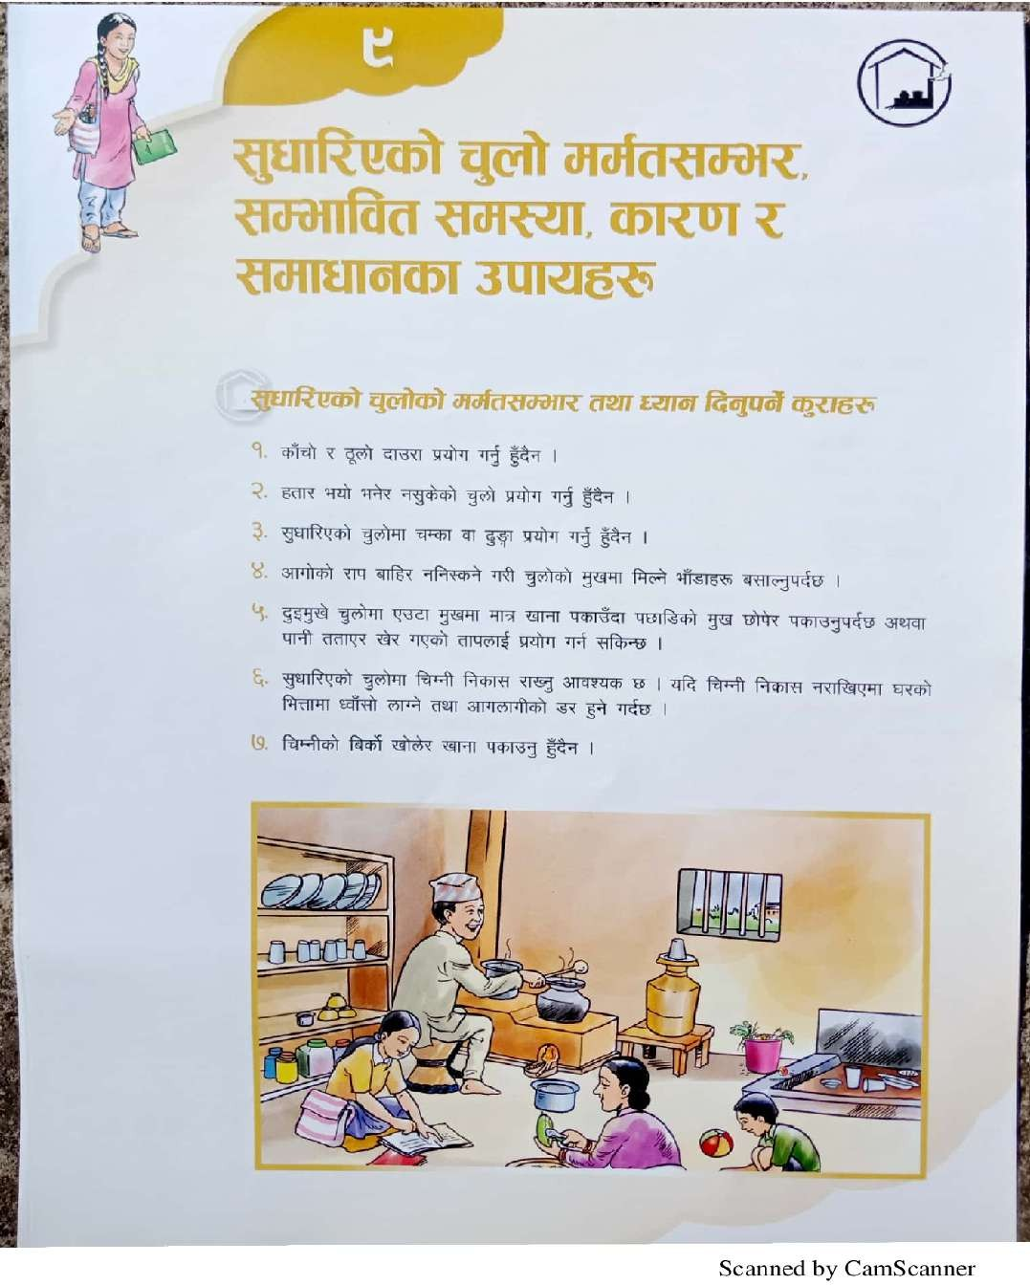

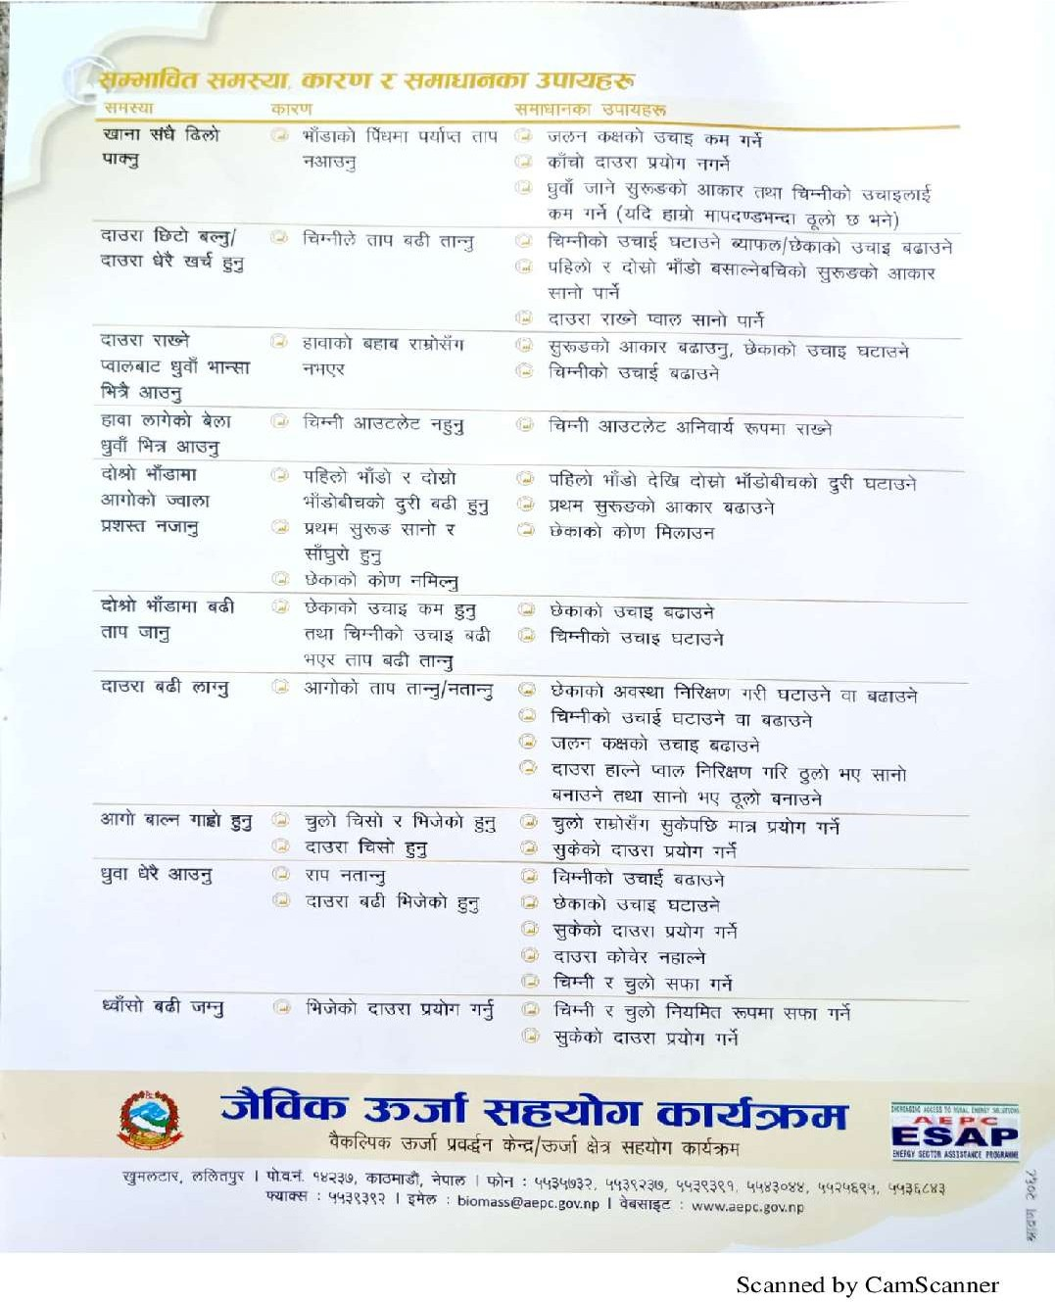

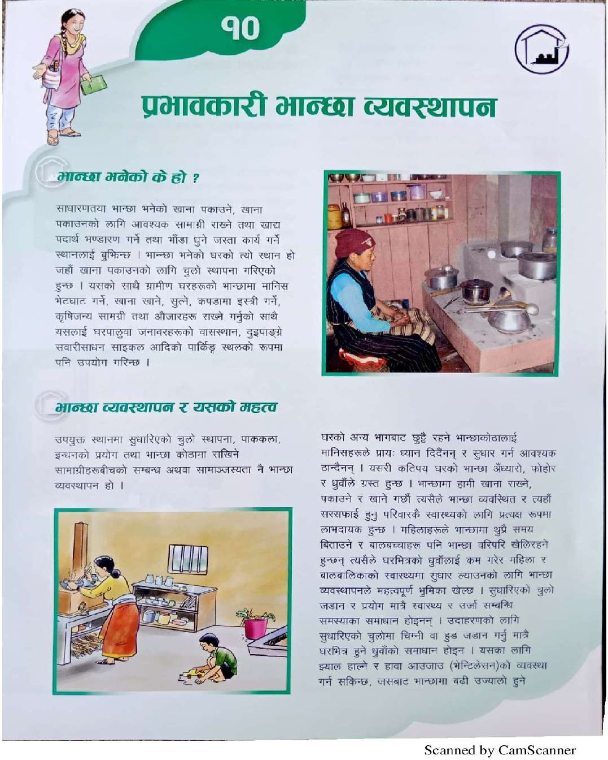

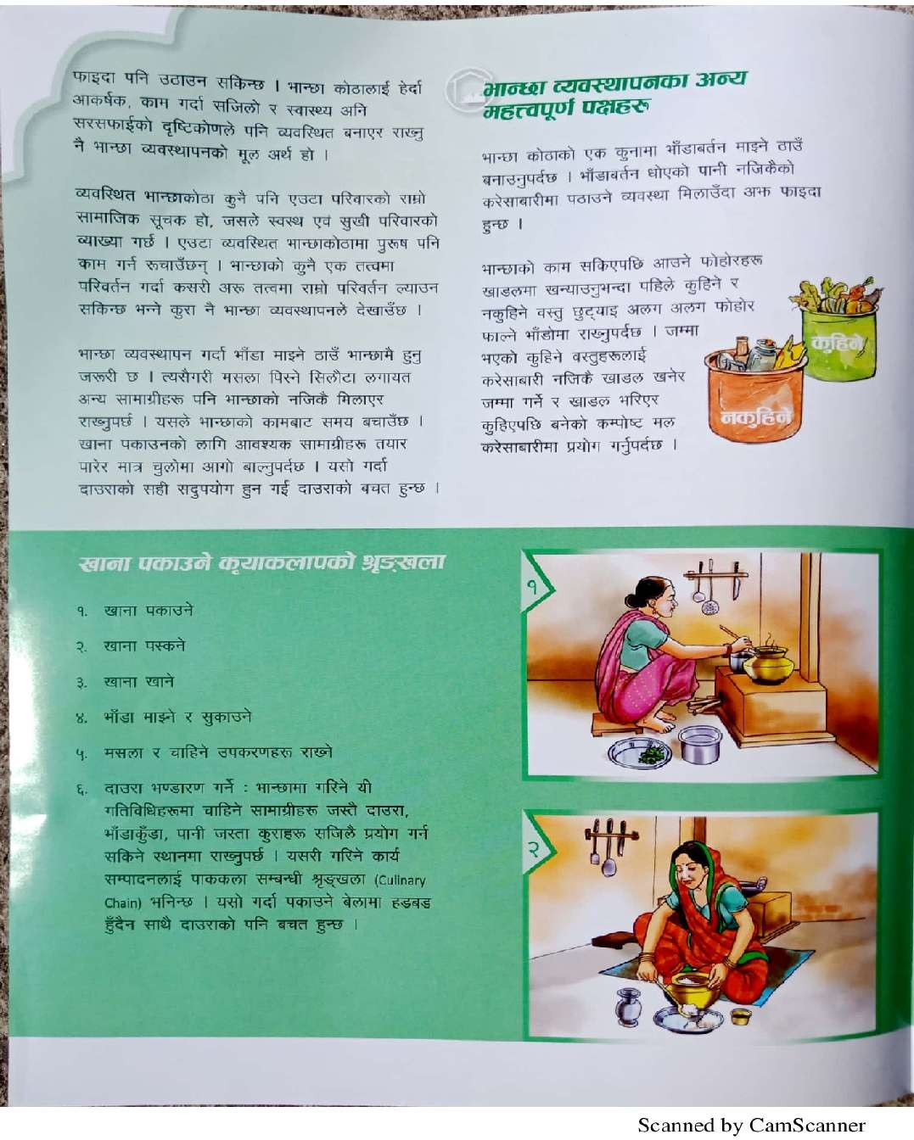

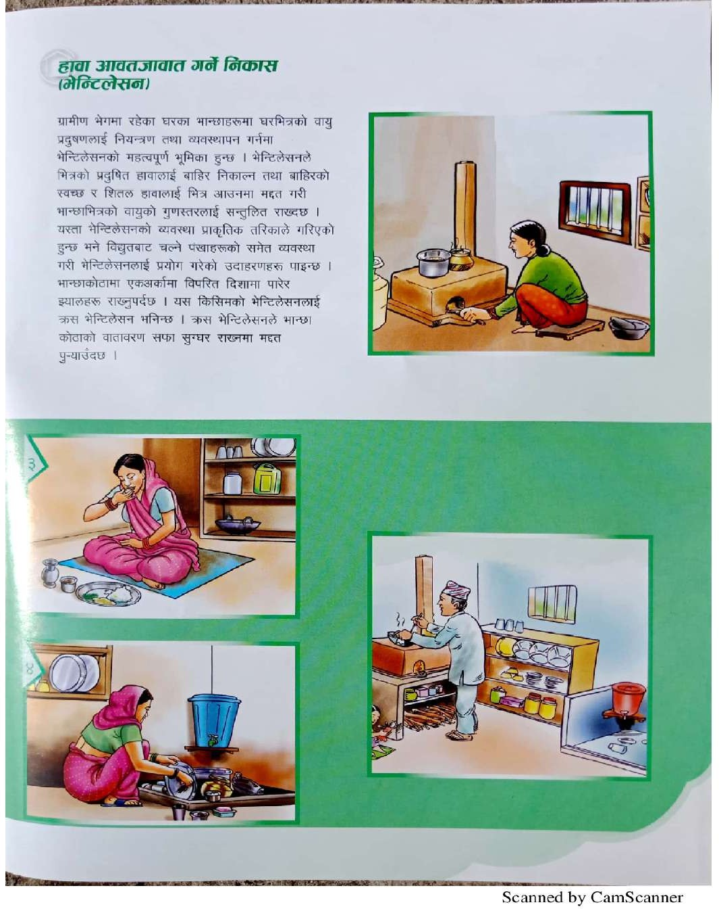

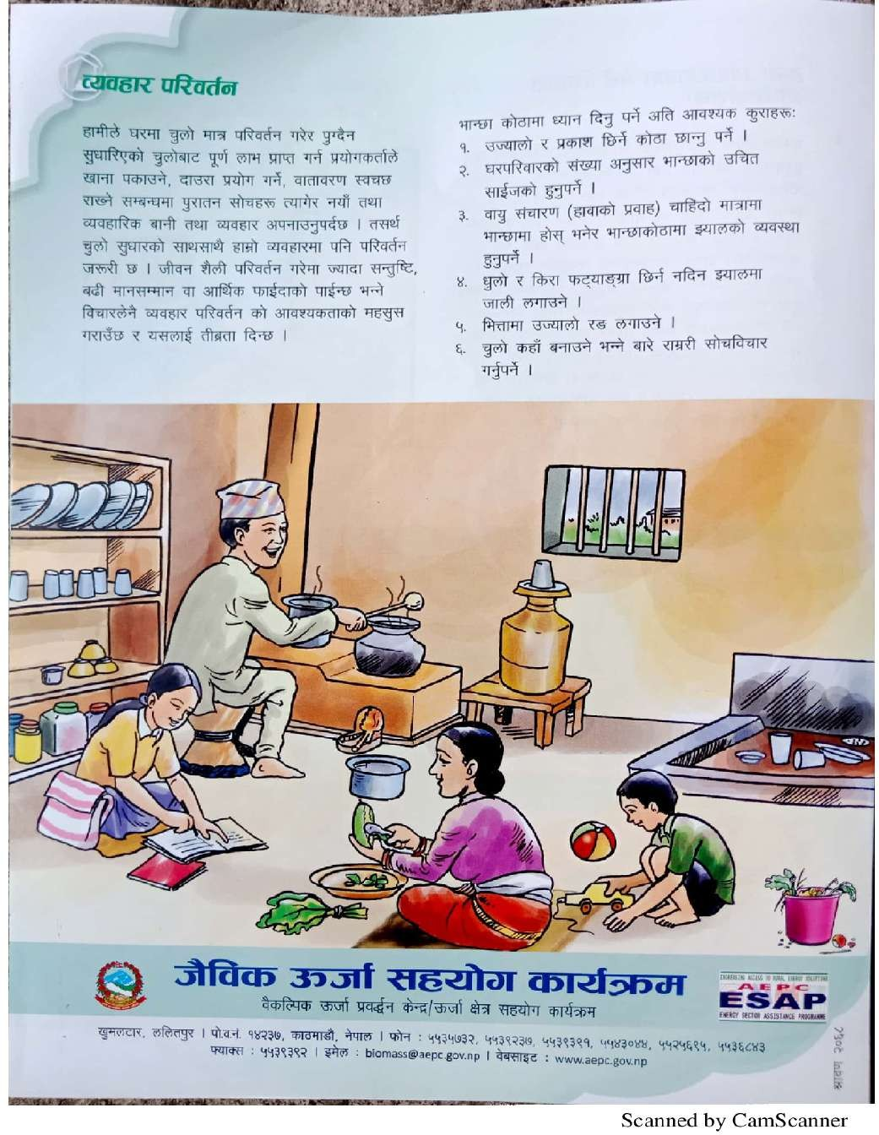
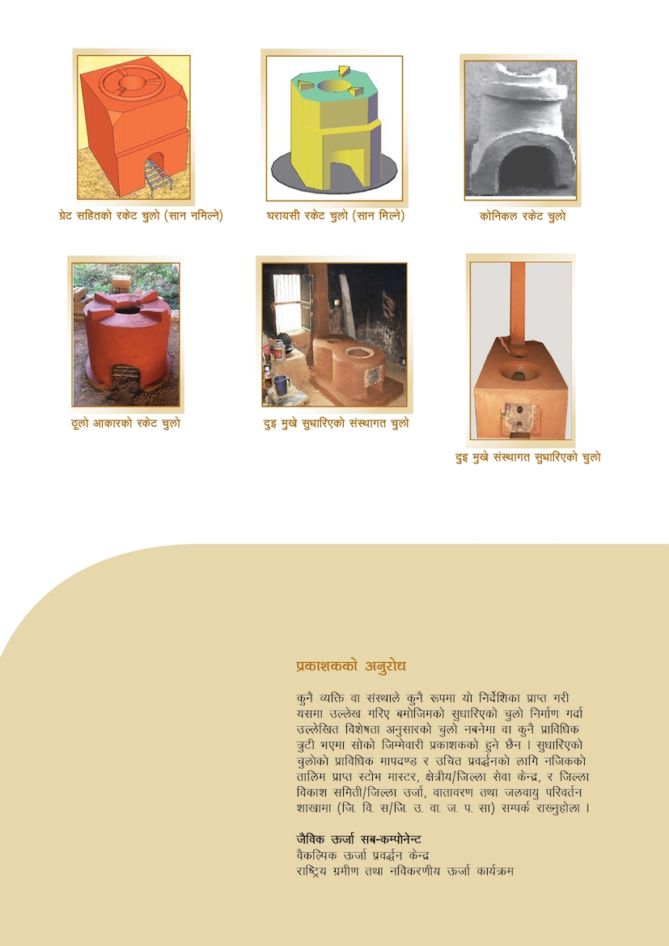
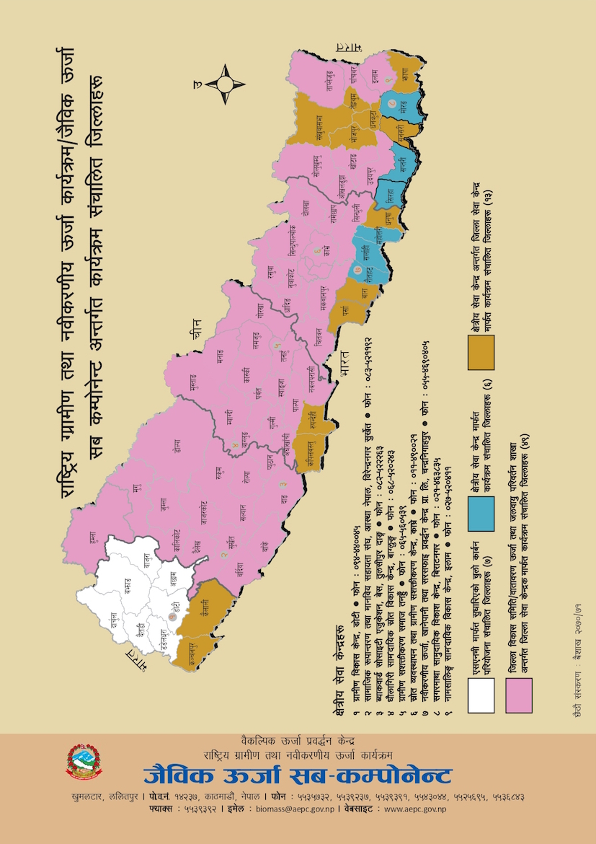

ICS Users Booklet:
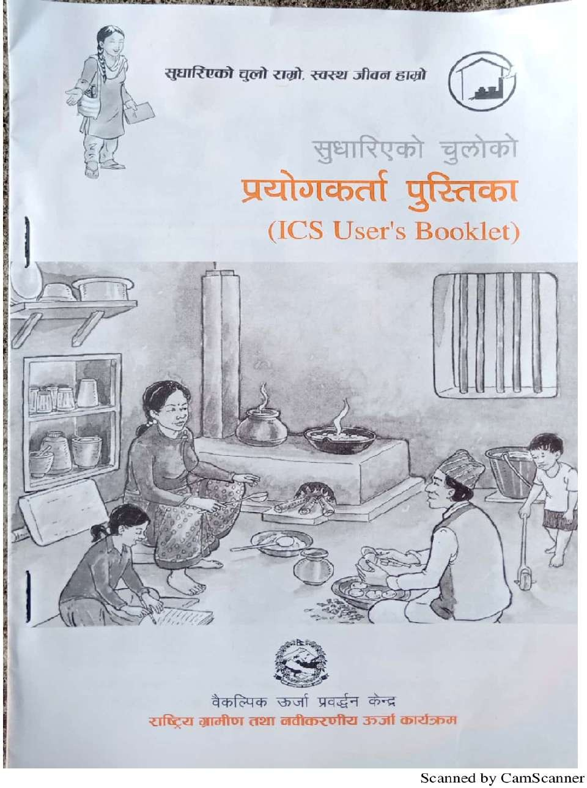

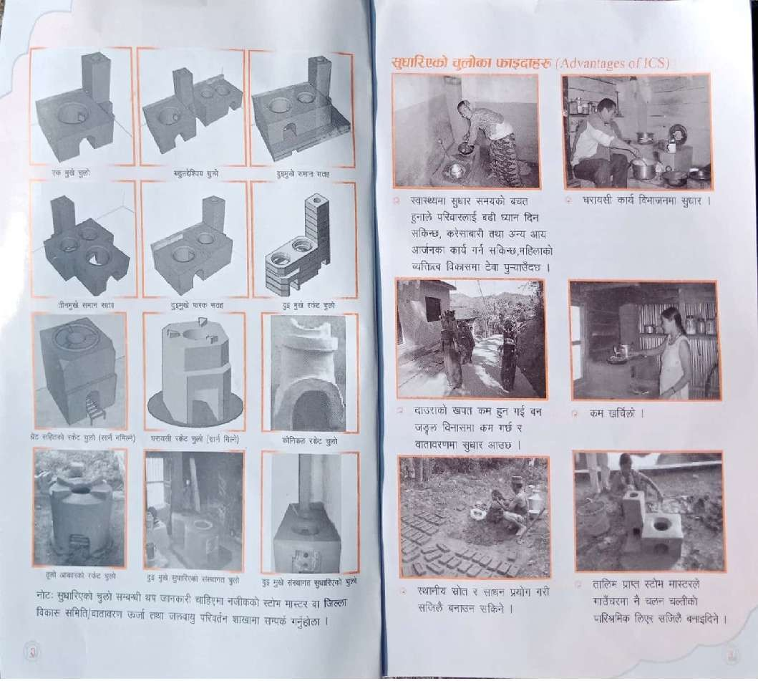

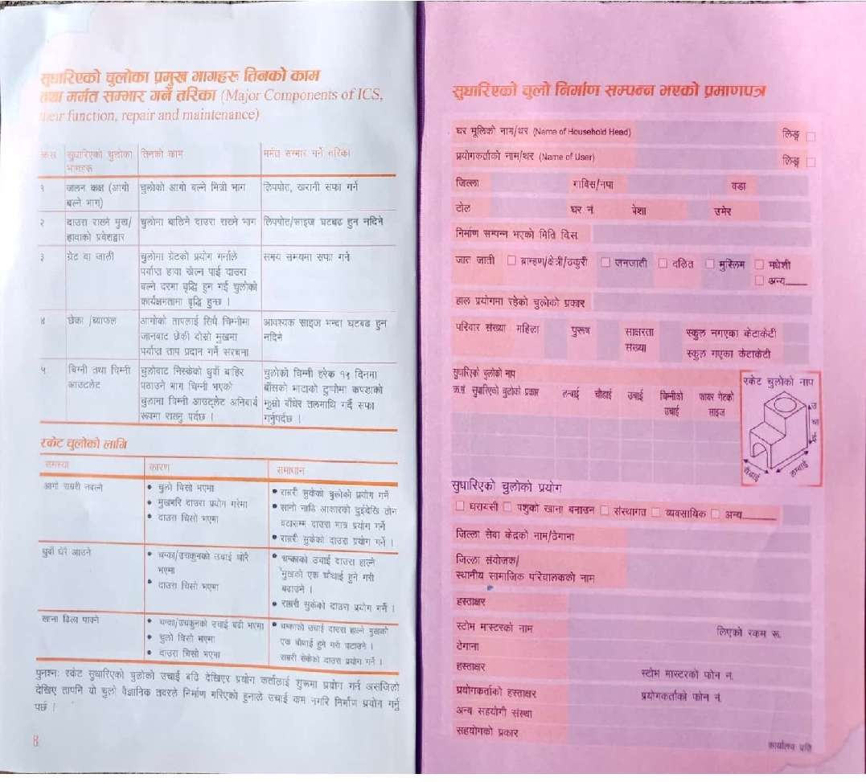

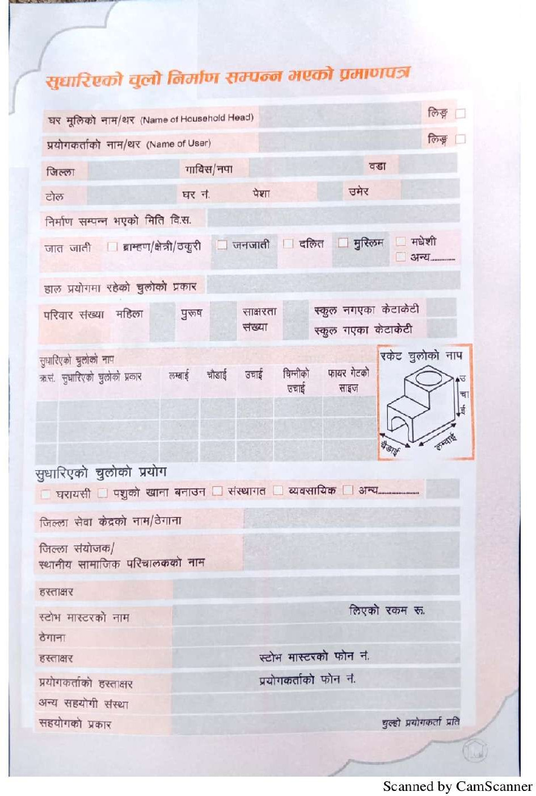
NCDC Progress Report_ICS Capacity Development and After Sale Service Training at Miklajung Rural Municipality 72

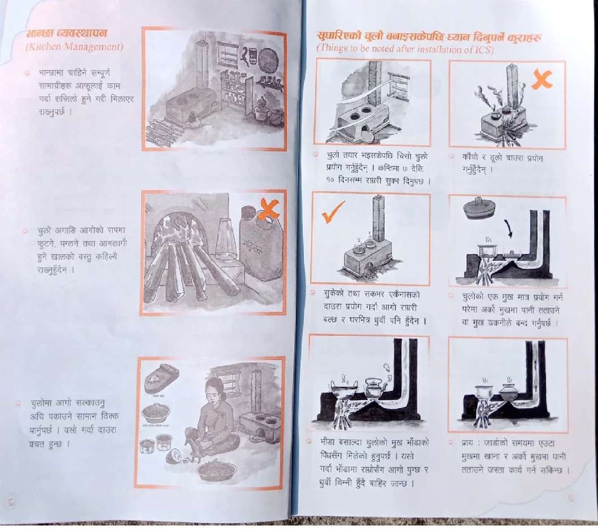

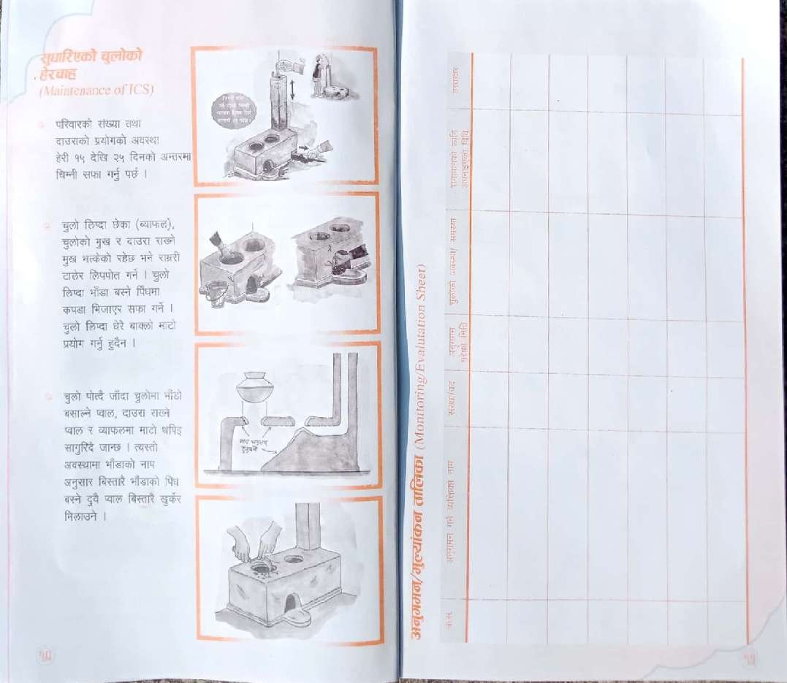

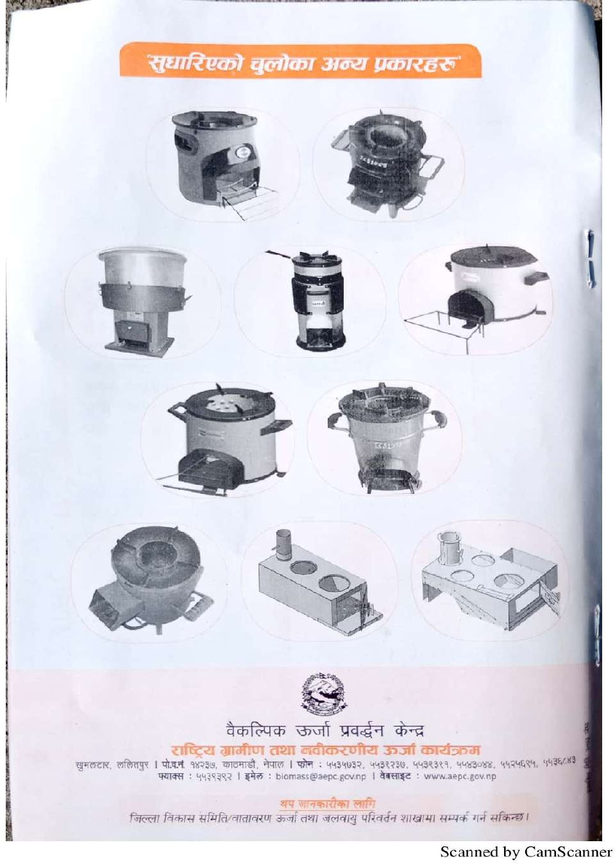

Photographs

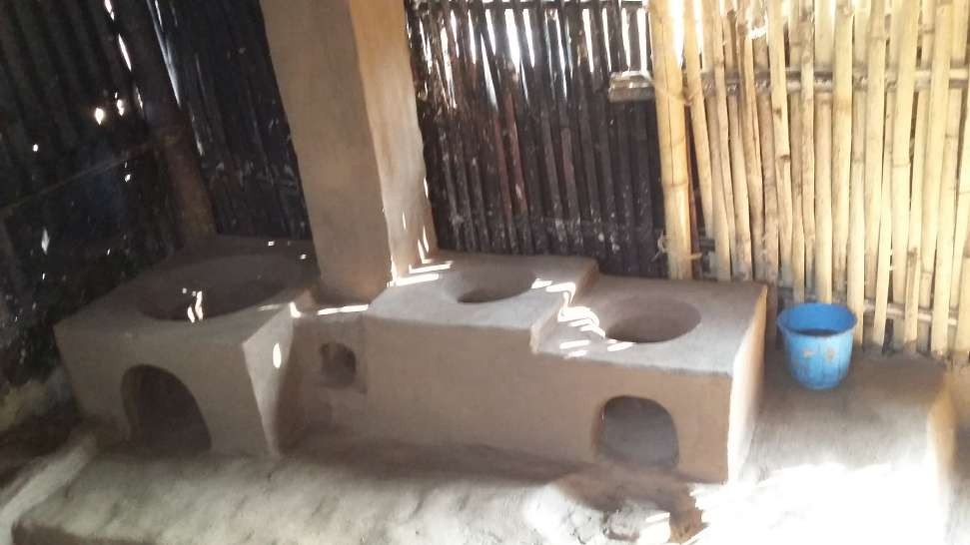
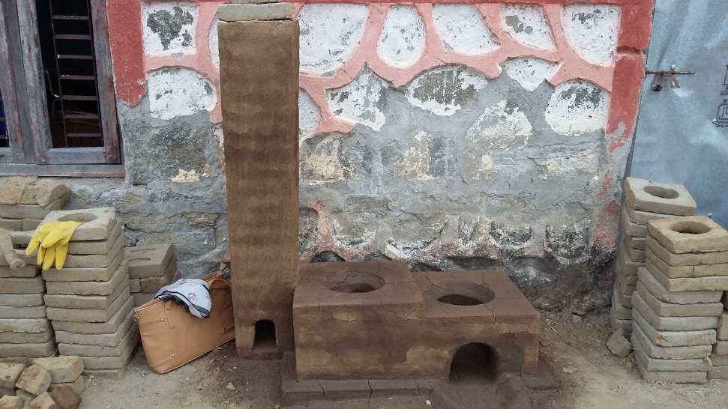
ICS Constructed at Miklajung RM-3 Multipurpose ICS constructed

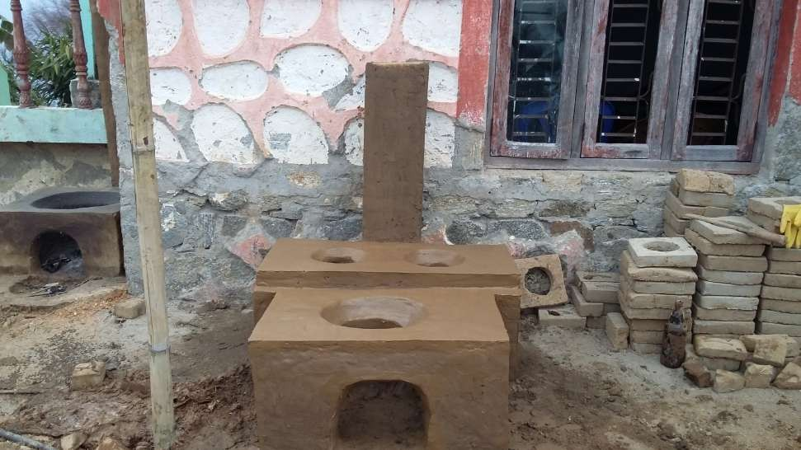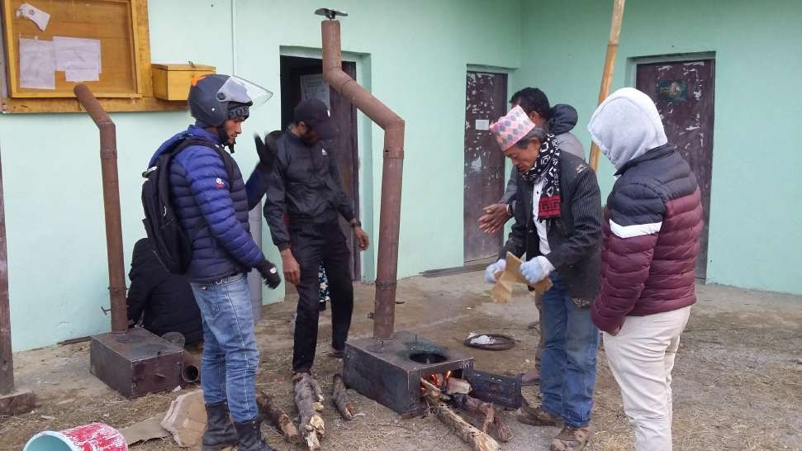
ICS constructed at Miklajung RM-3 3 Pot Hole MICS at Miklajung RM-3

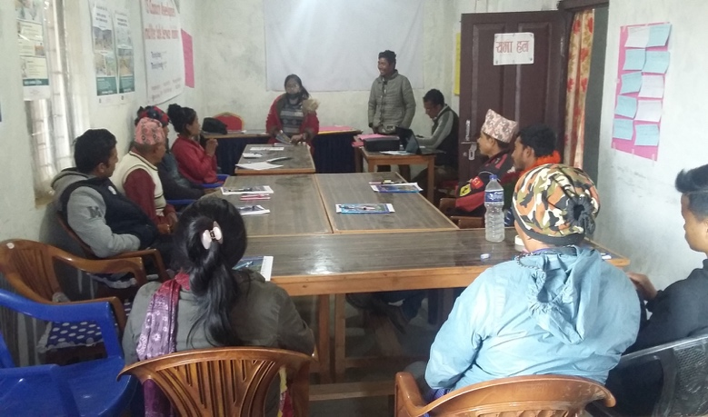 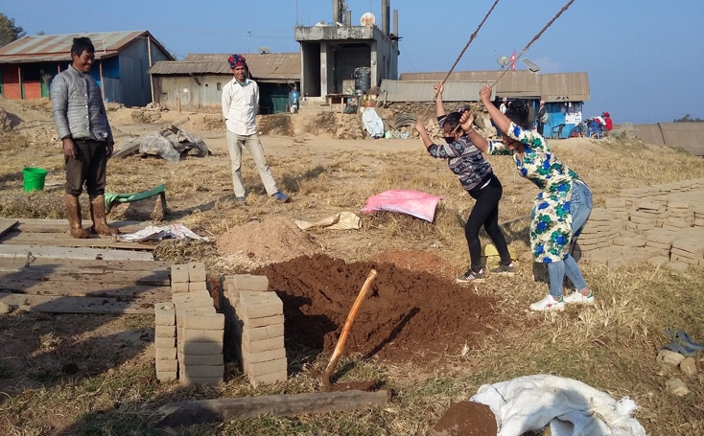 Trainees during introduction program at Mangsebung Trainees preparing clay for Bricks
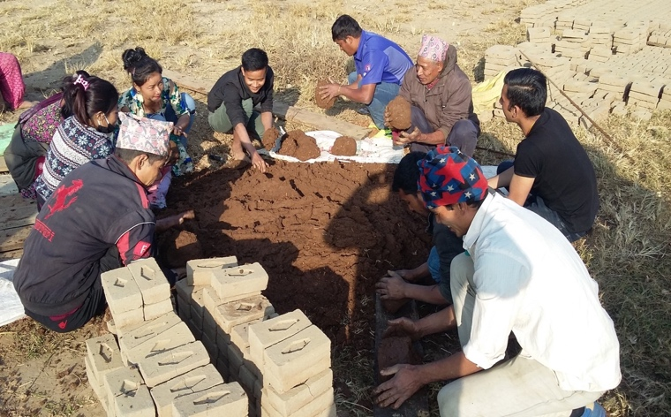 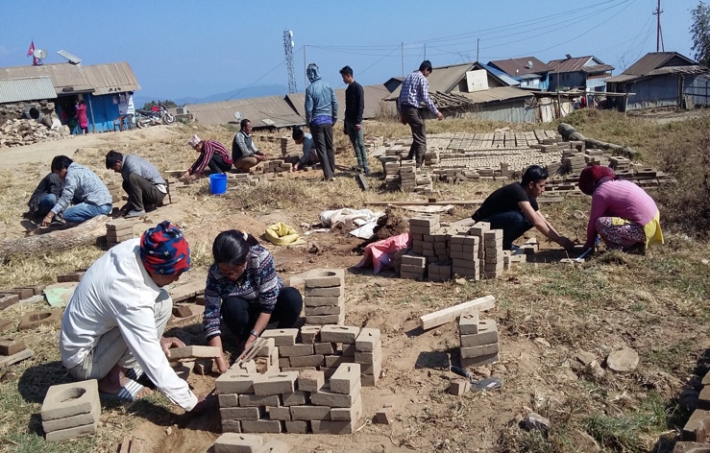 Trainee ready to make Blocks after mixing Trainees Joining the Blocks of ICS

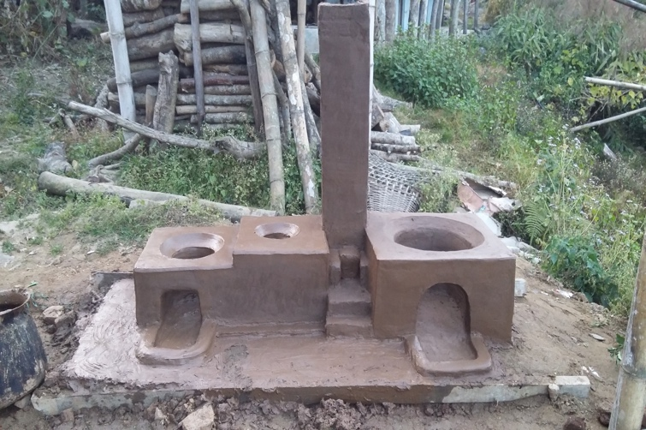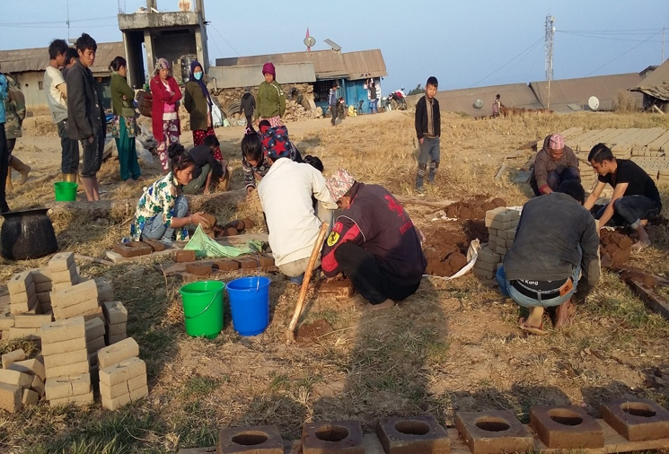
Multipurpose ICS constructed at Mangsebung Trainees Making Block themselves

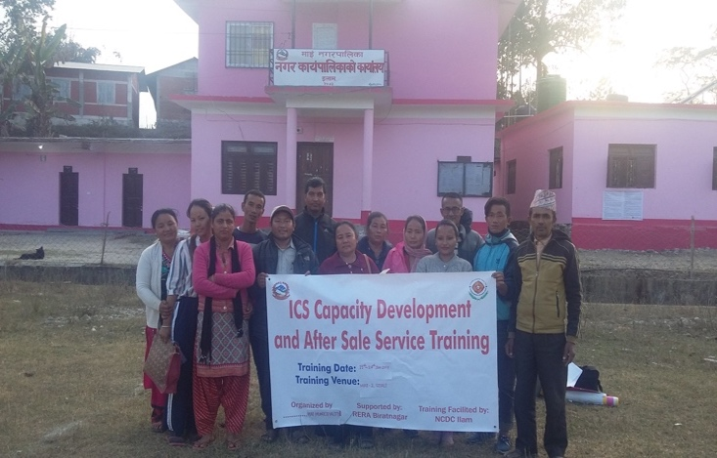 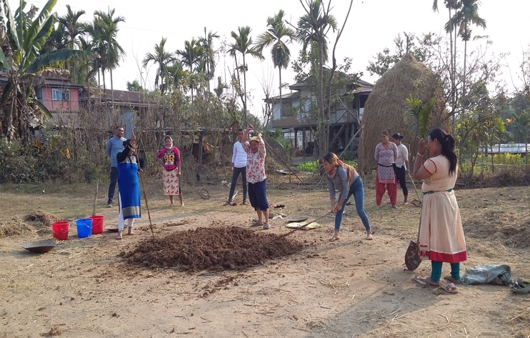 Trainees and Trainers during the Training at Mai Trainees preparing clay for Bricks

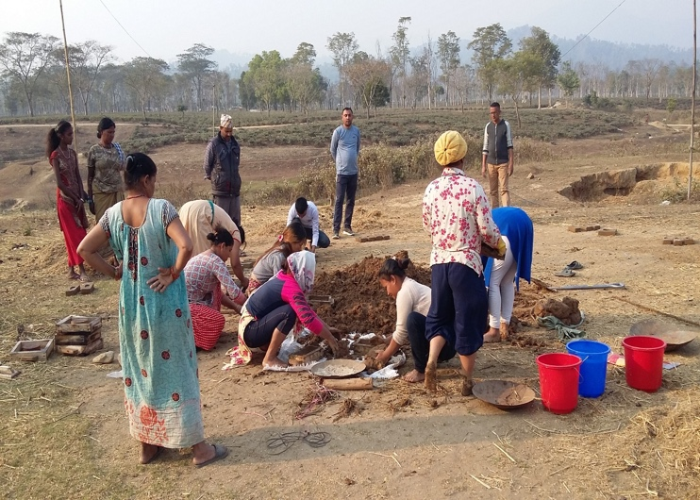 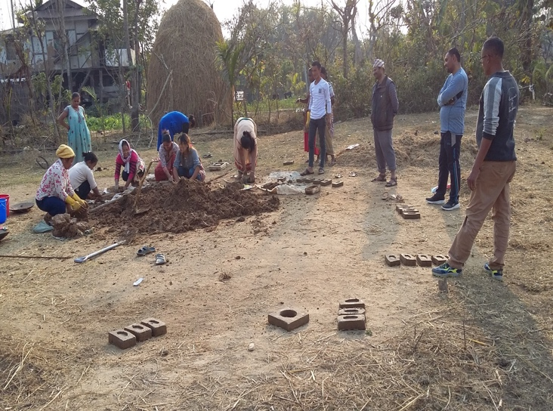 Trainees ready to make Blocks Trainees making the Blocks

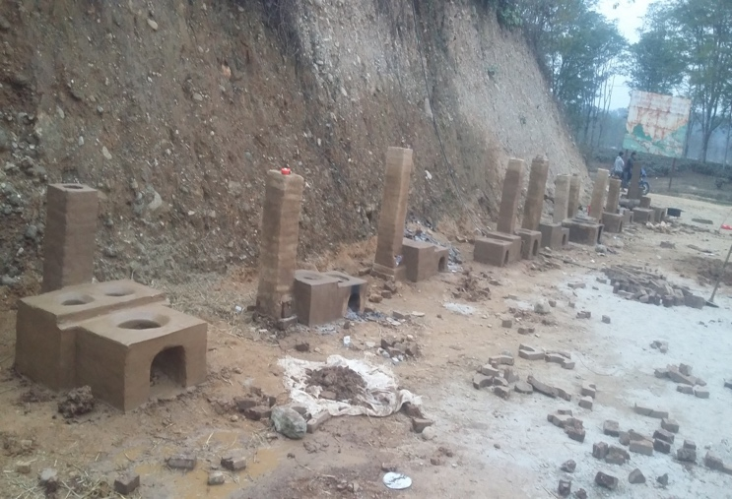 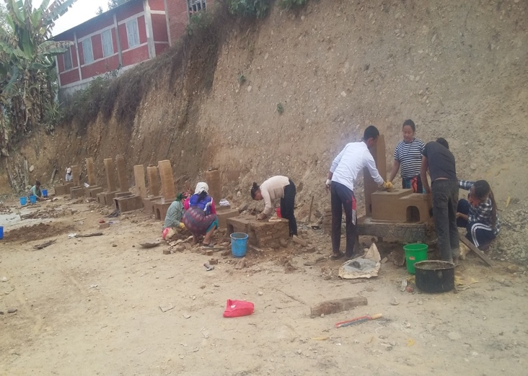 ICS Finishing of ICS done by Trainees Constructing ICS by Trainees

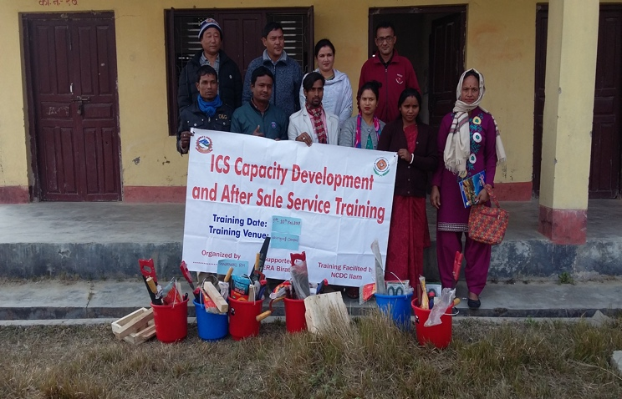 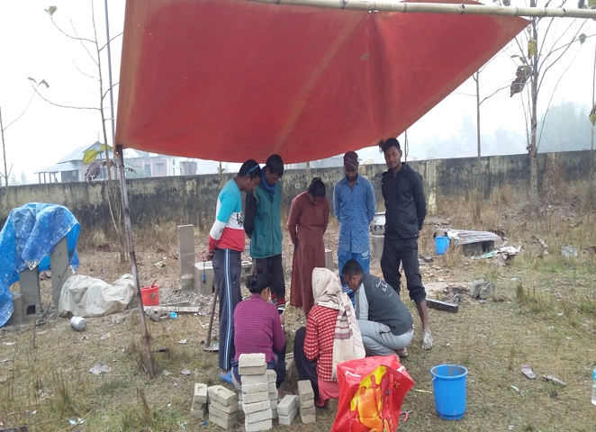 Trainer, Trainees & Tools provided at Gaurigunj Providing instructions to Trainees

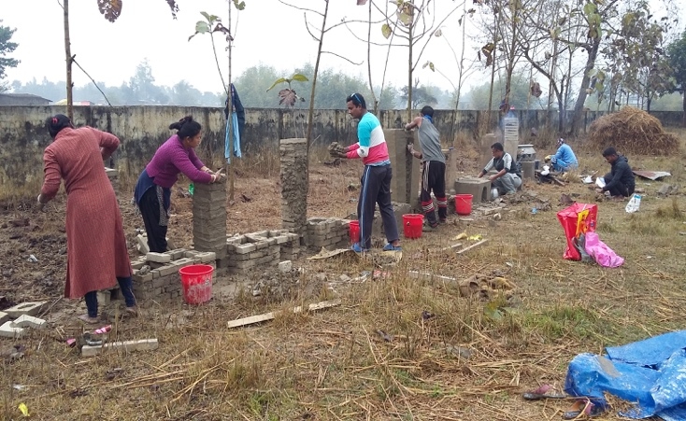 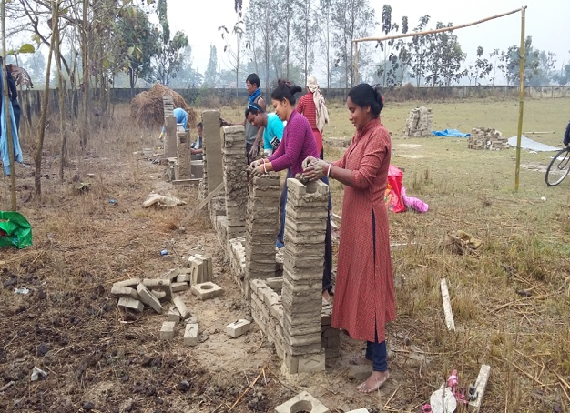 Trainees making 2 Pot Hole ICS Trainees on practical works

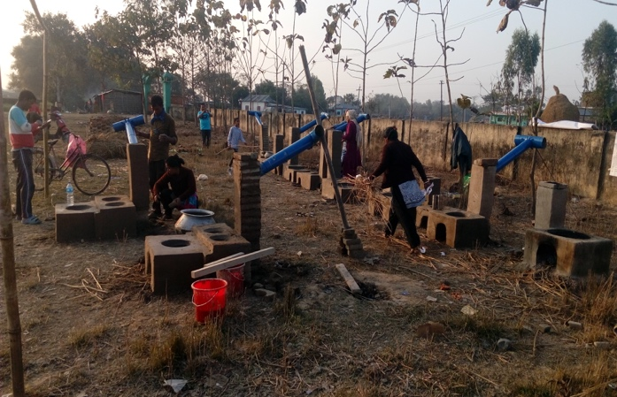 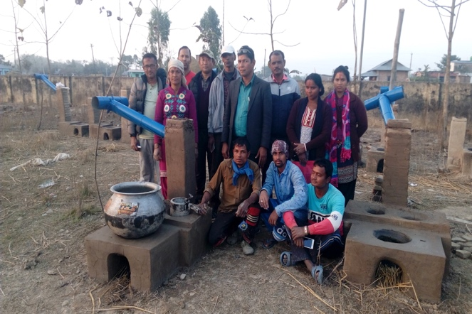 ICS made by Trainees at Gaurigunj Group Photo of Trainer & Trainees

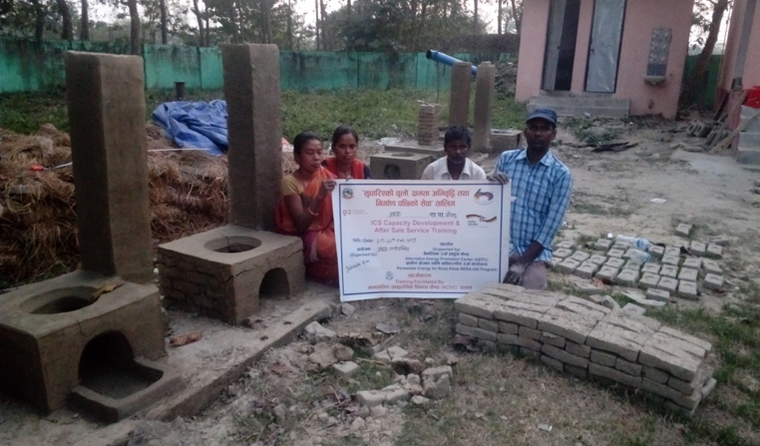 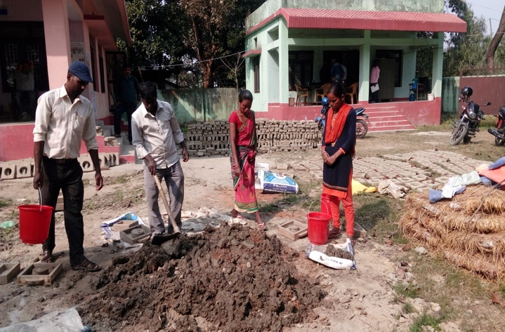 Trainees after completion of Training at Jahada Trainees mixing clay for finishing work

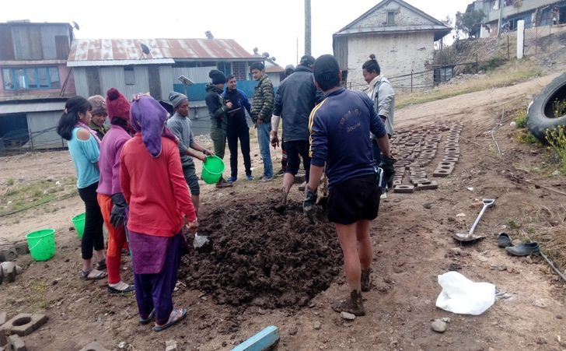 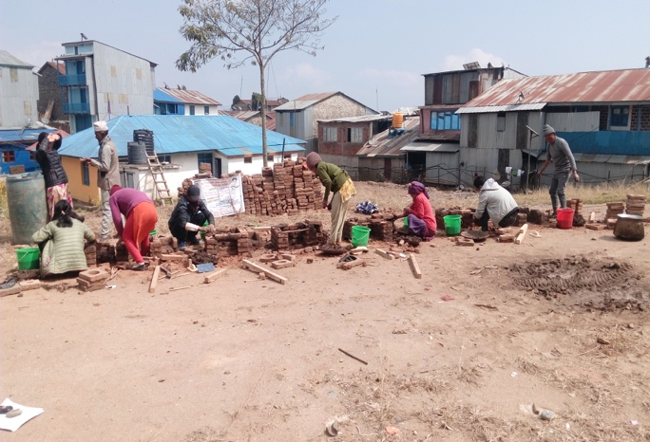 Making Clay for Practice at Aamchowk Trainees practicing to join the bricks

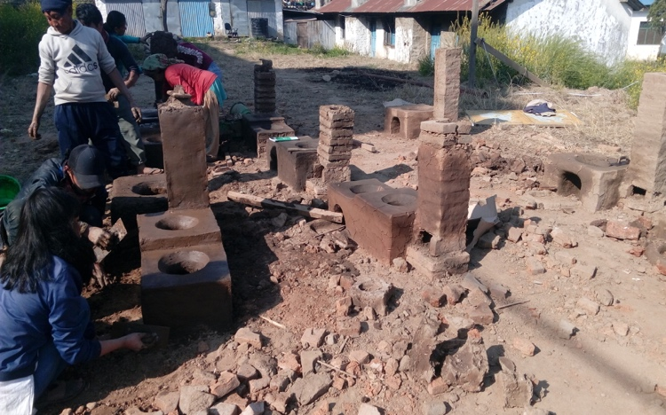 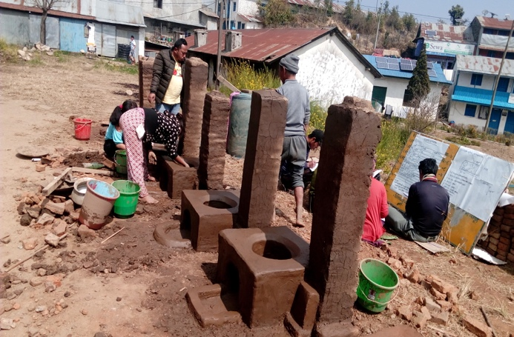 Trainees practicing to make ICS Finishing work ongoing

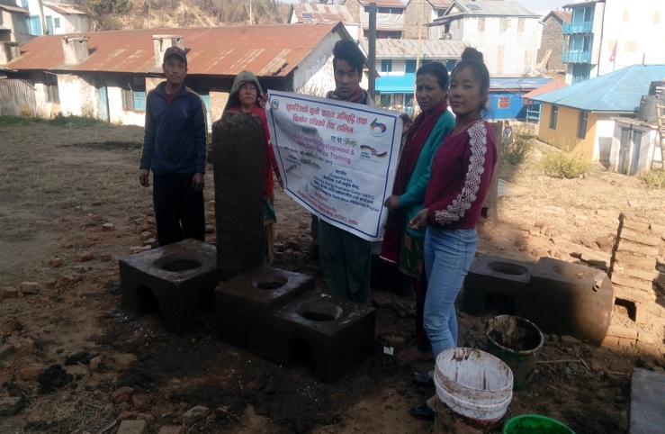 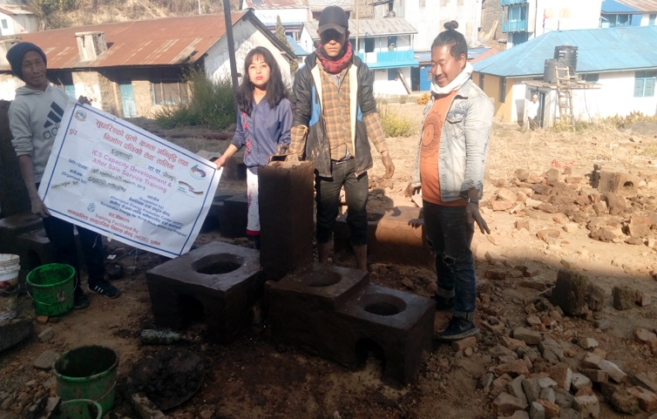Trainees with Banner during Training Trainees with Banner during Training

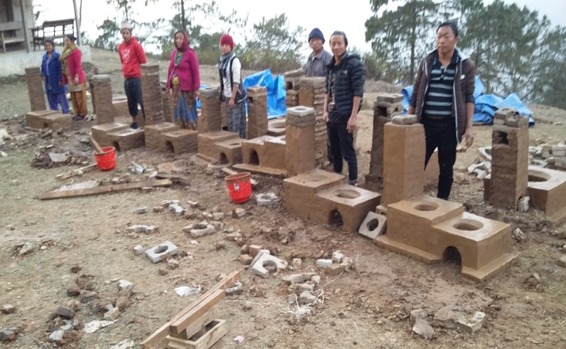 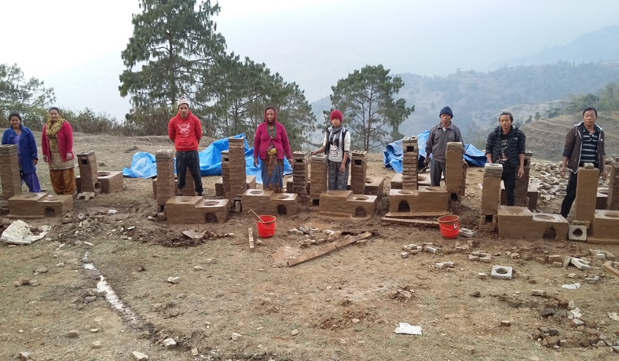 Trainees with installed ICS at Aamchowk Trainees with installed ICS at Aamchowk

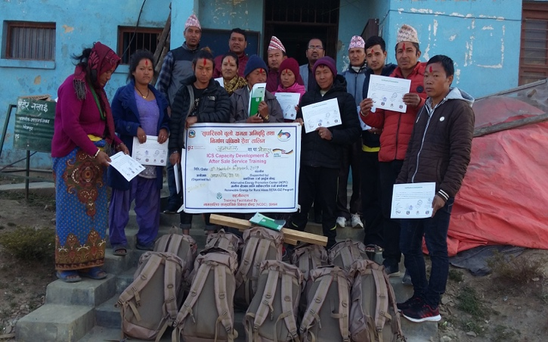 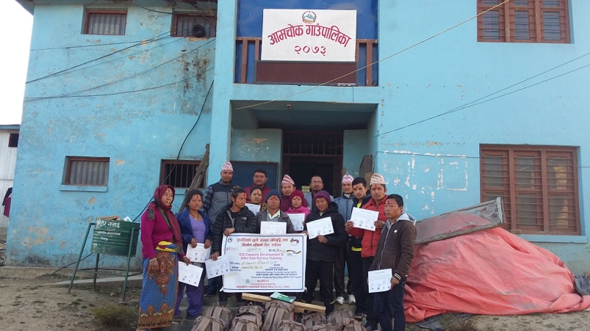Trainees ready to go for Installation at Rural area Group photo at Aamchowk RM after training

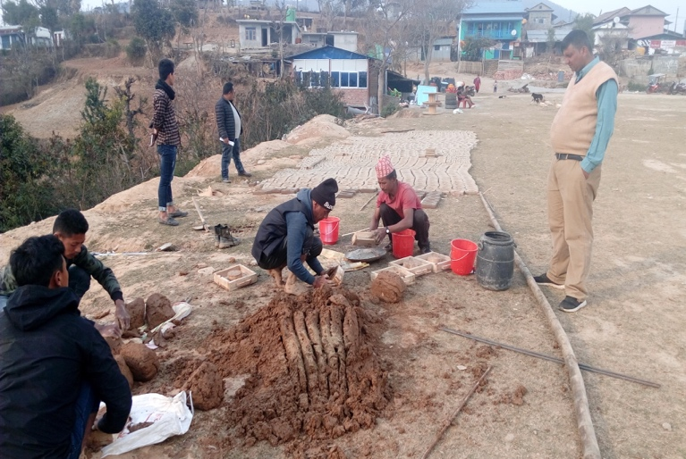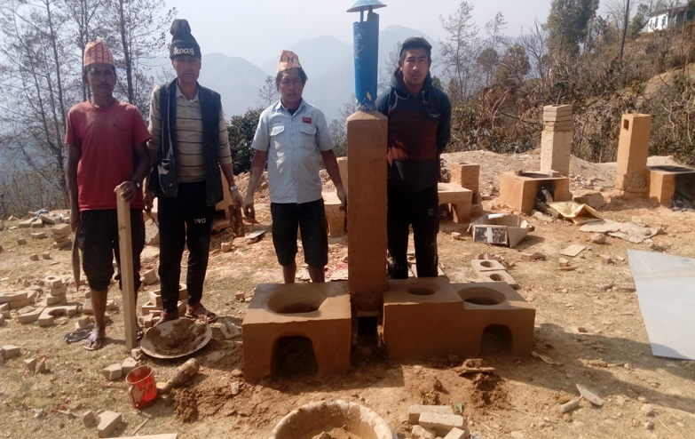
Trainees making clay at Manebhanjyang Trainees finished 3 Pot Hole ICS

Bill of quantities and materials required for each stove type

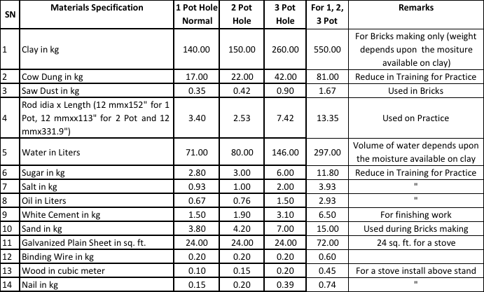

Technical specification of tools including moulds and purpose

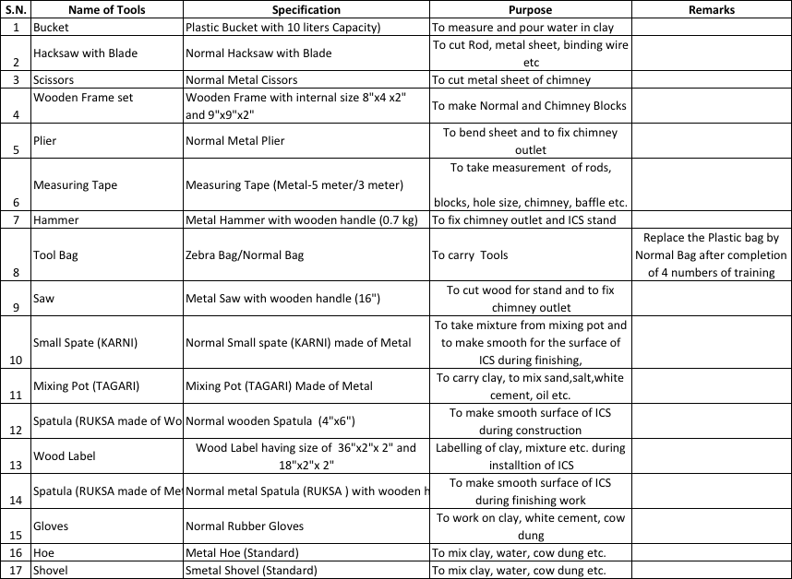

Flyer and posters
